|  |
| --- |
|  |
| Capstone Project Document |

KARYWELL SYSTEM

Detail Desgin

|  |  |  |
| --- | --- | --- |
| **KaryWell System** | | |
| **Group Members** | Le Van Quy Hoang | SE90184 |
| Tran Dinh Hoang Huy | SE90201 |
| Nguyen Khac Hoang | SE02564 |
| Kieu Cao Khanh | SE02960 |
| Nguyen Van Quyen | SE02884 |
| Nguyen Thi Hong Nhung | SE02437 |
| **Supervisor** | Mr. Tran Binh Duong | |
| **Project code** | KW | |

**- Hanoi, 12/2015 -**

**Table of Contents**

1. INTRODUCTION 3

1.1 Purpose 3

1.2 Definitions, Acronyms and Abbreviations 3

2. DETAIL DESIGN 4

2.1 Mobile Application 5

2.1.1 Login 5

2.1.2 View Profile 7

2.1.3 Confirm Code 8

2.1.4 Grab Order 9

2.1.5 View Task’s List 9

2.1.6 View Task’s Detail 10

2.1.7 Send Issue Information 11

2.1.8 Change Working Status 12

2.1.9 View History 13

2.1.10 Continue When Pending 14

2.1.11 Class Description 15

2.2 Web Application 21

2.2.1 Web Client 21

2.2.2 Web Server 67

## INTRODUCTION

### Purpose

This document describe details of function in system by using many types of diagram (class diagram, object diagram, sequence diagram) to help developer understand easily and develop these functions efficiently following requirement.

### Definitions, Acronyms and Abbreviations

|  |  |  |
| --- | --- | --- |
| Abbreviations | Description | Comment |
| N/A | Not available |  |
| KW | KaryWell |  |

## DETAIL DESIGN

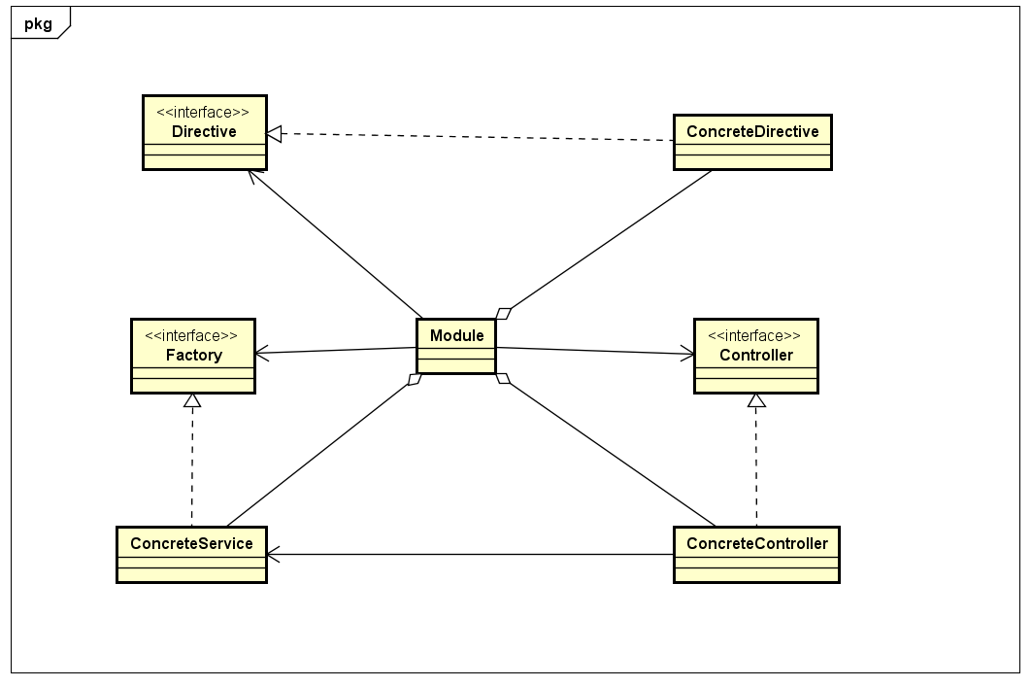

Figure Class Diagram of Angular module

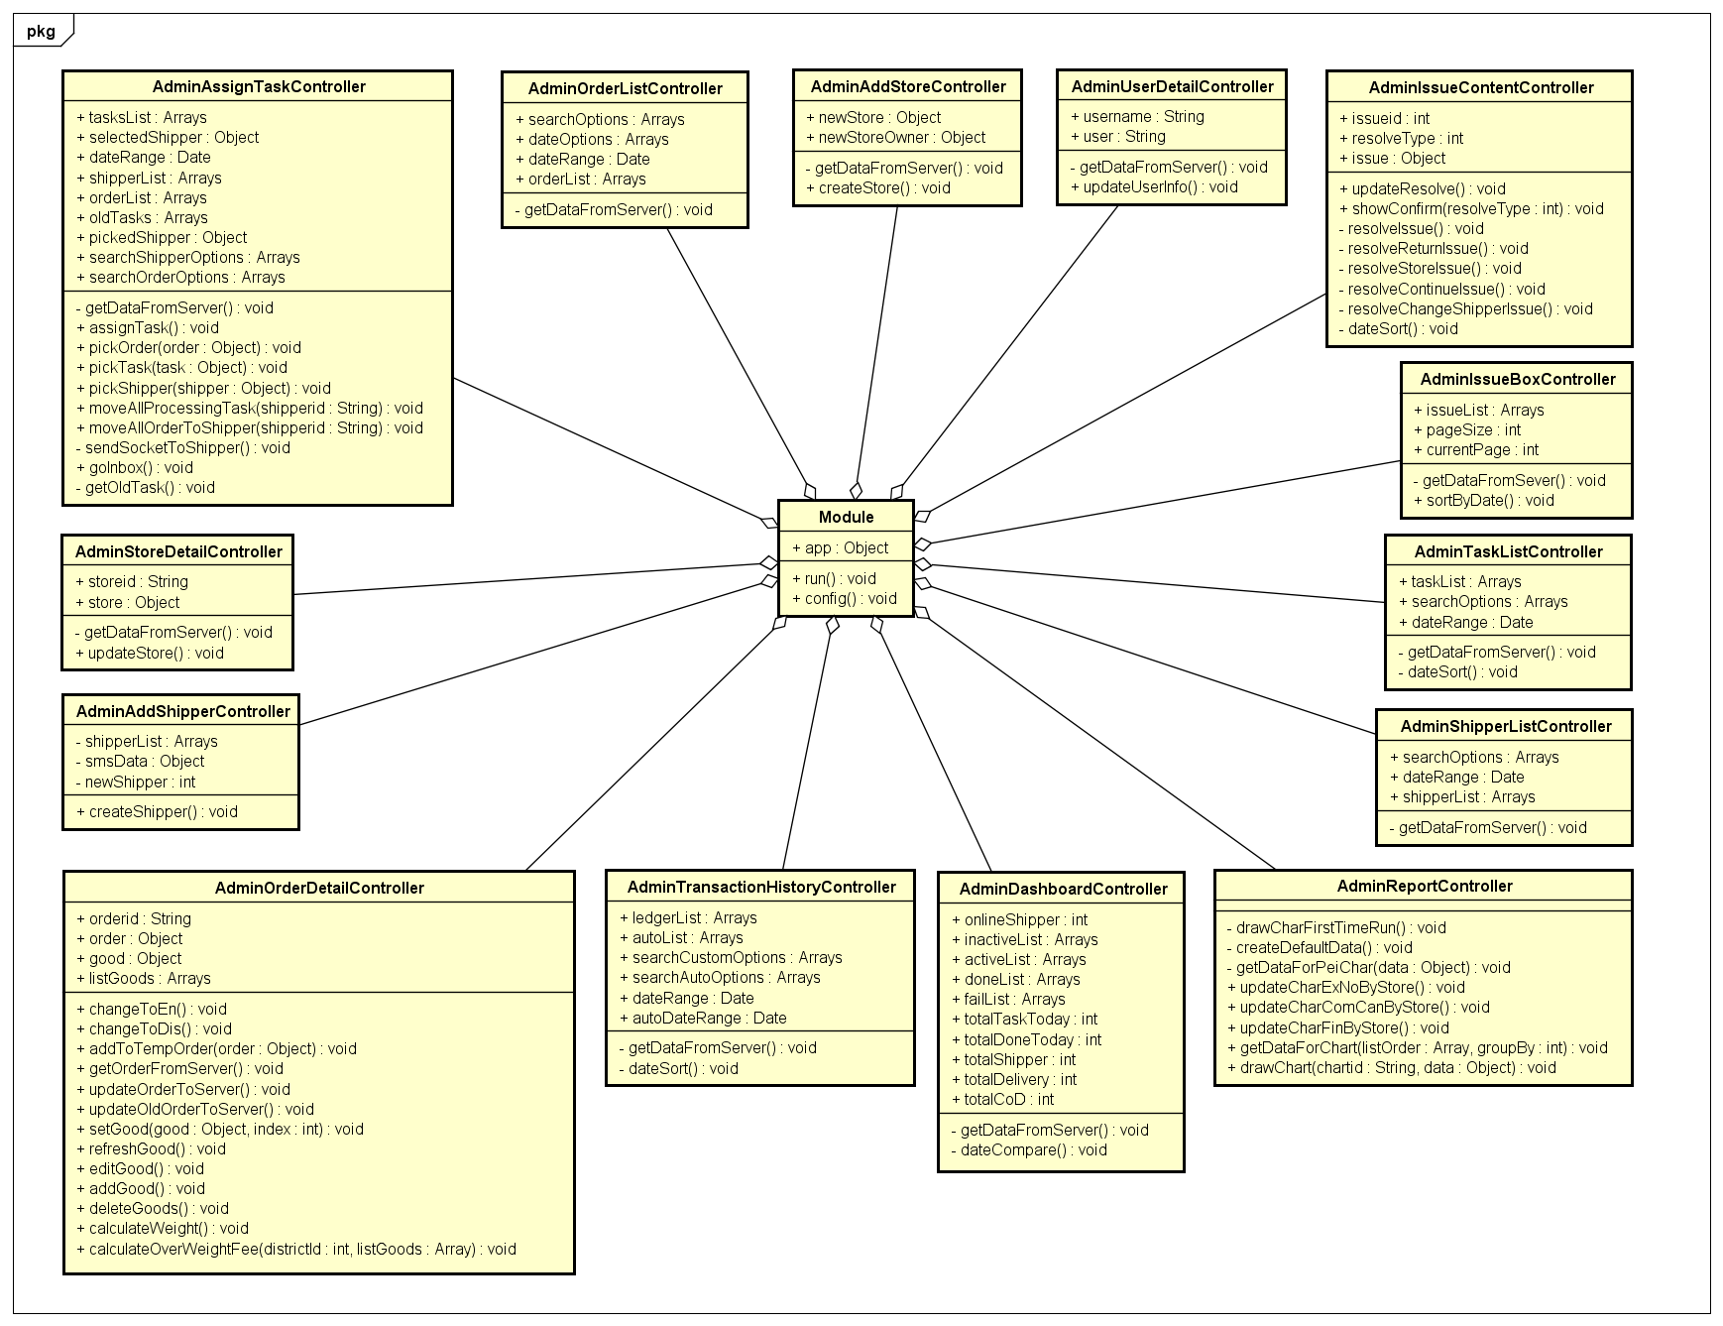

Figure . Class Diagram of Controller for Admin

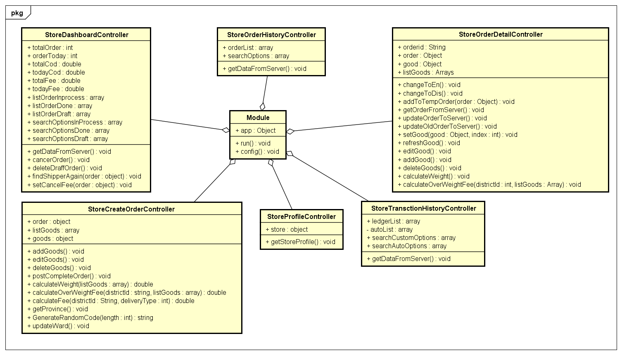

Figure . Class Diagram of Controller for Store

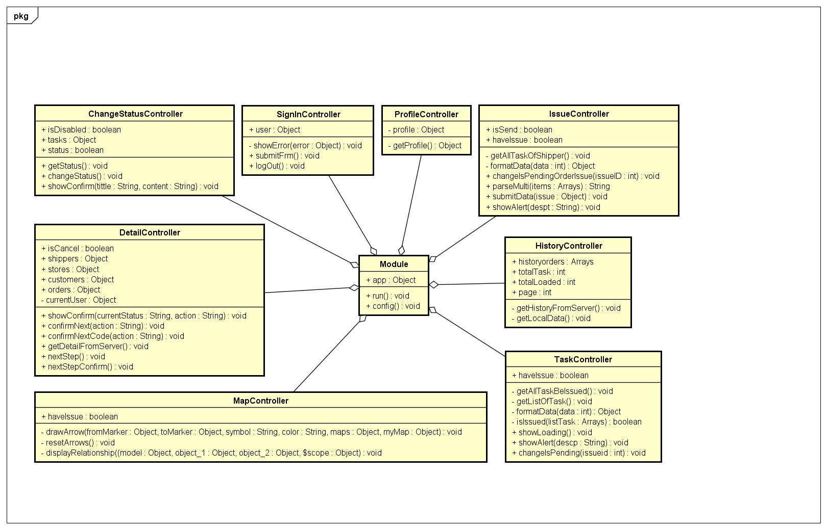

Figure . Class Diagram of Controller for Shipper

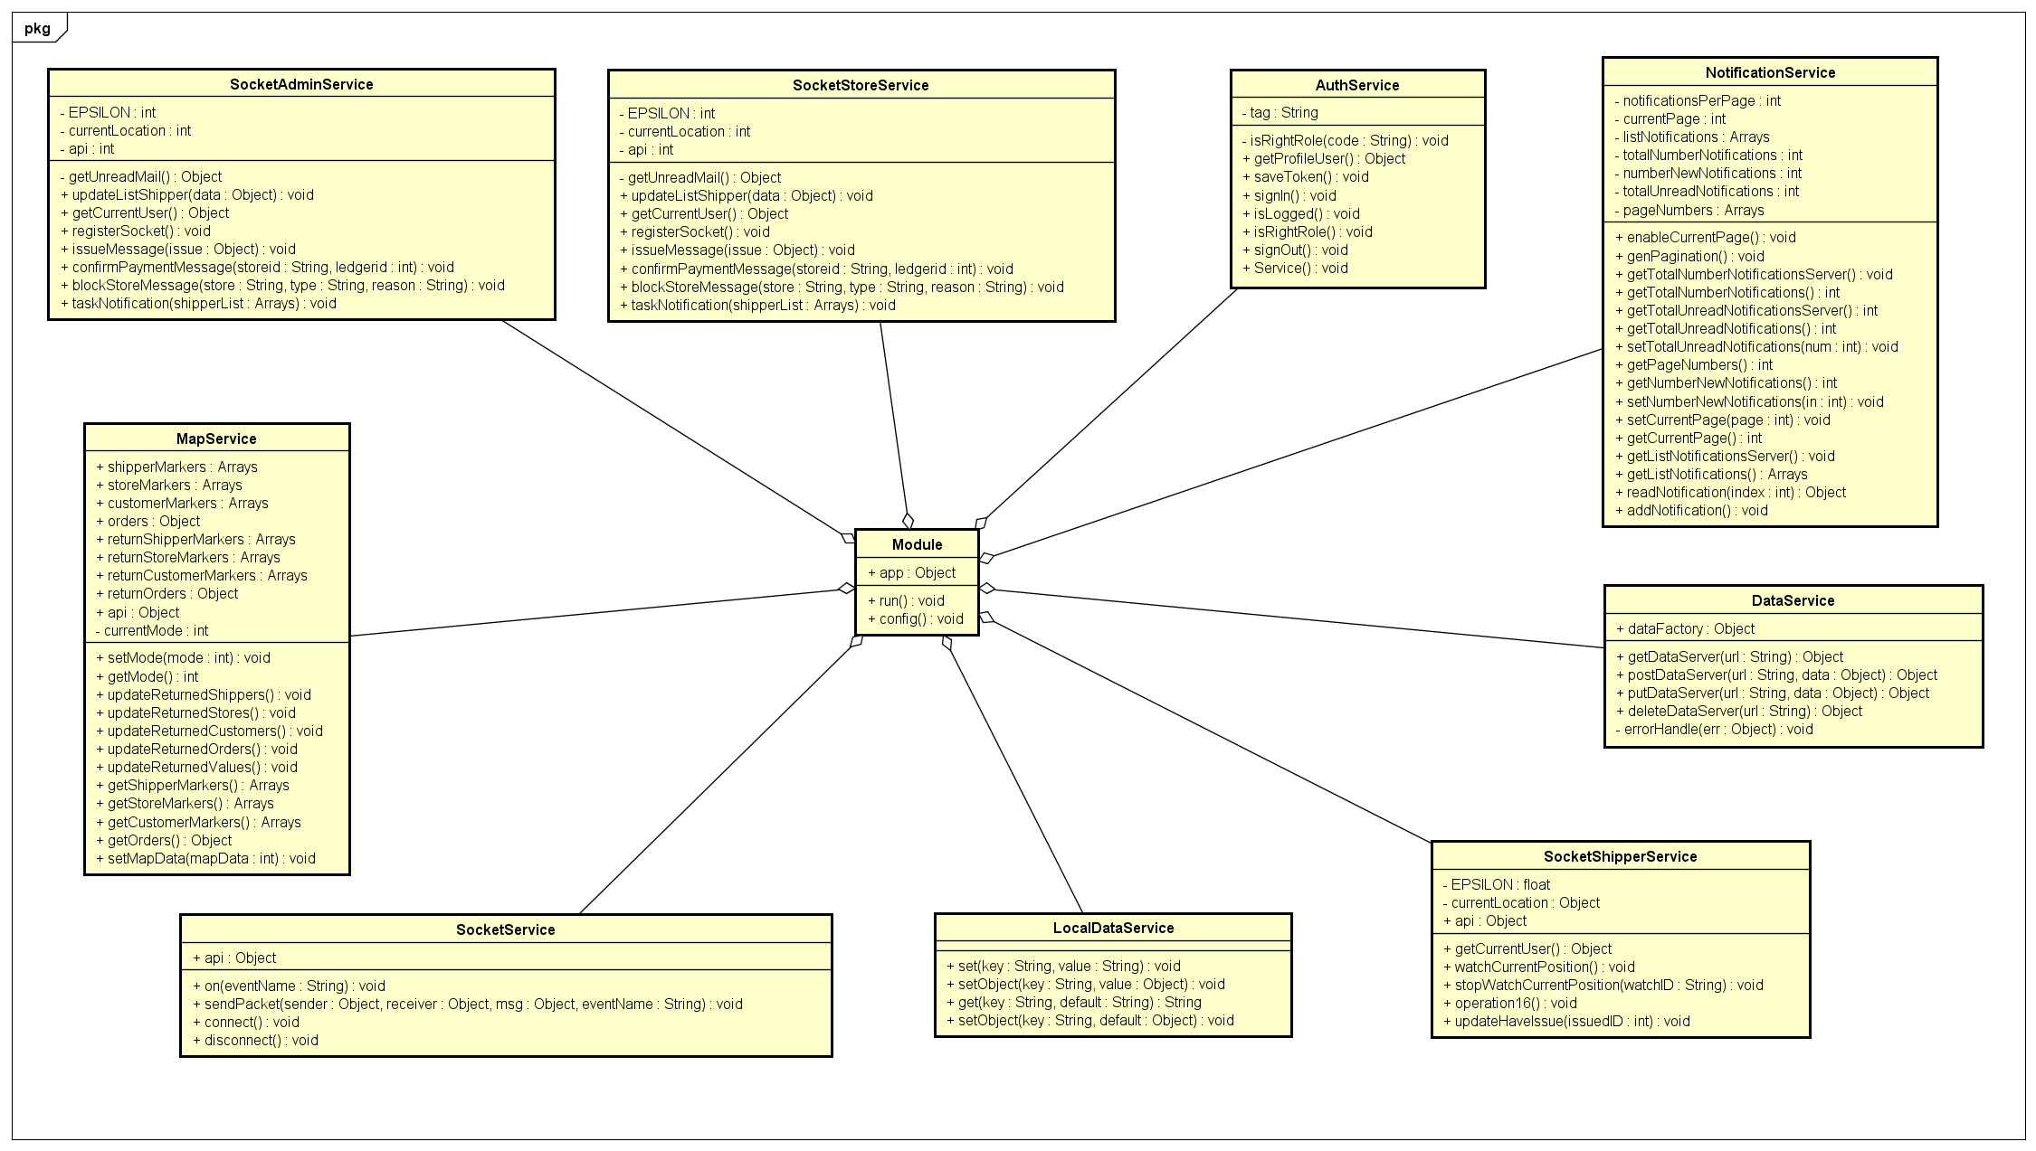

Figure . Class Diagram for Service

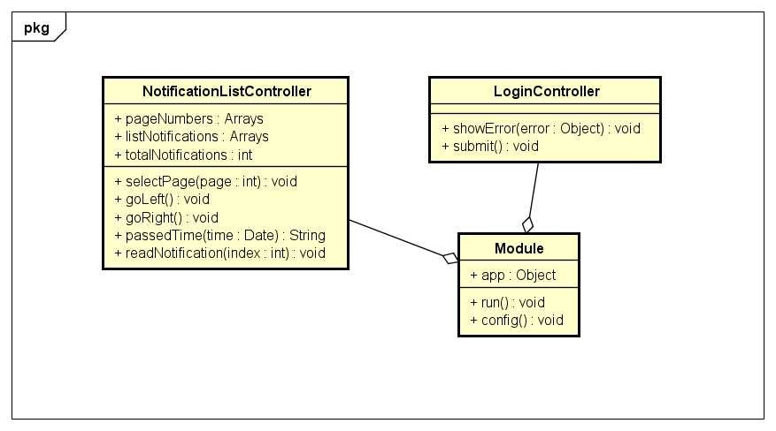

Figure . Class Diagram of Controller for Common

### Mobile Application

#### Login

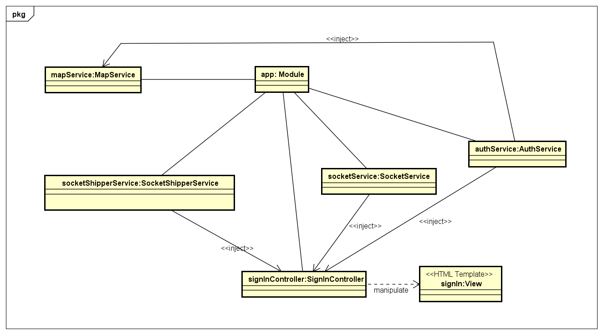

Figure . Object Diagram of Login use case

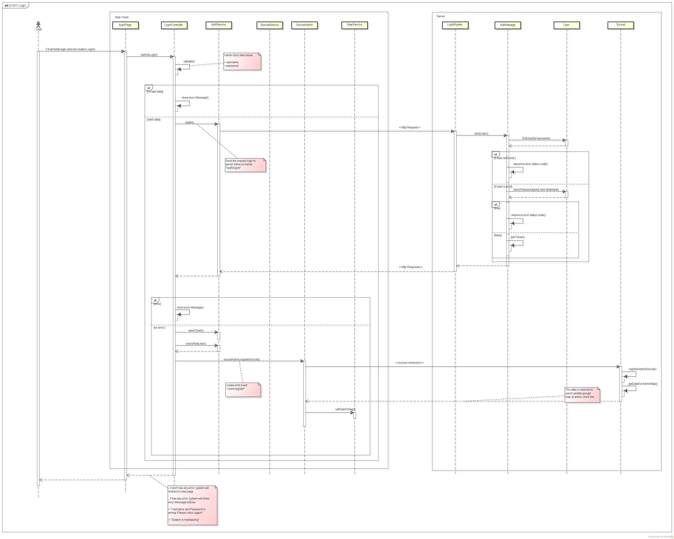

Figure . Sequence Diagram of Login use case

#### Logout

*Refer to 2.2.1.3.2. Logout*

#### View Profile

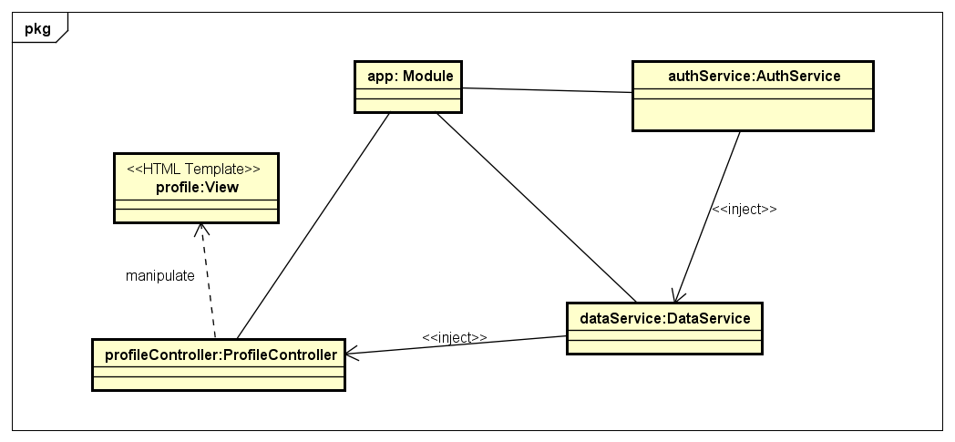

Figure Object Diagram of View Profile use case

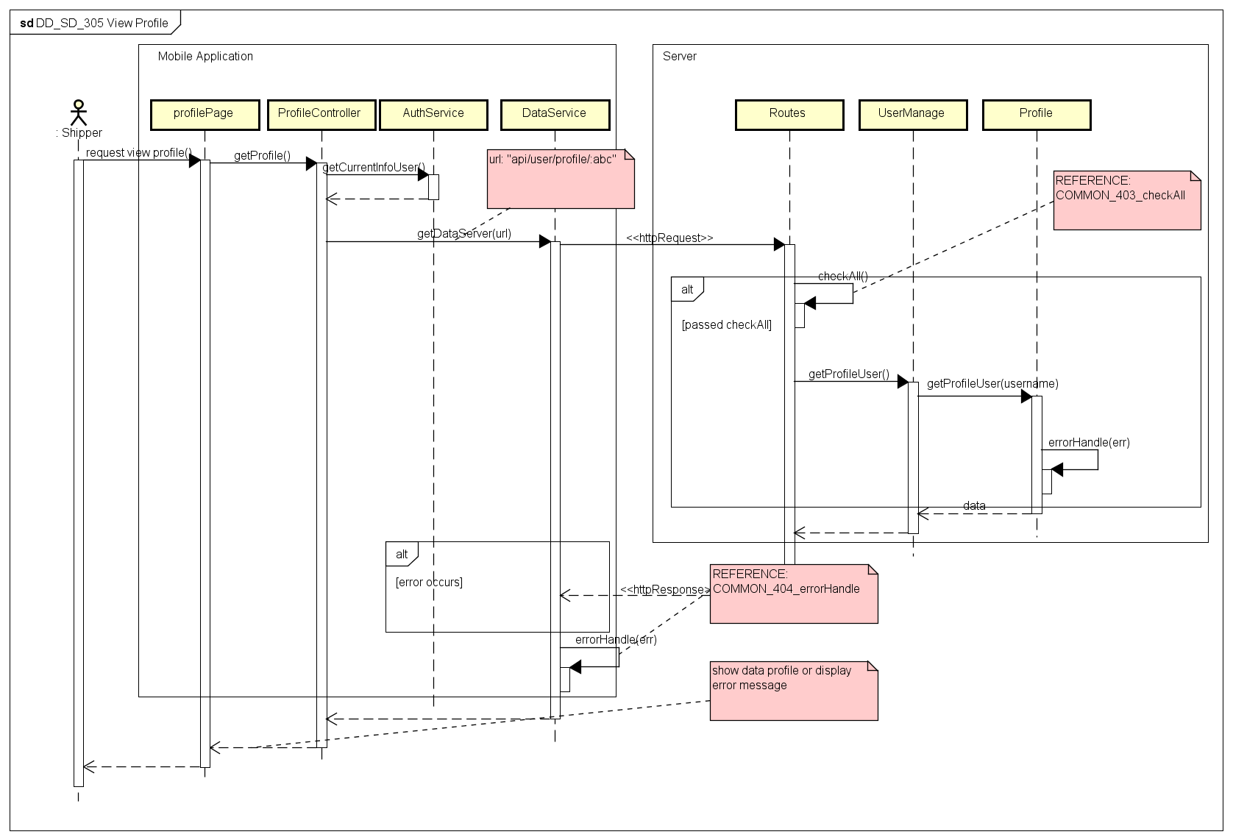

Figure . Sequence Diagram of View Profile use case

#### Confirm Code

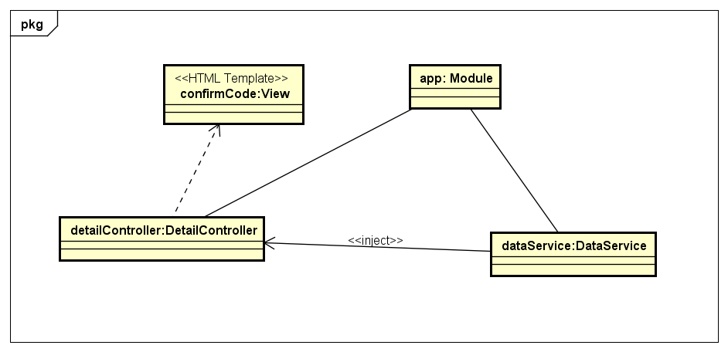

Figure Object Diagram of Confirm Code use case

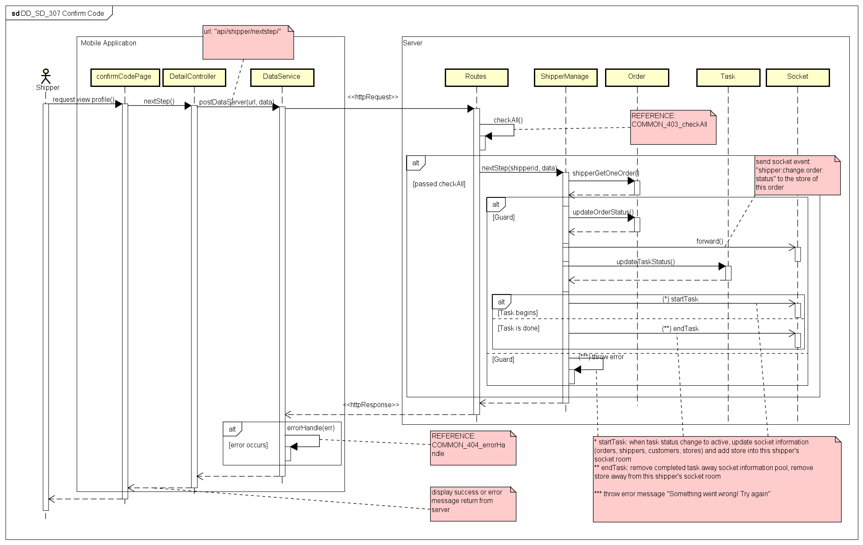

Figure Sequence Diagram of Confirm Code use case

#### Grab Order

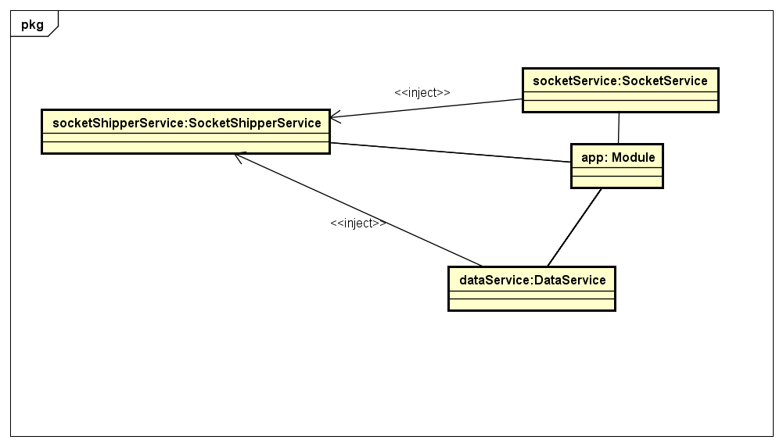

Figure . Object Diagram of Grab Order use case

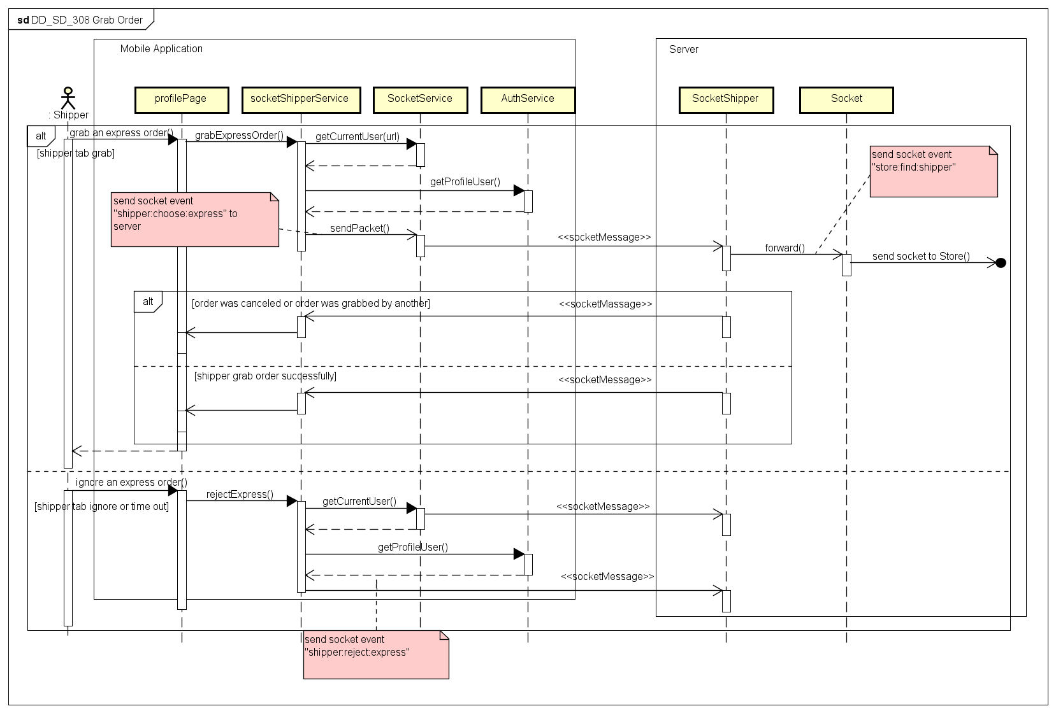

Figure . Sequence Diagram of Grab Order use case

#### View Task’s List

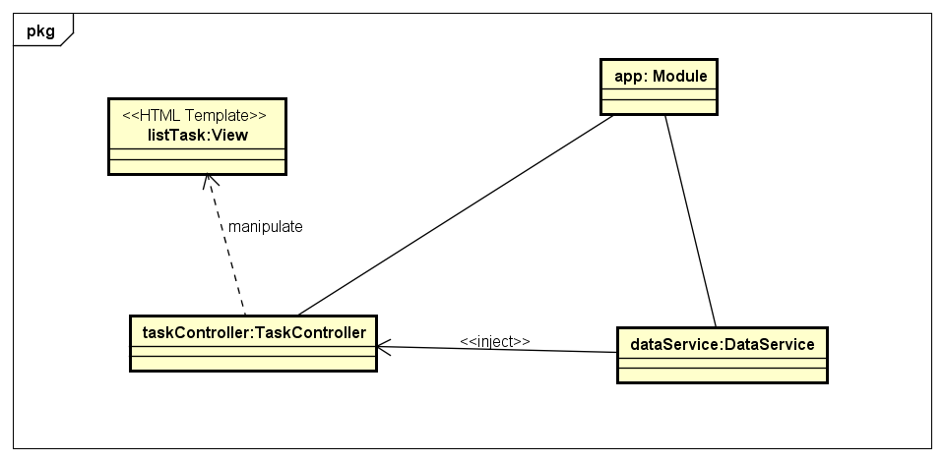

Figure Object Diagram of View Task’s List use case

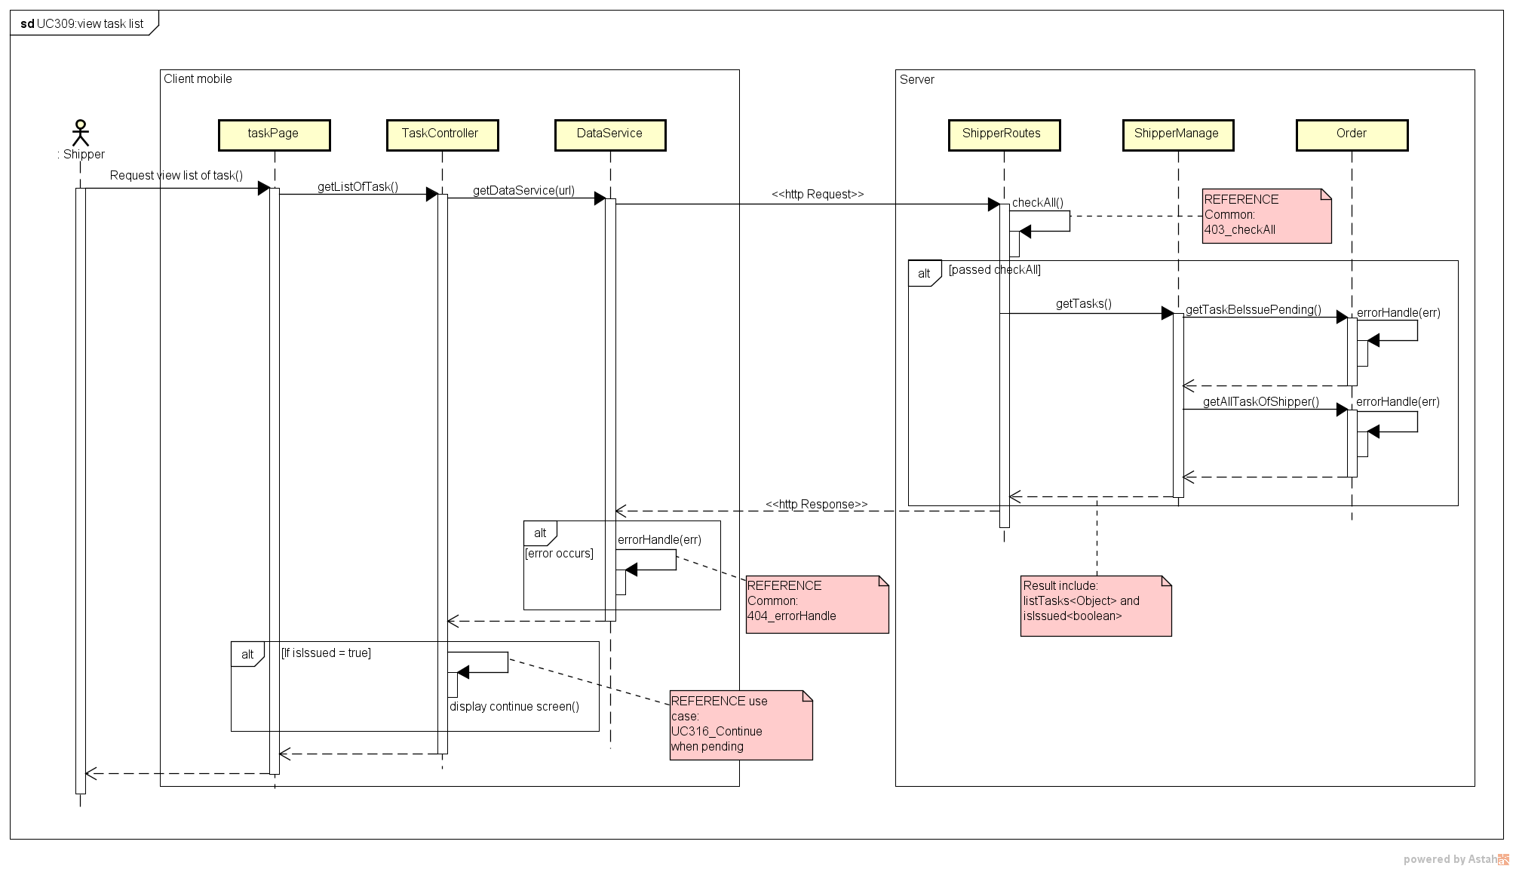

Figure Sequence Diagram of View Task’s List use case

#### View Task’s Detail

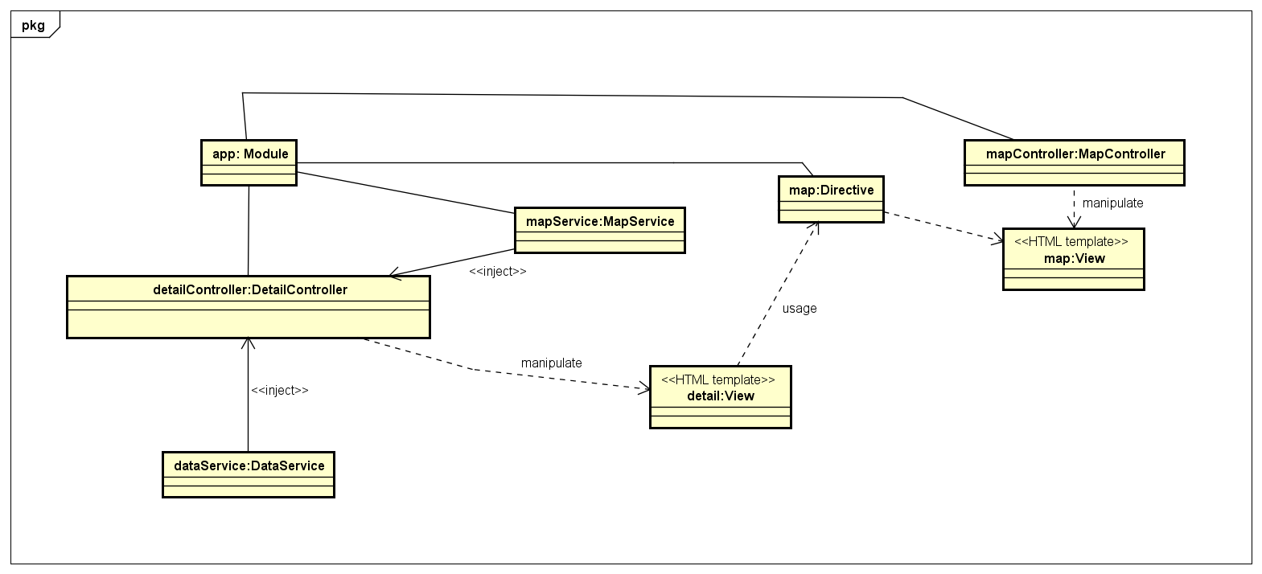

Figure Object Diagram of View Task’s Detail use case

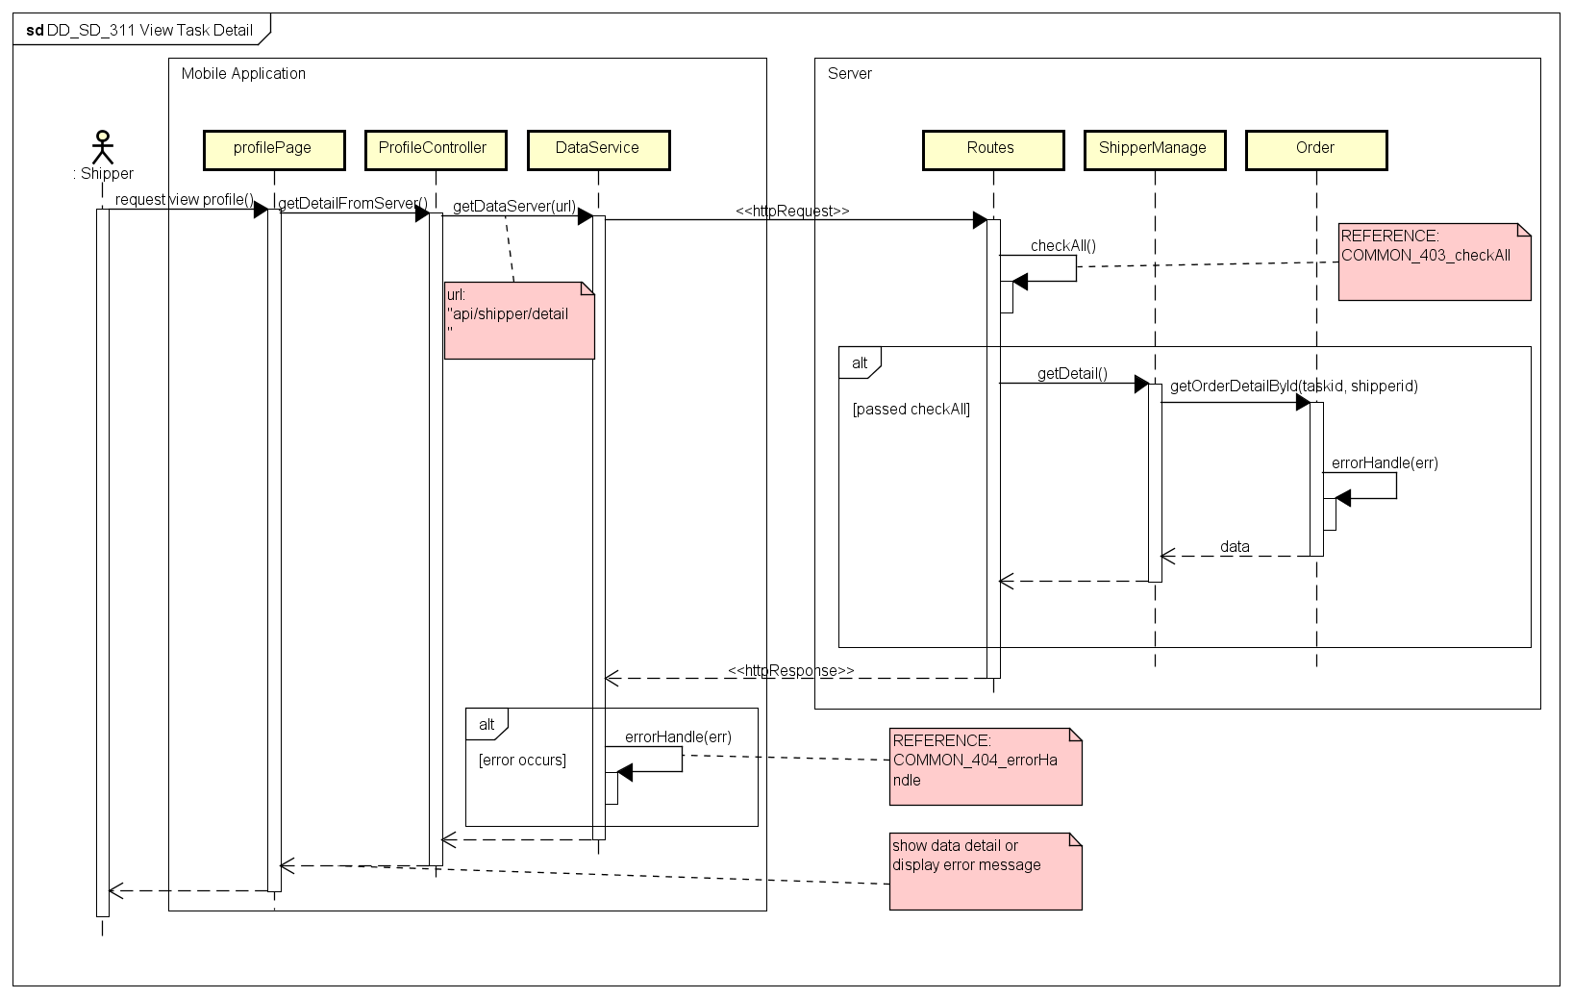

Figure Sequence Diagram of View Task’s Detail use case

#### Send Issue Information

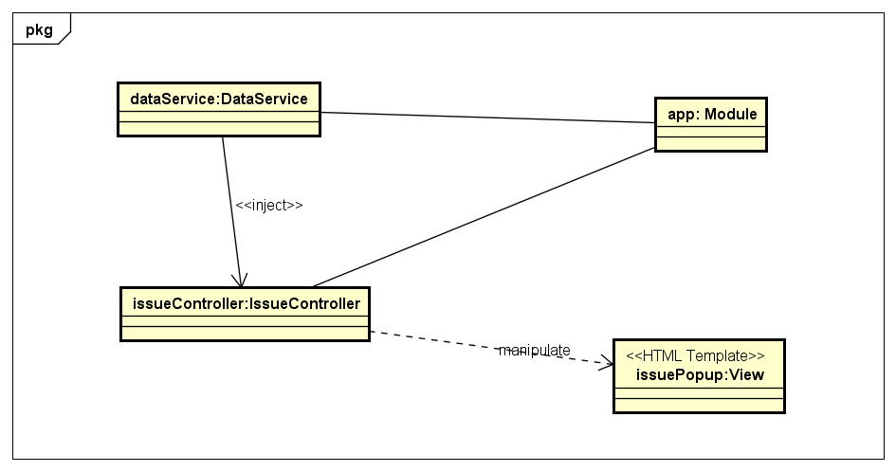

Figure Object Diagram of Send Issue use case

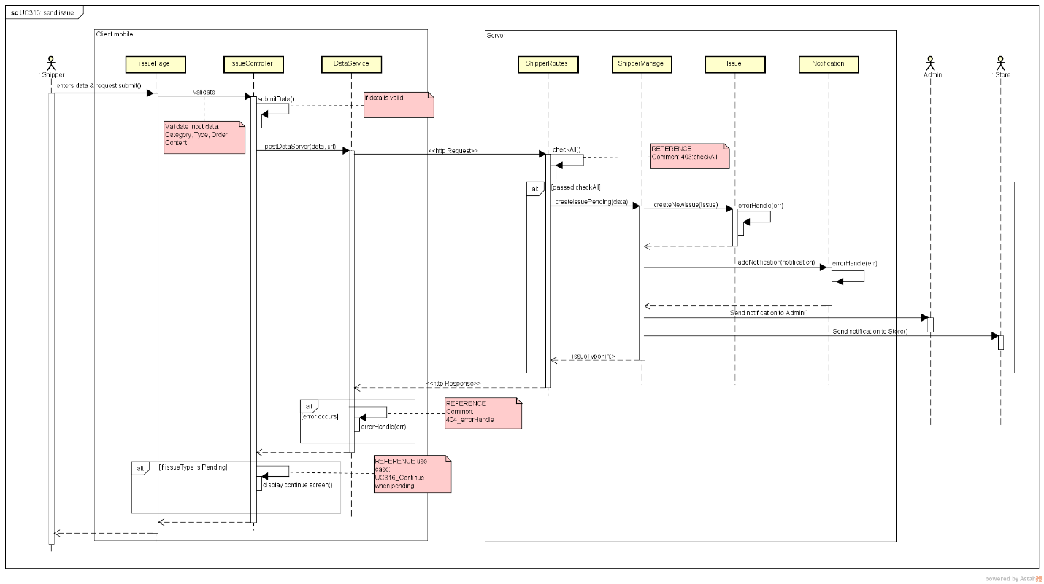

Figure Sequence Diagram of Send Issue use case

#### Change Working Status

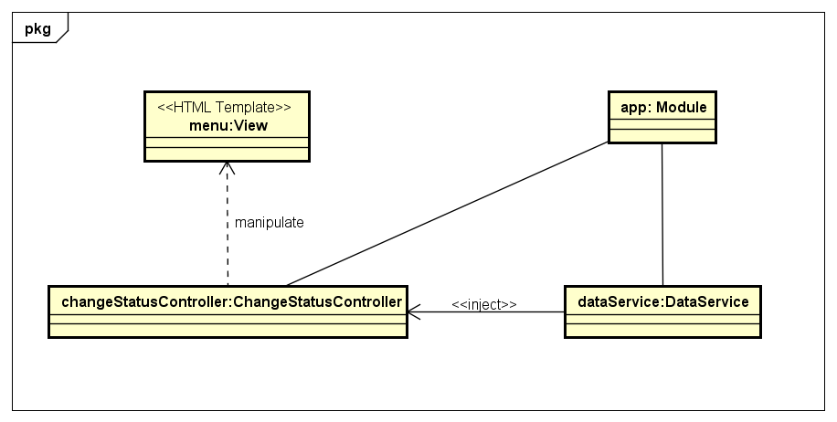

Figure . Object Diagram of Change Working Status use case

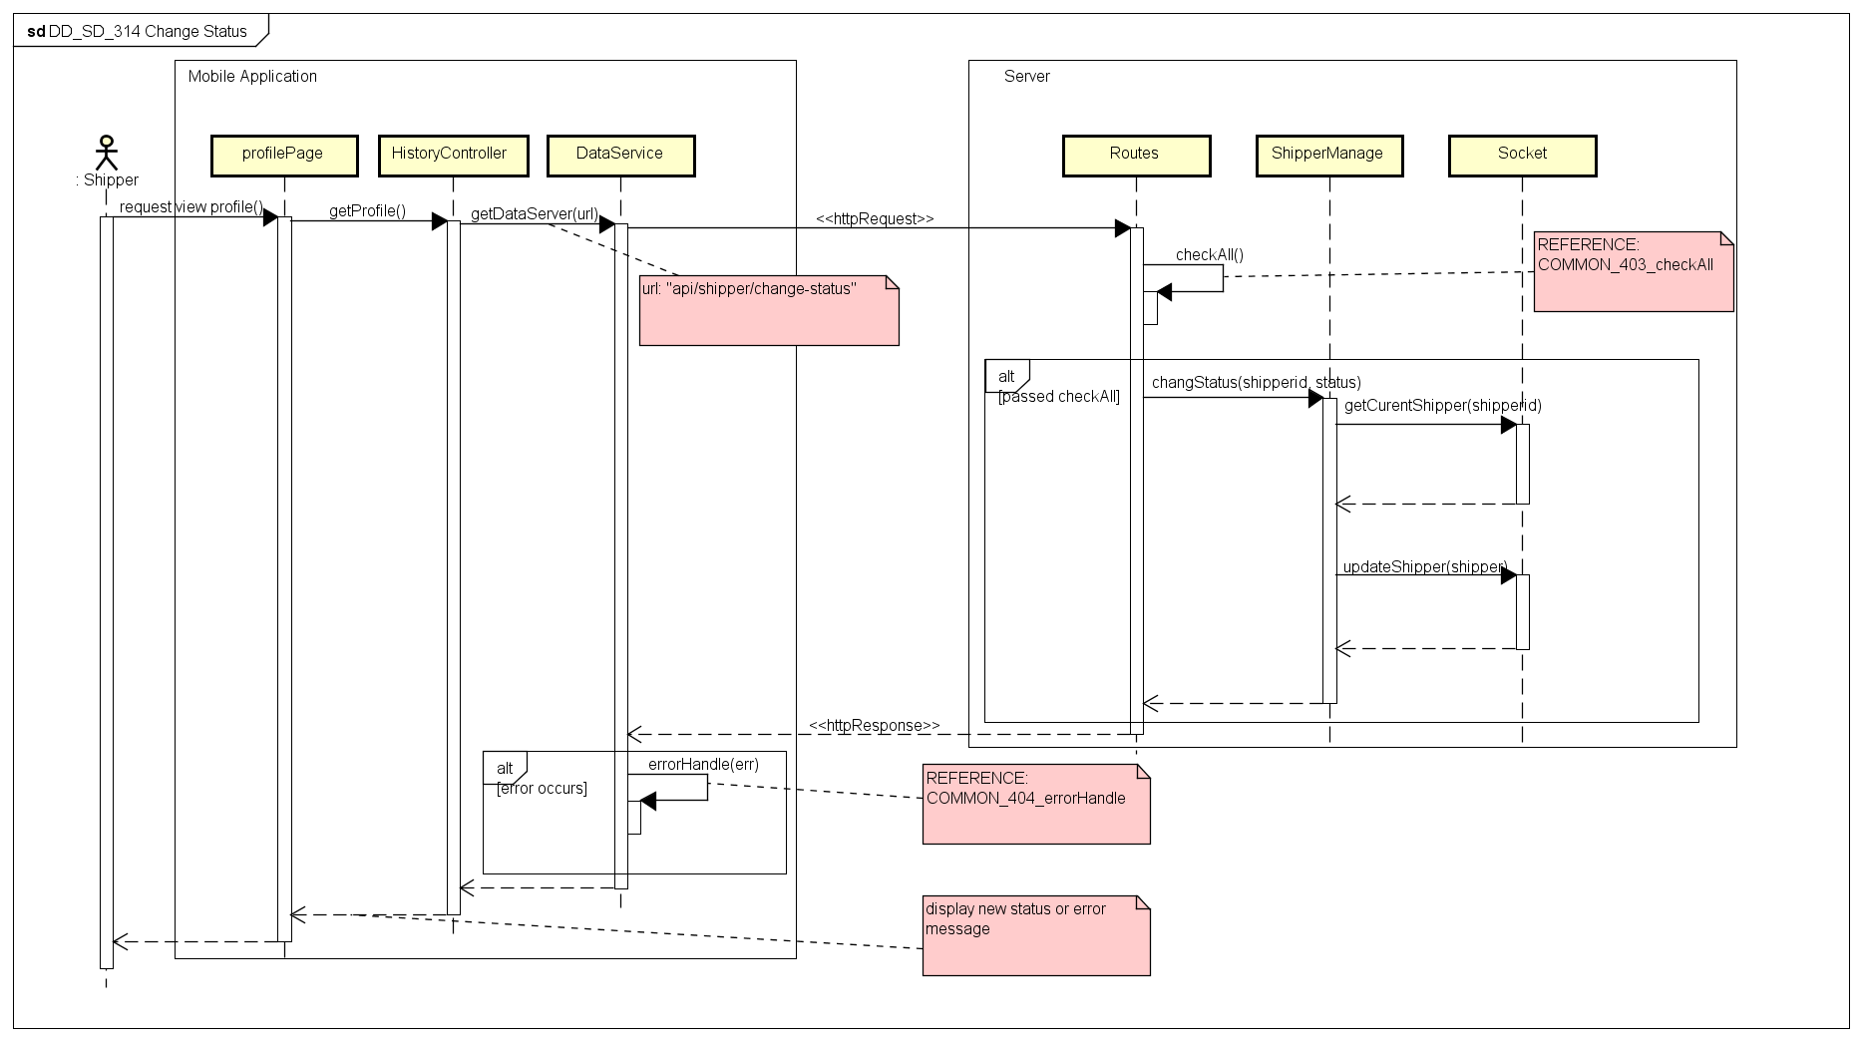

Figure . Sequence Diagram of Change Working Status use case

#### View History

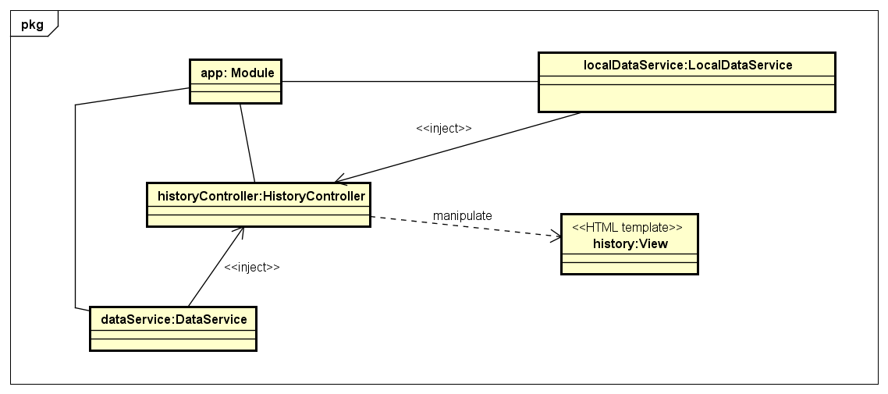

Figure . Object Diagram of View History use case

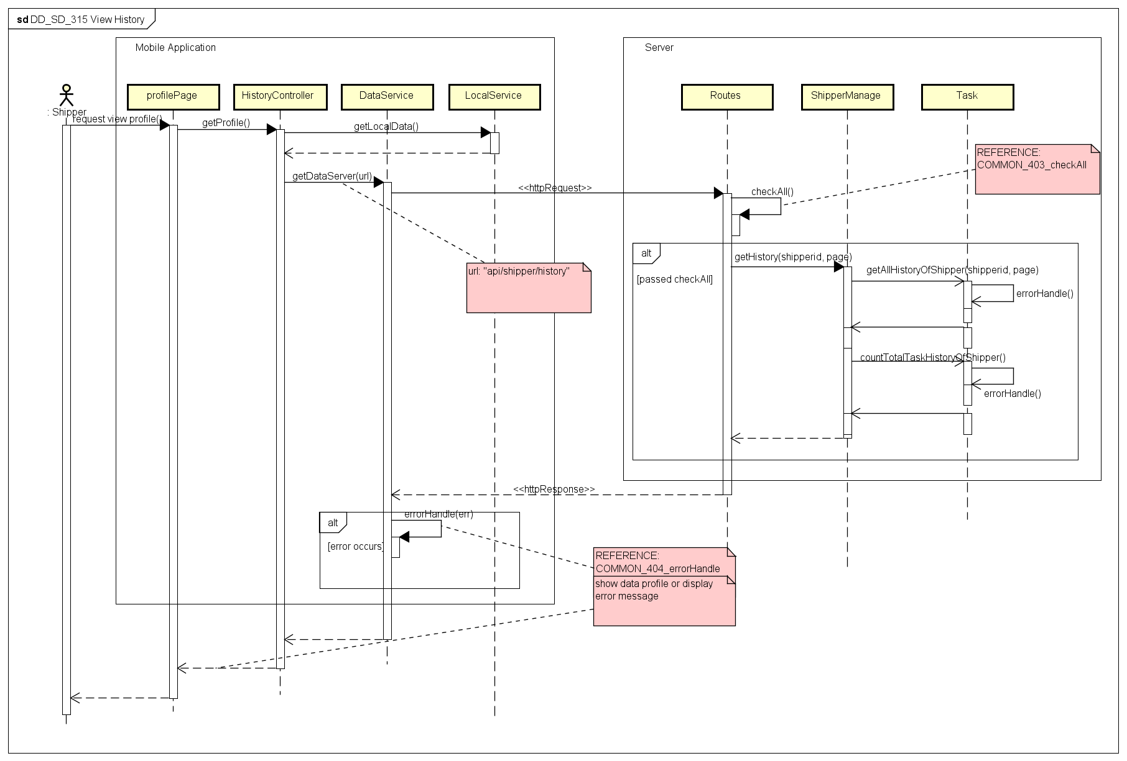

Figure . Sequence Diagram of View History use case

#### Continue When Pending

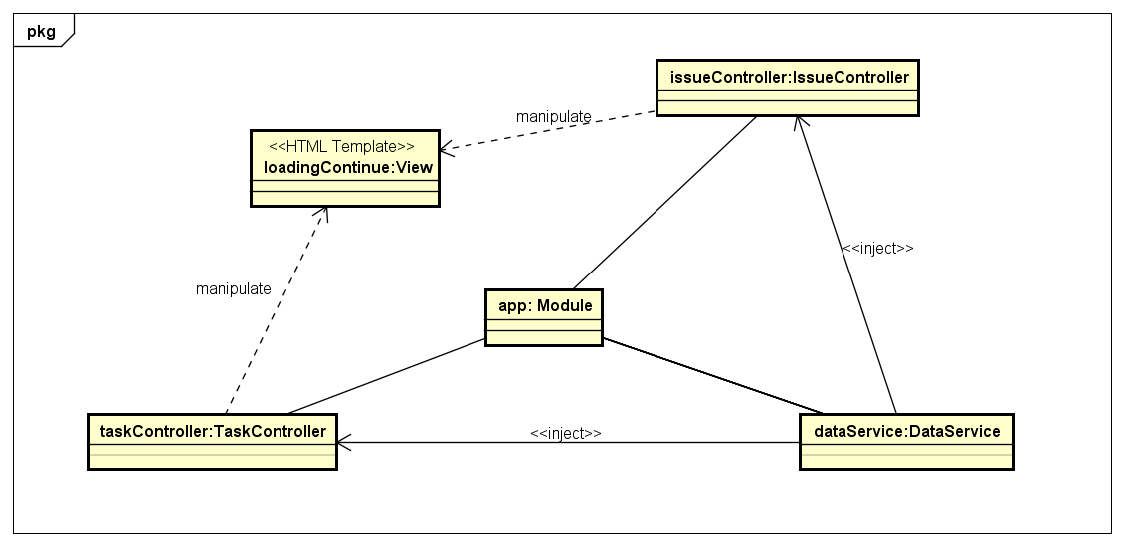

Figure . Object Diagram of Continue When Pending use case

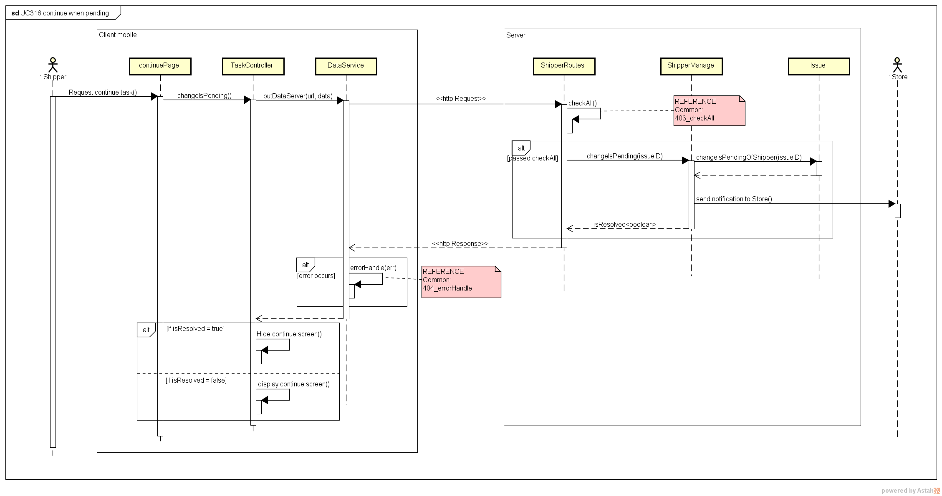

Figure . Sequence Diagram of Continue When Pending use case

#### Class Description

##### SigninController

* Attributes

|  |  |  |  |  |
| --- | --- | --- | --- | --- |
| No | Attributes | Type | Default | Description |
| 1 | User | Object | {} | Content information of logged in user |

* Methods

|  |  |  |  |  |
| --- | --- | --- | --- | --- |
| No | Methods | Parameters | Return | Description |
| 1 | showError | Object | N/A | Show message error to user |
| 2 | submitFrm | N/A | N/A | Send login request to server |
| 3 | logout | N/A | N/A | Sign out, clear token save in local |

##### DetailController

* Attributes

|  |  |  |  |  |
| --- | --- | --- | --- | --- |
| No | Attributes | Type | Default | Description |
| 1 | isCancel | boolean | N/A | Is the current order canceled? |
| 2 | Shippers | Object | N/A | Information of shipper to display in map |
| 3 | Stores | Object | N/A | Information of stores to display in map |
| 4 | Customers | Object | N/A | Information of customers to display in map |
| 5 | Orders | Object | N/A | Information of orders that the shipper is having, to connect markers on map |
| 6 | Center | Object | {} | The center of the map |

* Methods

|  |  |  |  |  |
| --- | --- | --- | --- | --- |
| No | Methods | Parameters | Return | Description |
| 1 | showConfirm | int, String | N/A | Show the pop up to confirm when shipper want to move to next step |
| 2 | confirmNext | String | N/A | Send request to server without confirmation code |
| 3 | confirmNextCode | String | N/A | Send request to server with a confirmation code regard to current task and current status |
| 4 | getDetailFromServer | N/A | N/A | Get detail information of task from server |

##### HistoryController

* Attributes

|  |  |  |  |  |
| --- | --- | --- | --- | --- |
| No | Attributes | Type | Default | Description |
| 1 | historyOrders | Array | [] | Current loaded history |
| 2 | totalTask | int | 0 | The number of total tasks of the shipper |
| 3 | totalLoaded | int | 0 | The number of total tasks that displayed |
| 4 | Page | int | 1 | Last displayed page of history |

* Methods

|  |  |  |  |  |
| --- | --- | --- | --- | --- |
| No | Methods | Parameters | Return | Description |
| 1 | getHistoryFromServer | int | N/A | Load data history from server |
| 2 | getLocalData | N/A | N/A | Load data history from local storage |

##### IssueController

* Attributes

|  |  |  |  |  |
| --- | --- | --- | --- | --- |
| No | Attributes | Type | Default | Description |
| 1 | isSend | boolean | False | If the issue is send or not |
| 2 | haveIssue | boolean | False | If the shipper is having issue or not |
| 3 | issueCategories | Array | [] | List categories of issue |
| 4 | listReasons | Array | [] | List reasons of issue |
| 5 | pendingReasons | Array | [] | List reasons to pending a task |
| 6 | cancelReasons | Array | [] | List reason to cancel a task |

* Methods

|  |  |  |  |  |
| --- | --- | --- | --- | --- |
| No | Methods | Parameters | Return | Description |
| 1 | getAllTaskOfShipper | N/A | N/A | Get list current tasks of the shipper |
| 2 | formatData | Object | Object | Format data to display in view |
| 3 | parseMulti | Array | String | Parse a list into a string |
| 4 | showLoading | N/A | N/A | Show a loading icon on the screen |

##### ProfileController

* Attributes

|  |  |  |  |  |
| --- | --- | --- | --- | --- |
| No | Attributes | Type | Default | Description |
| 1 | Profile | Object | {} | Profile information of the shipper |

* Methods

|  |  |  |  |  |
| --- | --- | --- | --- | --- |
| No | Methods | Parameters | Return | Description |
| 1 | getProfile | N/A | N/A | Request into server to get profile information of shipper display to screen |

##### TaskController

* Attributes

|  |  |  |  |  |
| --- | --- | --- | --- | --- |
| No | Attributes | Type | Default | Description |
| 1 | haveIssue | boolean | false | If the shipper is having an issue |

* Methods

|  |  |  |  |  |
| --- | --- | --- | --- | --- |
| No | Methods | Parameters | Return | Description |
| 1 | showLoading | N/A | N/A | Display a loading icon on screen |
| 2 | showAlert | String | N/A | Show a pop up to shipper |
| 3 | getAllTaskBeIssued | N/A | N/A | Get a list tasks having issue and update haveIssue attribute |
| 4 | changeIsPending | int | N/A | Send request to server to continue when shipper resolved his issue |
| 5 | getListOfTask | N/A | N/A | Get list of current task of the shipper |
| 6 | formatData | Object | Object | Format data for html view |
| 7 | isIssued | Array | boolean | Check if the shipper is having issue |

##### MapController

* Attributes

|  |  |  |  |  |
| --- | --- | --- | --- | --- |
| No | Attributes | Type | Default | Description |
| 1 | haveIssue | boolean | false | If the shipper is having an issue |

* Methods

|  |  |  |  |  |
| --- | --- | --- | --- | --- |
| No | Methods | Parameters | Return | Description |
| 1 | drawArrow | Object, Object, String, String, Object, Object | N/A | Push list of new order information into the *arrows* attribute |
| 2 | resetArrows | N/A | N/A | Reset value of *arrows* attribute to default |
| 3 | displayRelationship | Object, Object, Object, Object | N/A | Draw arrows on the map, bases on data in *arrows* attribute |

##### AuthService

* Attributes

|  |  |  |  |  |
| --- | --- | --- | --- | --- |
| No | Attributes | Type | Default | Description |
| 1 | Tag | String | EHID | Name of the local data that holding token information |

* Methods

|  |  |  |  |  |
| --- | --- | --- | --- | --- |
| No | Methods | Parameters | Return | Description |
| 1 | saveToken | String | N/A | Save token data into the local storage |
| 2 | signIn | Object | N/A | Send sign in request to server |
| 3 | isLogged | N/A | boolean | Check if the user is logged in |
| 4 | isRightRole | int | boolean | Check if the user has role that can access |
| 5 | signOut | N/A | N/A | Log out, clear token in local storage |
| 6 | getCurrentInfoUser | N/A | Object | Return the information of current logged in user |
| 7 | getProfileUser | N/A | Object | Return the profile information of current logged in user |

##### DataService

* Attributes

|  |  |  |  |  |
| --- | --- | --- | --- | --- |
| No | Attributes | Type | Default | Description |
| 1 | dataFactory | Object | {} | The object to provide API functions for calling from other places |

* Methods

|  |  |  |  |  |
| --- | --- | --- | --- | --- |
| No | Methods | Parameters | Return | Description |
| 1 | getDataServer | String | Object | Send http request to server with GET method |
| 2 | postDataServer | String, Object | Object | Send http request to server with POST method |
| 3 | putDataServer | String, Object | Object | Send http request to server with PUT method |
| 4 | deleteDataServer | String | Object | Send http request to server with DELETE method |
| 5 | errorHandle | Object | N/A | Handle the error return of sending http request, log out if the error has status 401 (Unauthorized) |

##### LocalDataService

* Attributes

|  |  |  |  |  |
| --- | --- | --- | --- | --- |
| No | Attributes | Type | Default | Description |
| N/A | N/A | N/A | N/A | N/A |

* Methods

|  |  |  |  |  |
| --- | --- | --- | --- | --- |
| No | Methods | Parameters | Return | Description |
| 1 | Set | String, String | N/A | Save a pair of String: key and value into local storage |
| 2 | setObject | String, Object | N/A | Save a pair of: key (String) and value(Object) into local storage |
| 3 | Get | String, String | String | Return value of a key save in local storage; if not found, return a default value |
| 4 | getObject | String | Object | Return value of a key save in local storage and parse to object; if not found, return a default value is {} |

##### MapService

* Attributes

|  |  |  |  |  |
| --- | --- | --- | --- | --- |
| No | Attributes | Type | Default | Description |
| 1 | shipperMarkers | Array | [] | List of shipper markers to display on map |
| 2 | storeMarkers | Array | [] | List of store markers to display on map |
| 3 | customerMarkers | Array | [] | List of customer markers to display on map |
| 4 | Orders | Object | {} | List of order to connect markers on map |
| 5 | returnedShipperMarkers | Array | [] | List of shipper markers that receive from server |
| 6 | returnedStoreMarkers | Array | [] | List of store markers that receive from server |
| 7 | returnedCustomerMarkers | Array | [] | List of customer markers that receive from server |
| 8 | returnedOrders | Object | {} | List information of orders that receive from server |
| 9 | currentMode | Object | N/A | The mode of markers displayed on map |
| 10 | Api | Object | N/A | The object to provide |

* Methods

|  |  |  |  |  |
| --- | --- | --- | --- | --- |
| No | Methods | Parameters | Return | Description |
| 1 | setMode | Object | N/A | Set mode of markers displayed on map |
| 2 | getMode | N/A | Object | Get the mode of markers on map |
| 3 | updateReturnedShippers | N/A | N/A | Update *returnedShipperMarkers* attribute after receive data from socket server |
| 4 | updateReturnedStores | N/A | N/A | Update *returnedStoreMarkers* attribute after receive data from socket server |
| 5 | updateReturnedCustomers | N/A | N/A | Update *returnedCustomerMarkers* attribute after receive data from socket server |
| 6 | updateReturnedOrders | N/A | N/A | Update *returnedOrders* attribute after receive data from socket server |
| 7 | updateReturnedValues | N/A | N/A | Call method 3, 4, 5, 6 |
| 8 | getShipperMarkers | N/A | Array | Return *returnedShipperMarkers* |
| 9 | getStoreMarkers | N/A | Array | Return *returnedStoreMarkers* |
| 10 | getCustomerMarkers | N/A | Array | Return *returnedCustomerMarkers* |
| 11 | getOrders | N/A | Object | Return *returnedOrders* |
| 12 | setMapData | Object | N/A | Set data for map |

### Web Application

#### Web Client

##### **Admin**

###### 2.2.1.1.1. Add Store

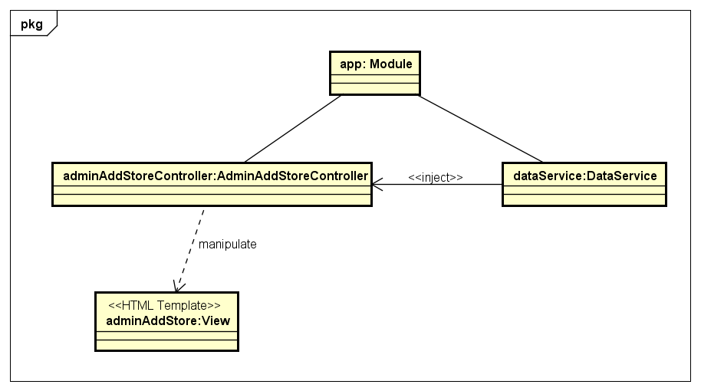

Figure . Object Diagram of Add Store use case

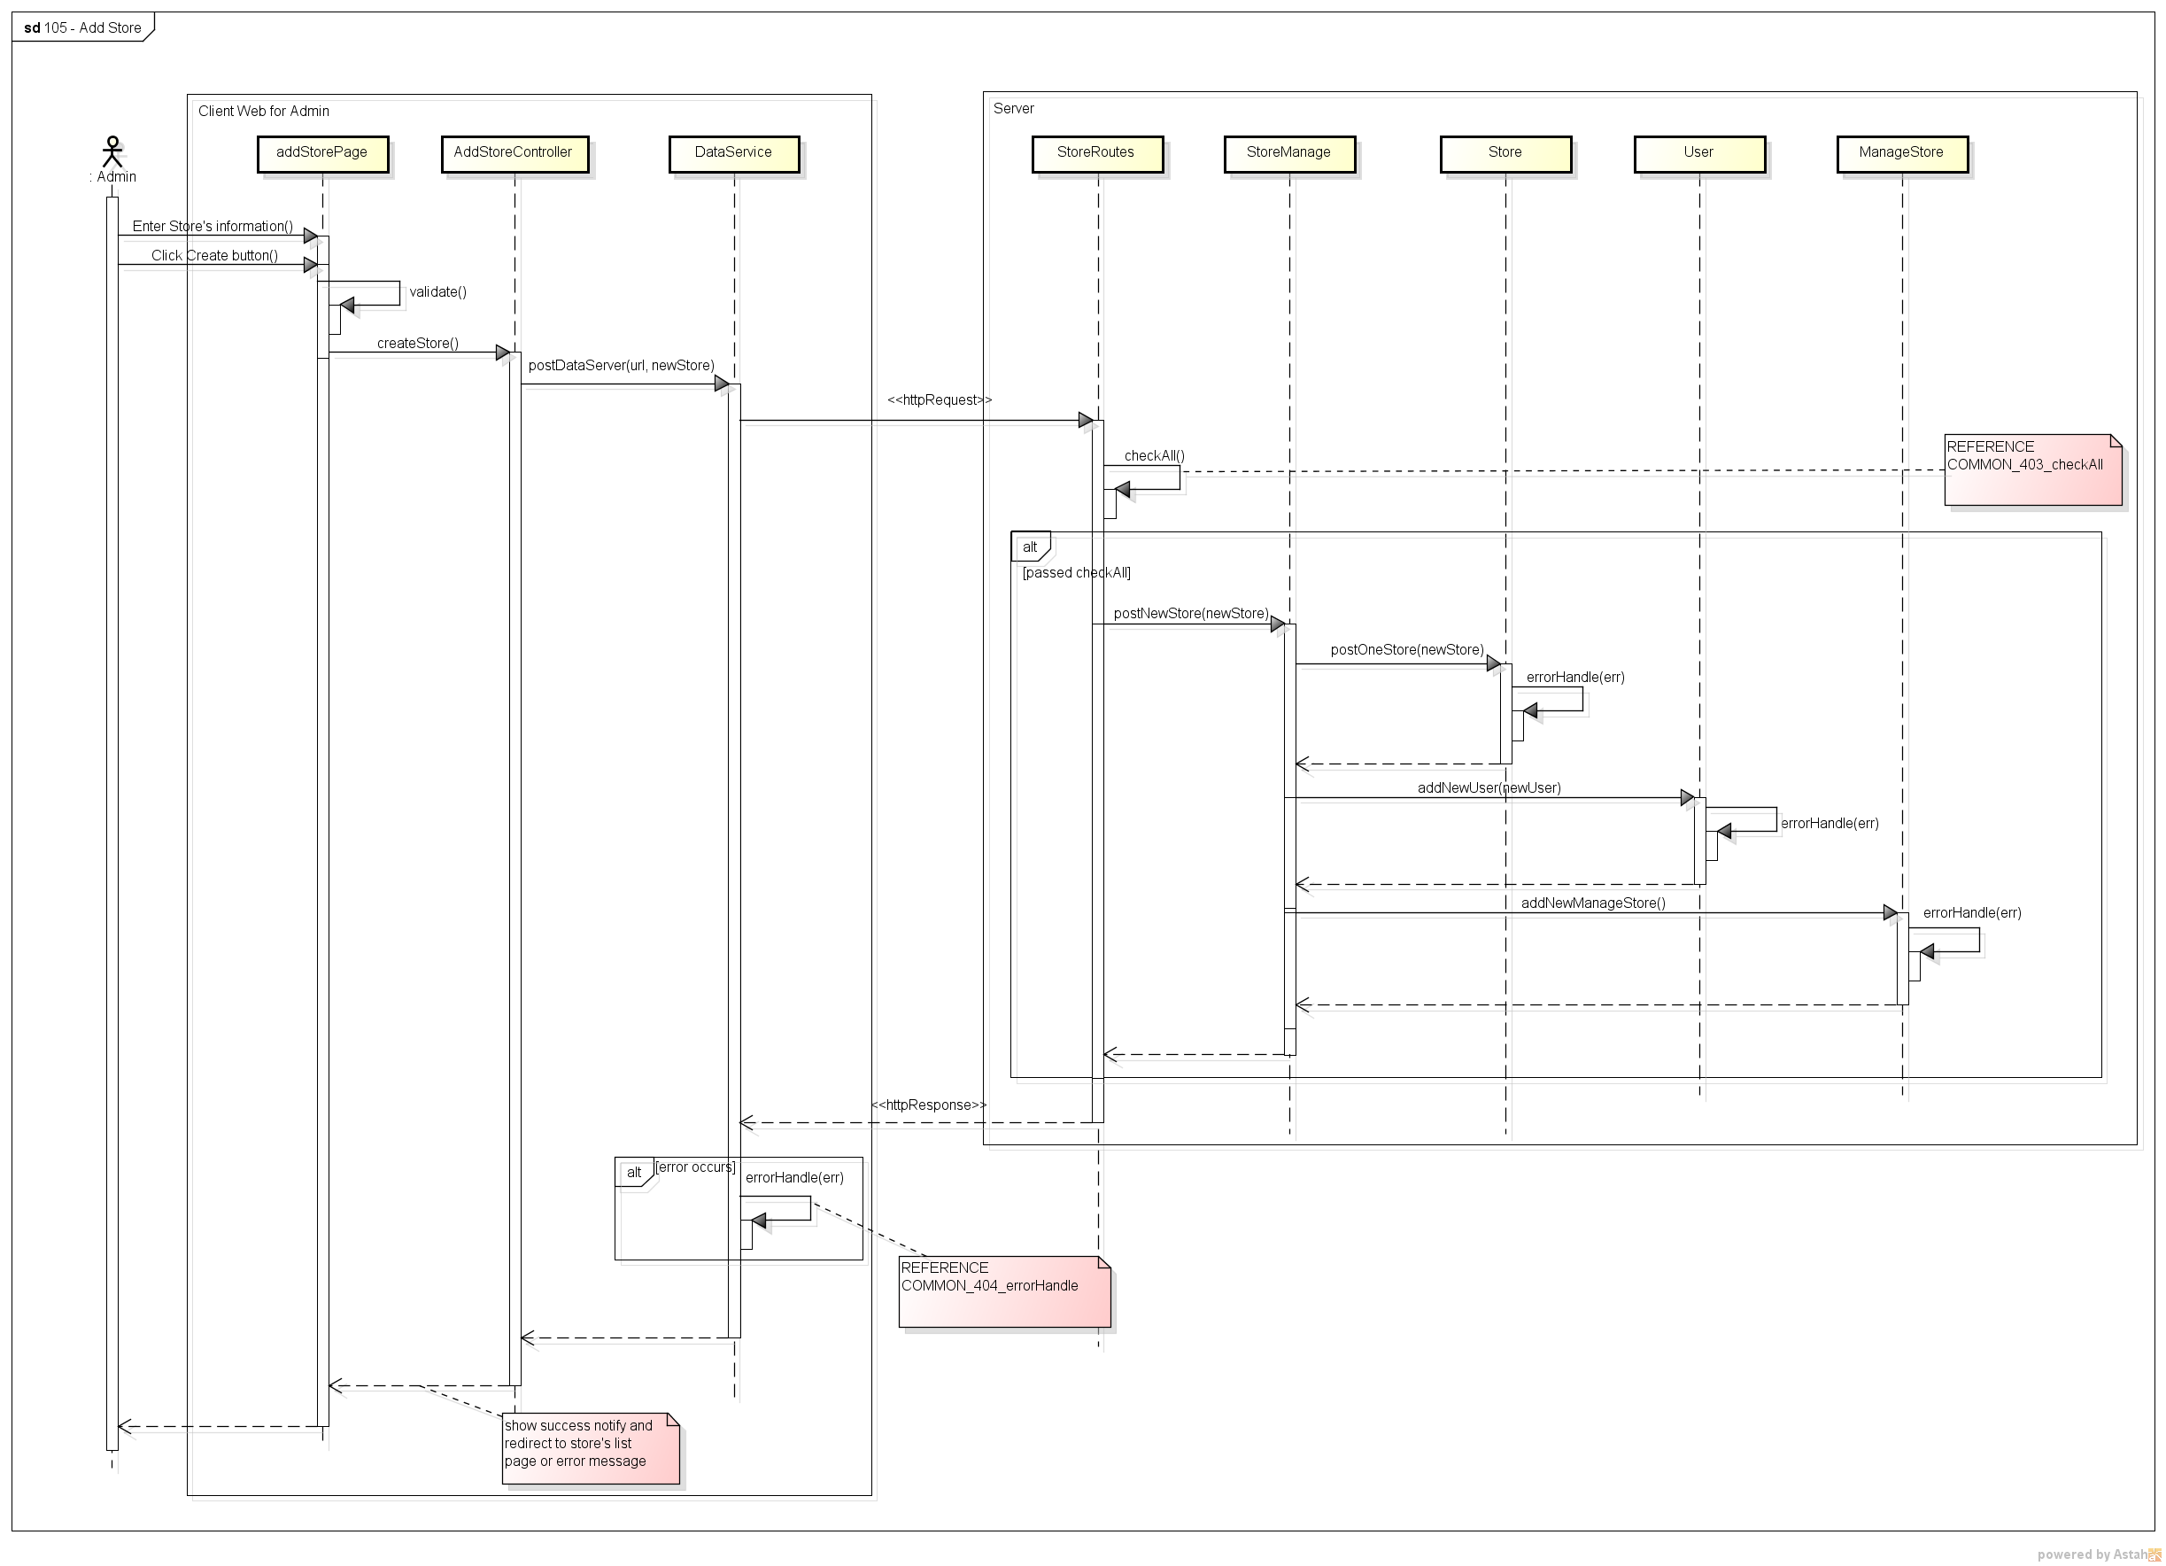

Figure . Sequence Diagram of Add Store use case

###### 2.2.1.1.2. View Store’s List

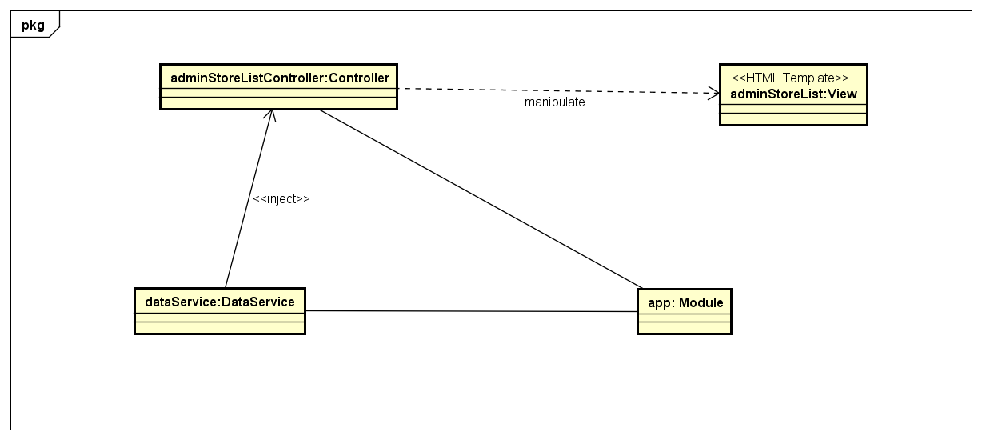

Figure . Object Diagram of View Store’s List use case

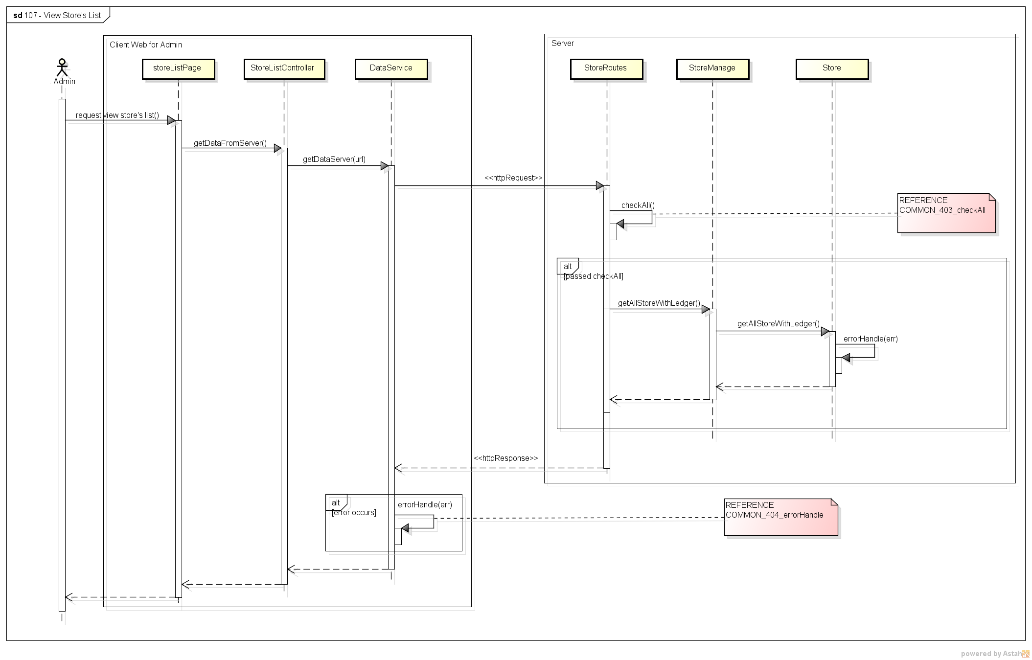

Figure . Sequence Diagram of View Store’s List use case

###### 2.2.1.1.3. Block/Unlock Store

*(*) Object Diagram of Block/Unblock Store use case refer to Figure 22*

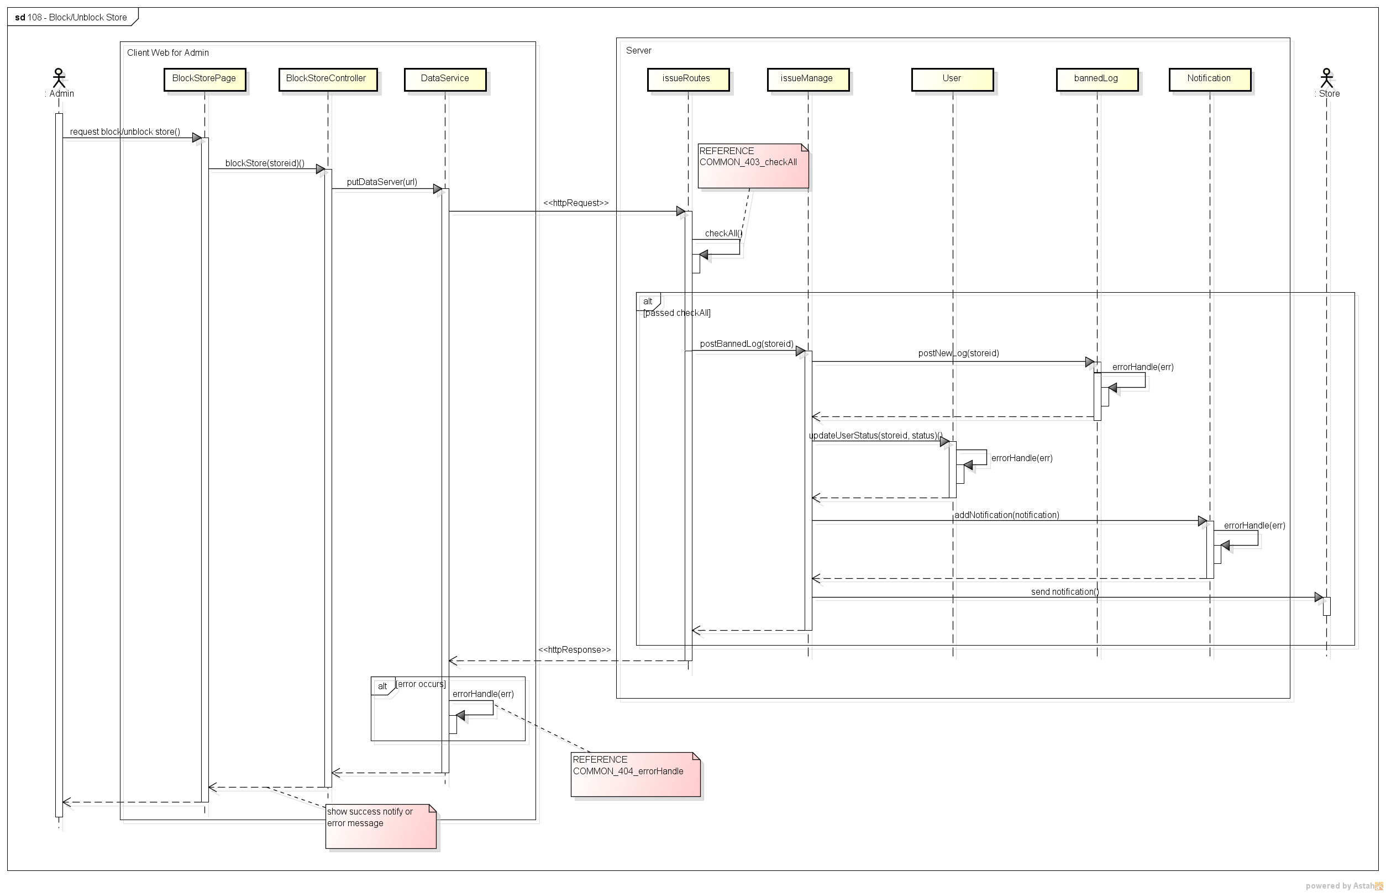

Figure . Sequence Diagram of Block/Unblock Store use case

###### 2.2.1.1.4. View Store’s Detail

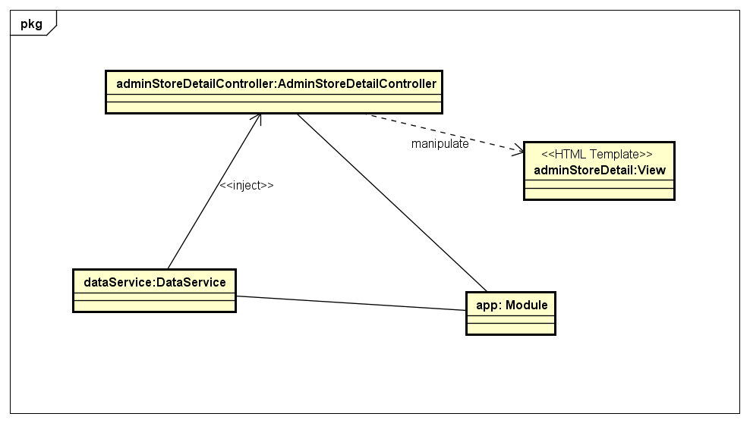

Figure . Object Diagram of View Store’s Detail use case

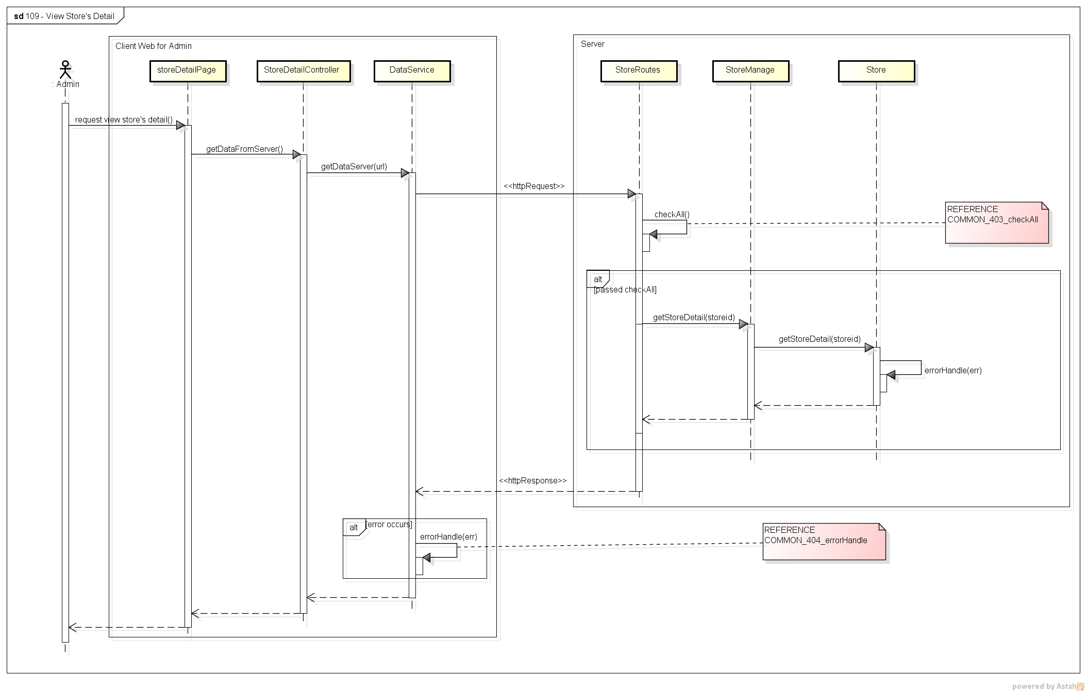

Figure . Sequence Diagram of View Store’s Detail use case

###### 2.2.1.1.5. Confirm Payment

*(*) Object Diagram of Confirm Payment use case refer to Figure 22*

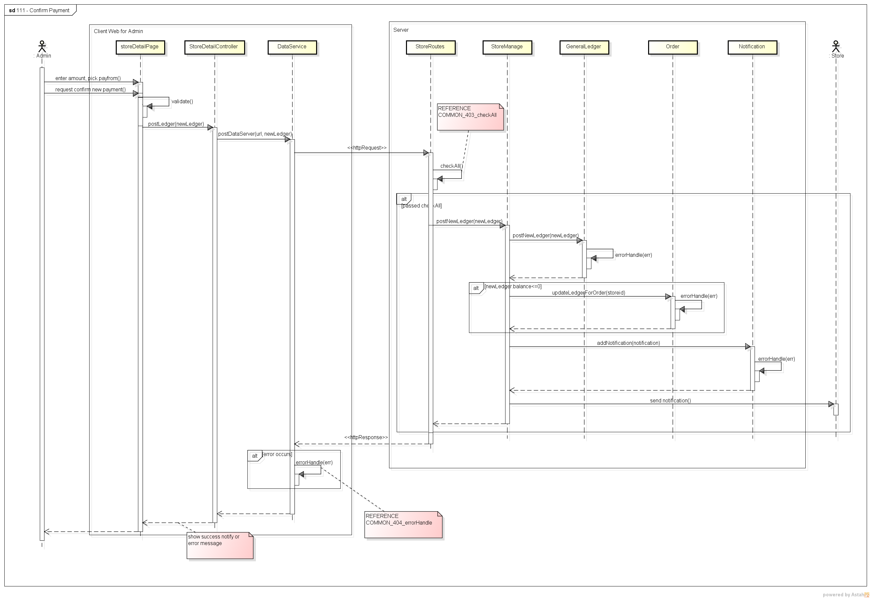

Figure . Sequence Diagram of Confirm Payment use case

###### 2.2.1.1.6. View Transaction History

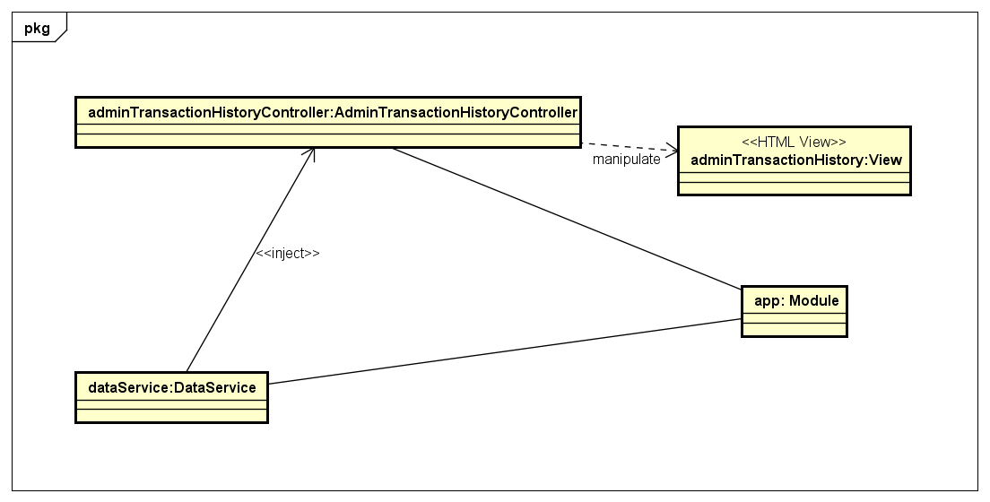

Figure . Object Diagram of View Transaction History use case

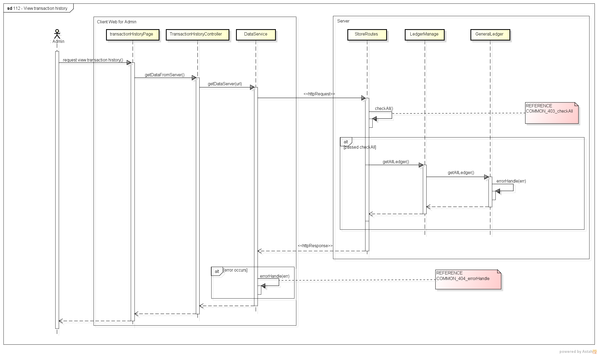

Figure Sequence Diagram of View Transaction History use case

###### 2.2.1.1.7. Add Shipper

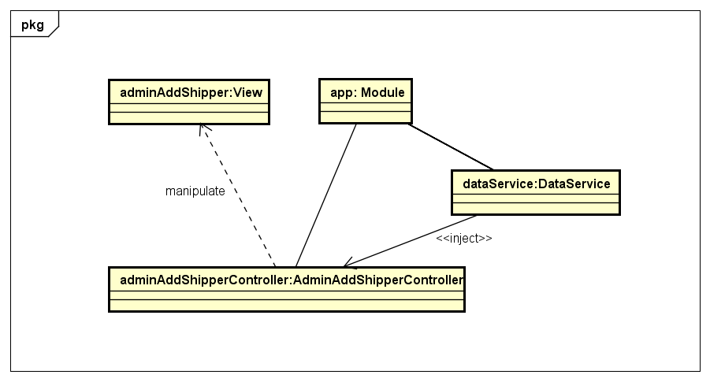

Figure . Object Diagram of Add Shipper use case

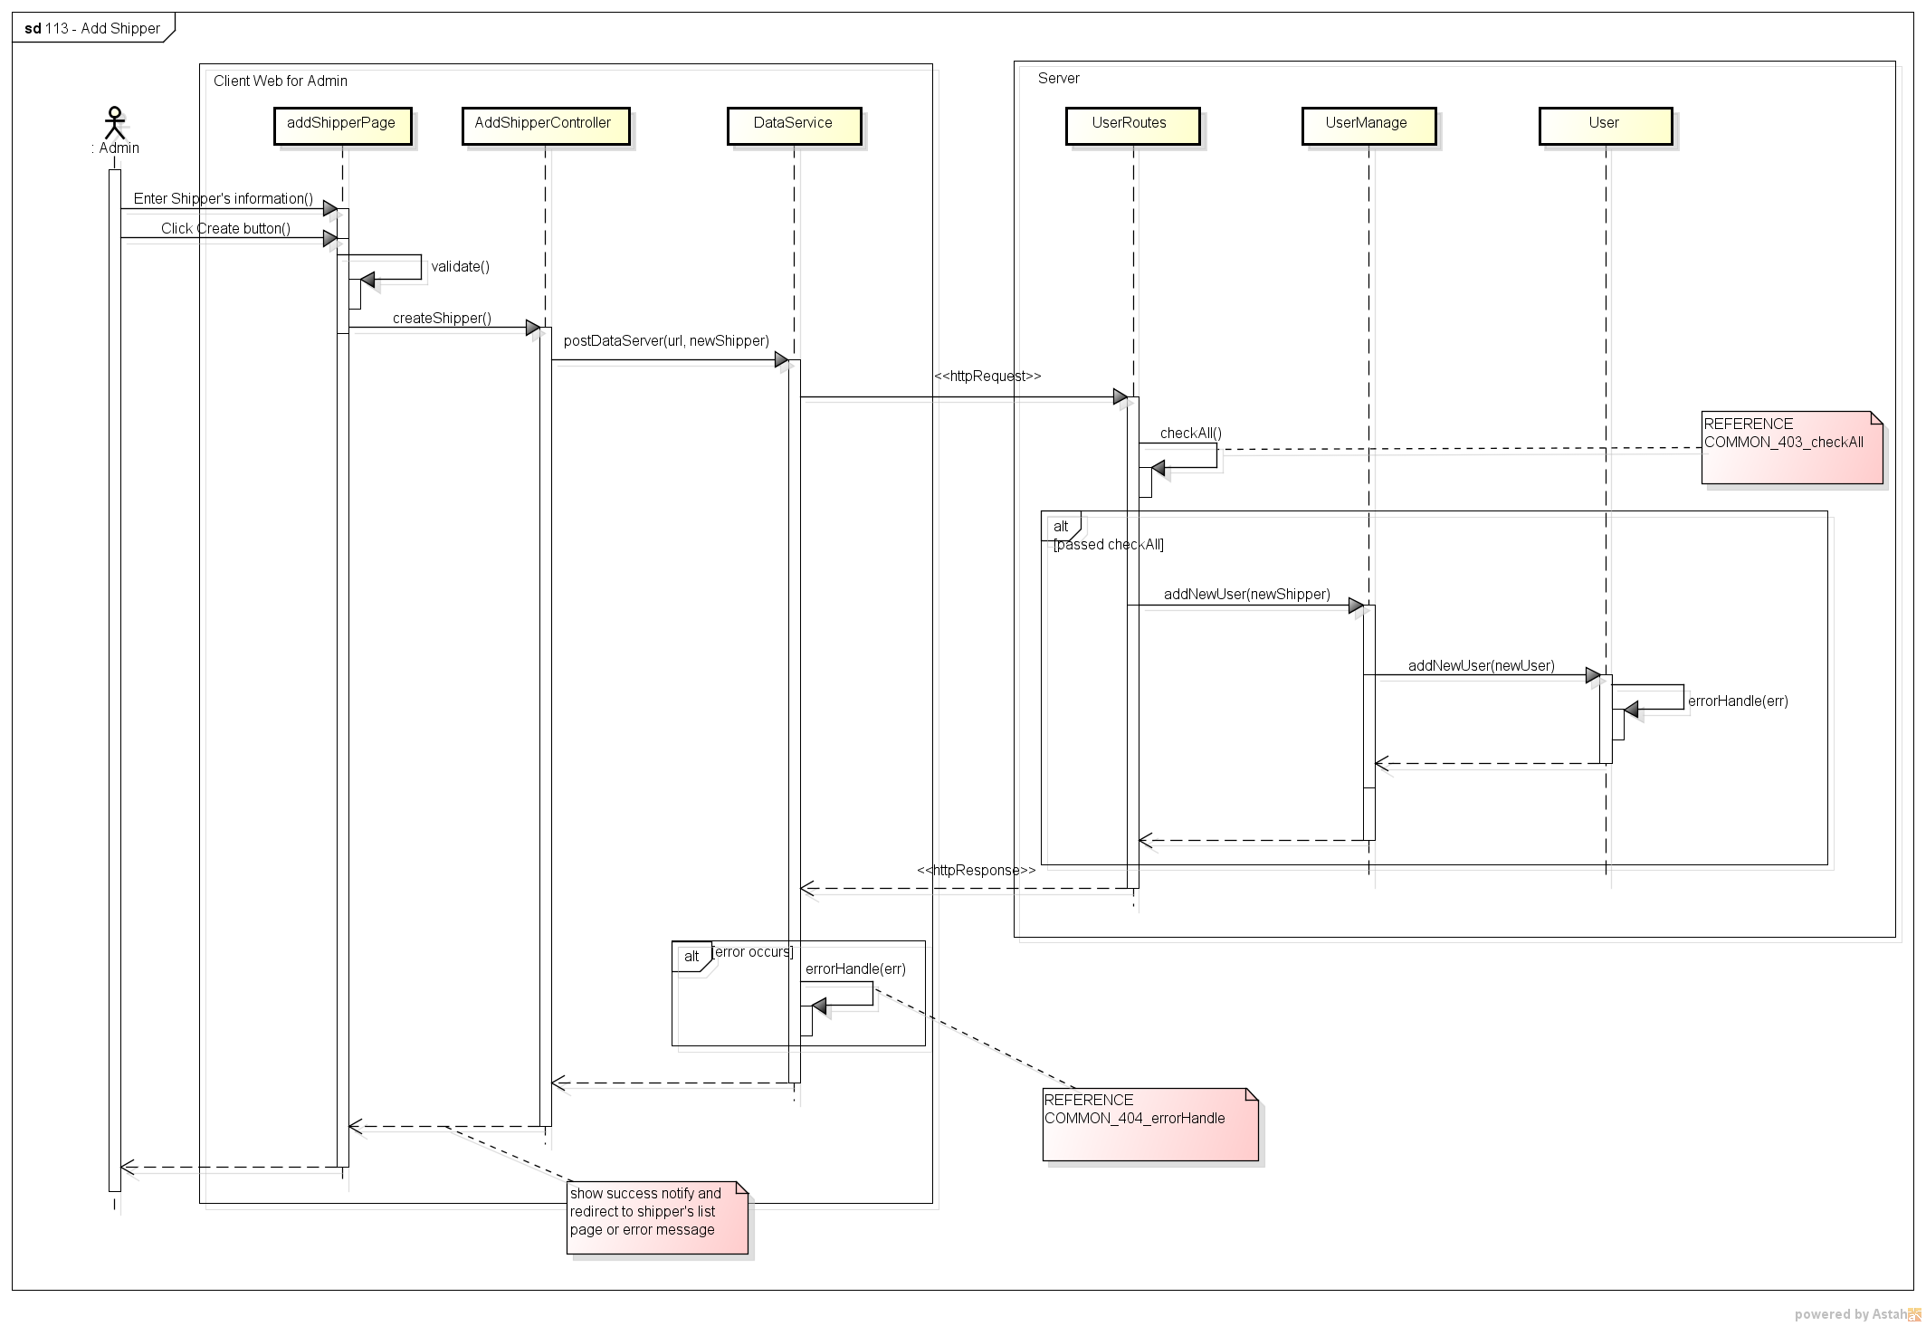

Figure . Sequence Diagram of Add Shipper use case

###### 2.2.1.1.8. View Shipper’s List

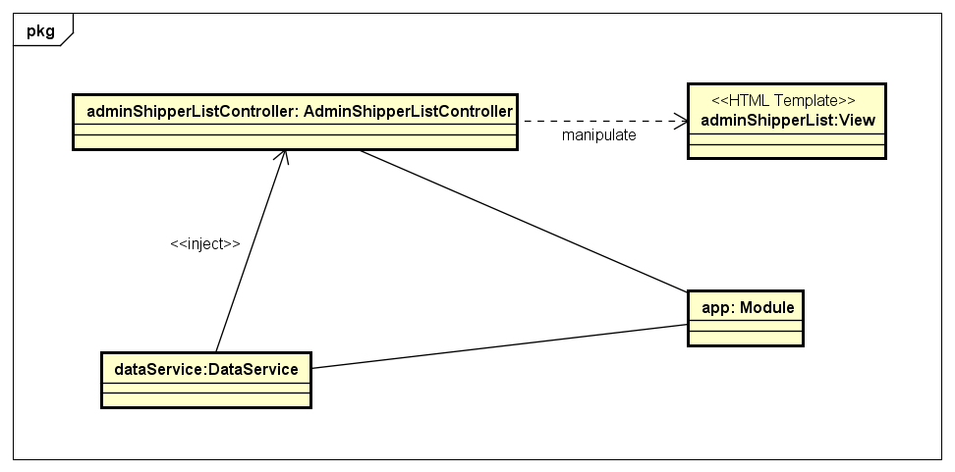

Figure . Object Diagram of View Shipper’s List use case

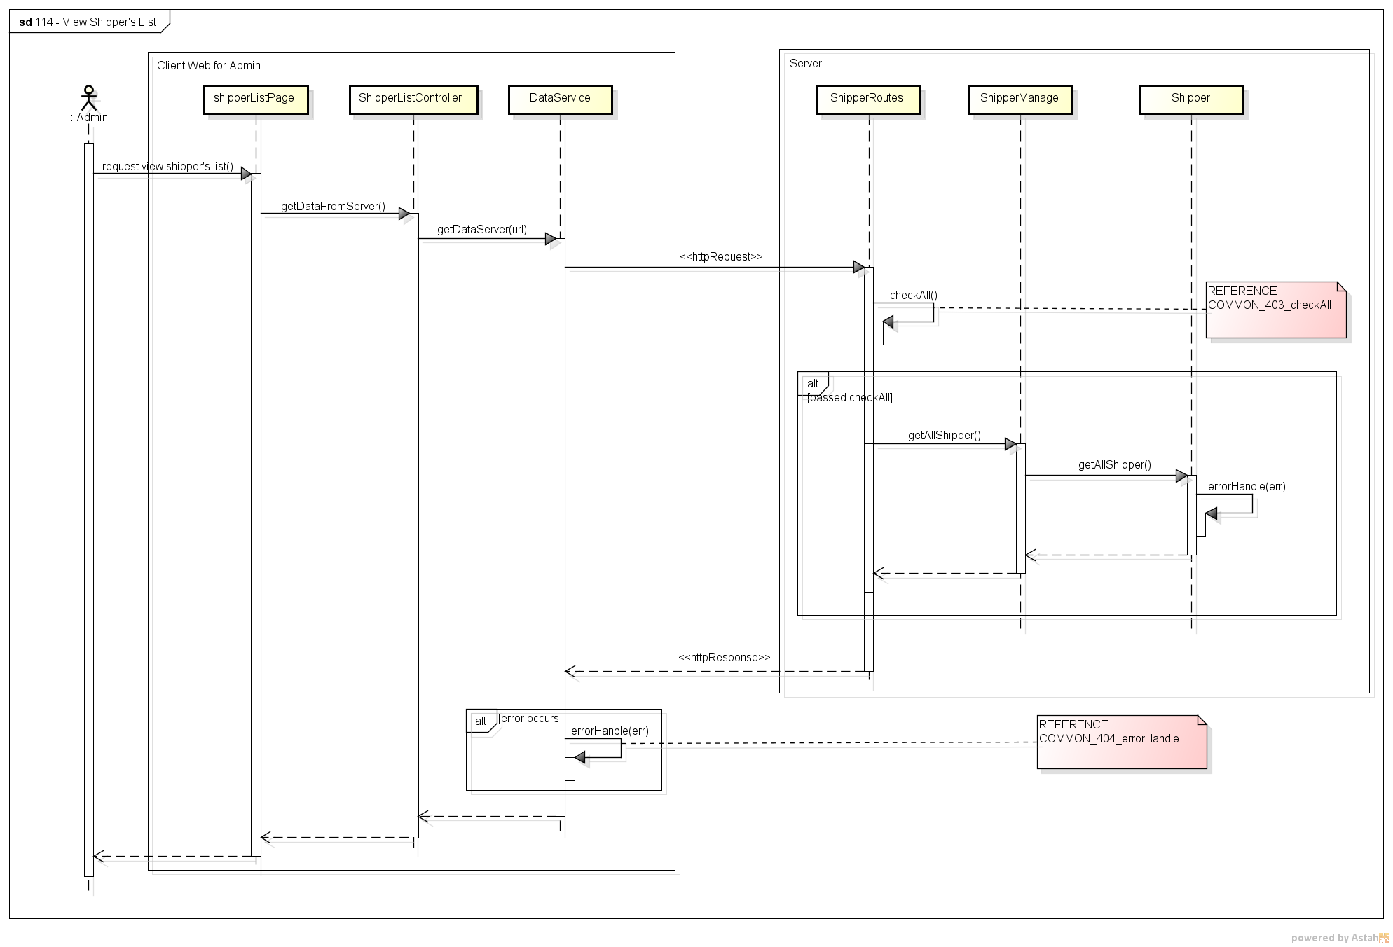

Figure . Sequence Diagram of View Shipper’s List use case

###### 2.2.1.1.9. View Order’s List

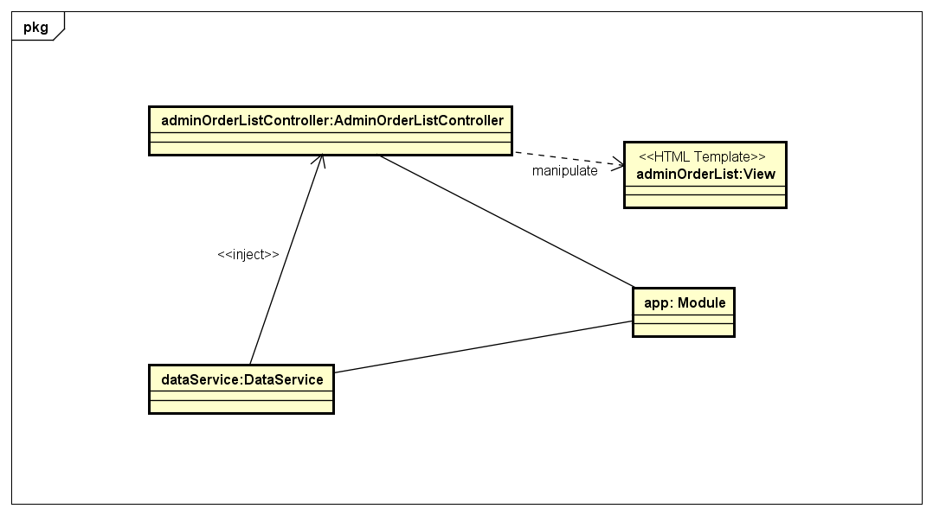

Figure . Object Diagram of View Order’s List use case

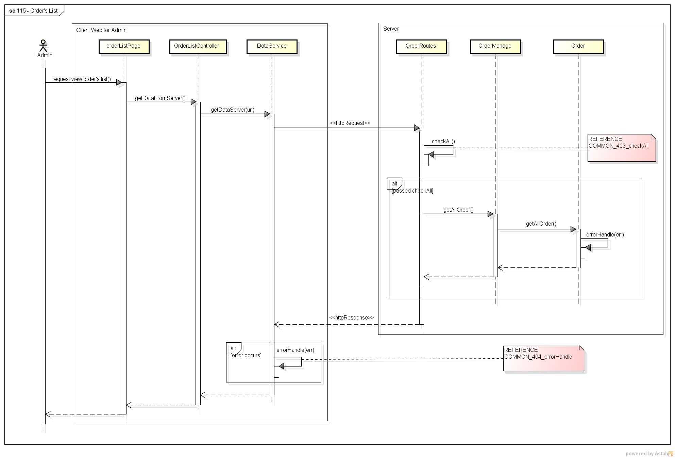

Figure . Sequence Diagram of View Order’s List use case

###### 2.2.1.1.10. View User’s Detail

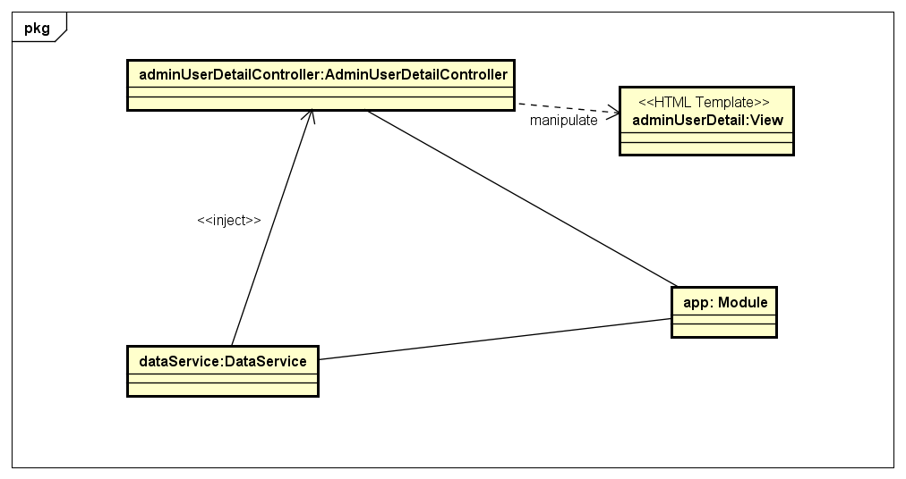

Figure . Object Diagram of View User’s Detail use case

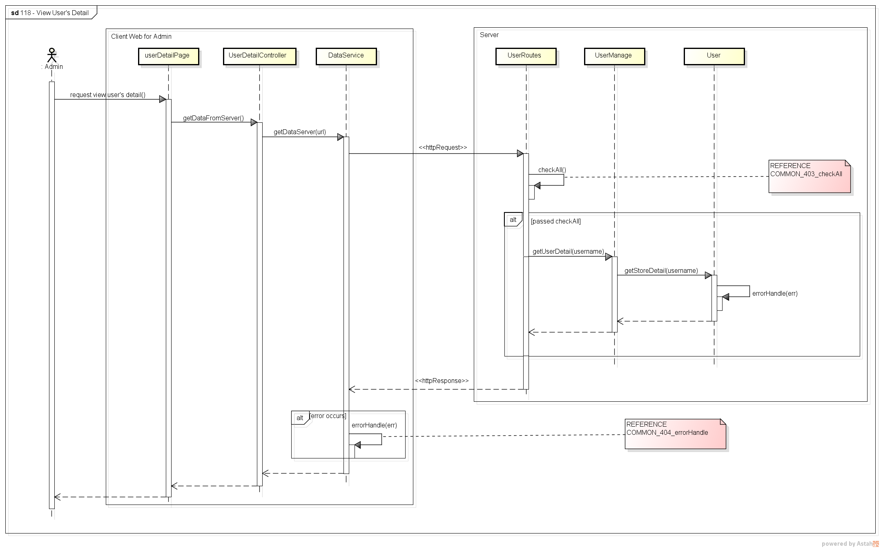

Figure . Sequence Diagram of View User’s Detail use case

###### 2.2.1.1.11. Update User’s Profile

*(*) Object Diagram of Update User’s Profile use case refer to Figure 37*

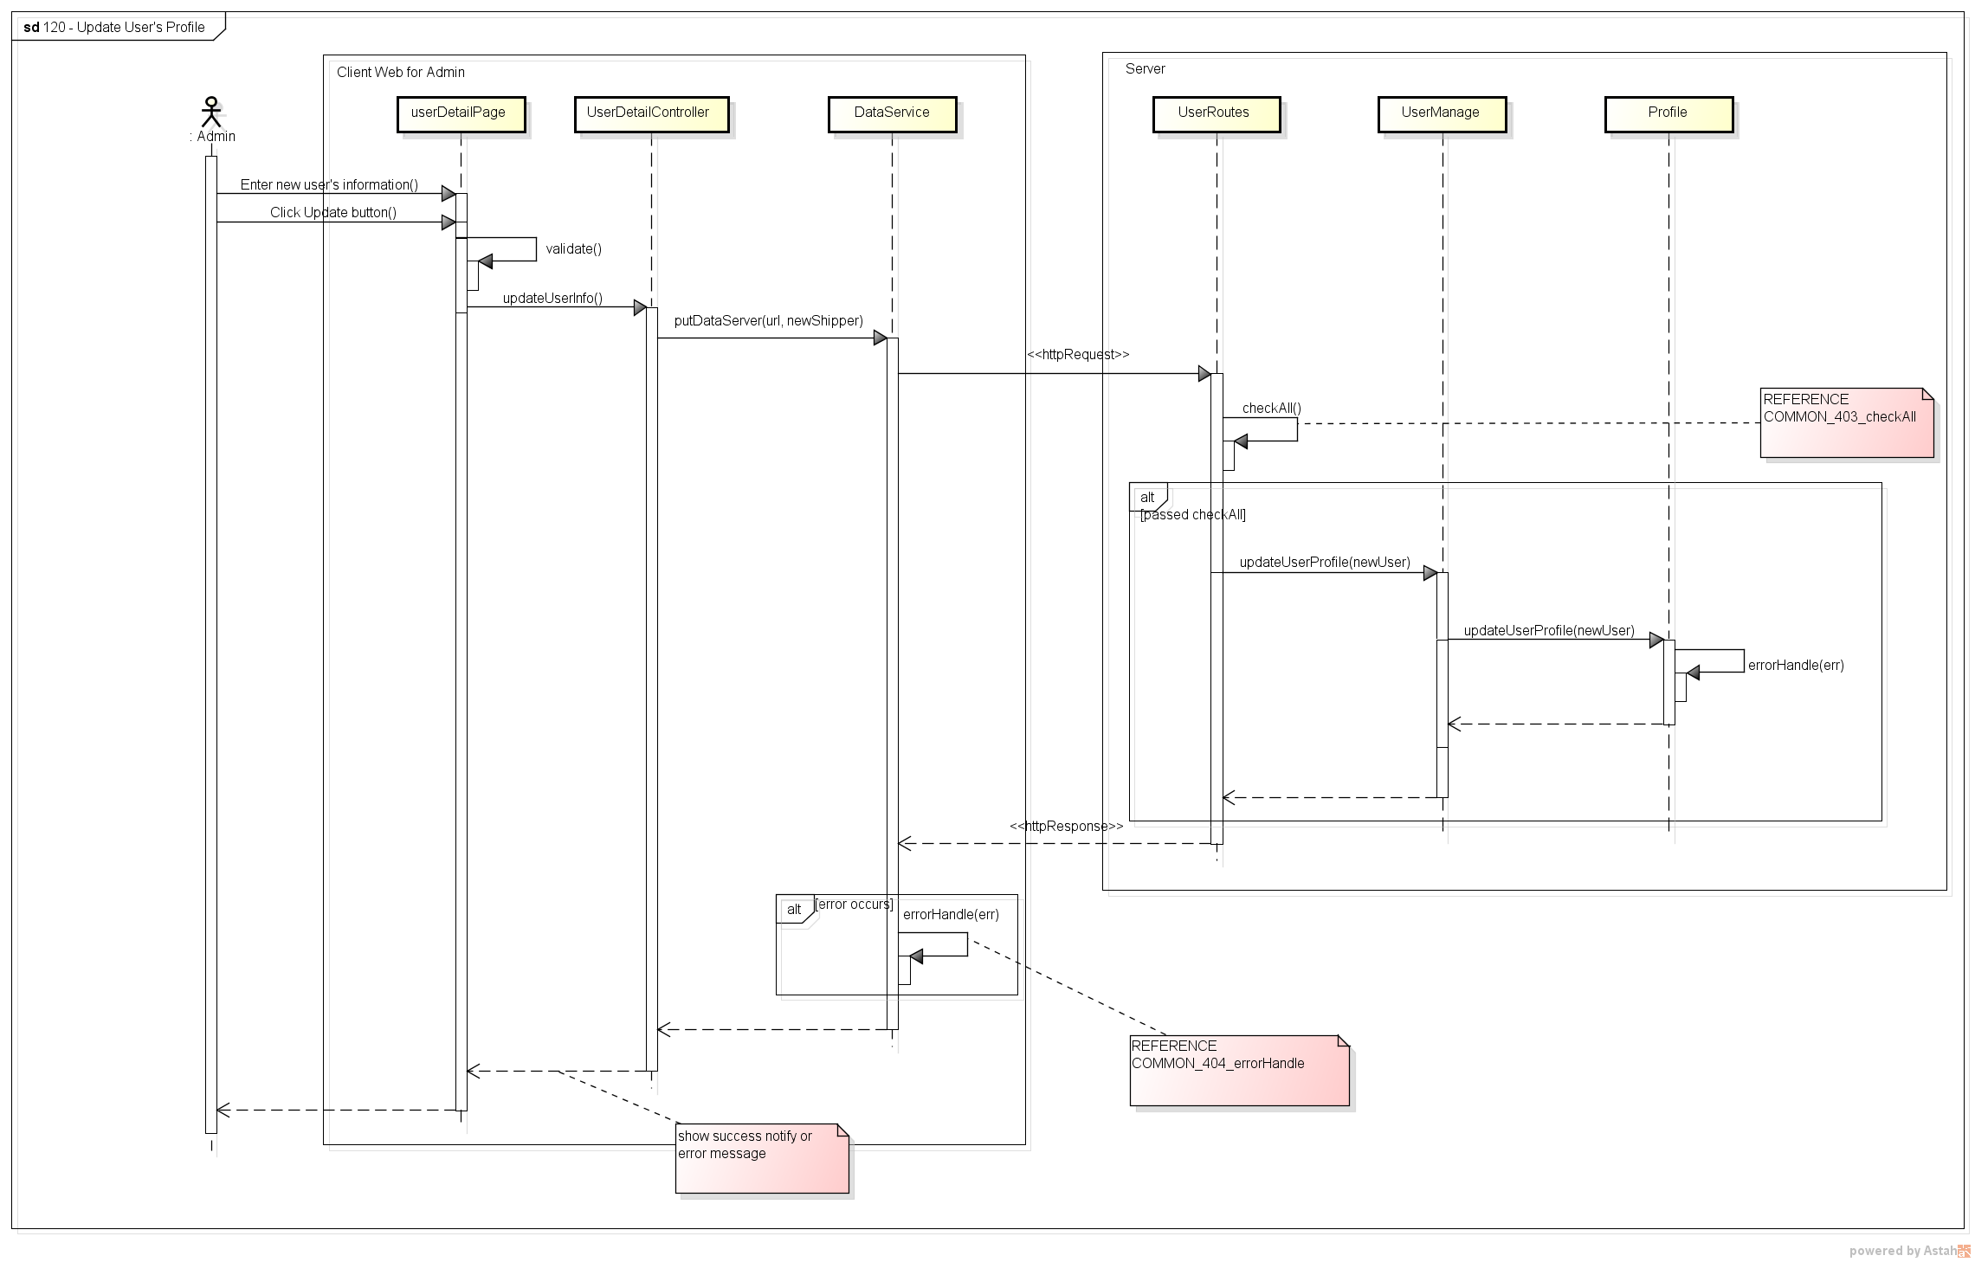

Figure . Sequence Diagram of Update User’s Profile use case

###### 2.2.1.1.12. Update Store’s Information

*(*) Object Diagram of Update Store’s Information use case refer to Figure 25*

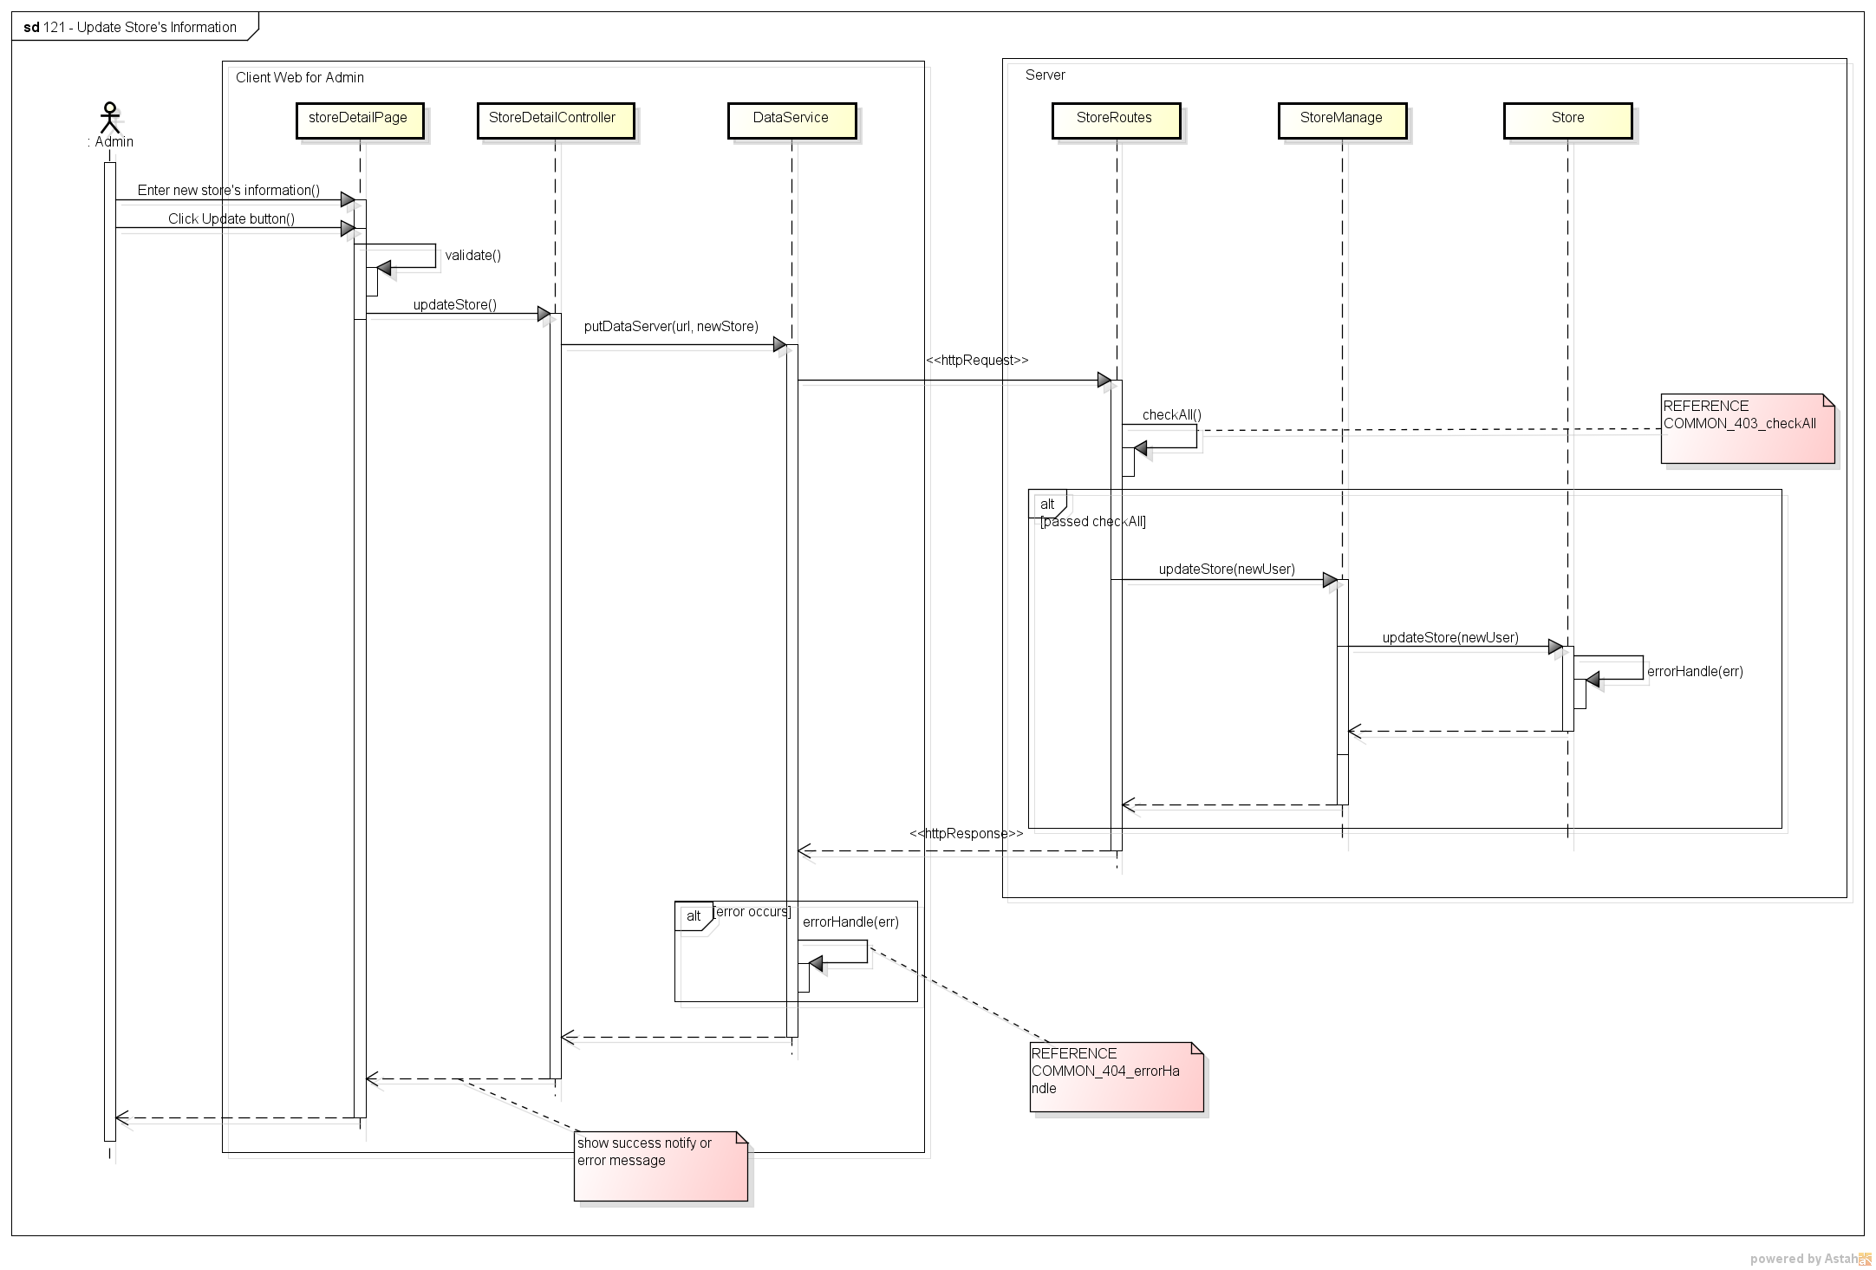

Figure . Sequence Diagram of Update Store’s Information use case

###### 2.2.1.1.13. Assign Task

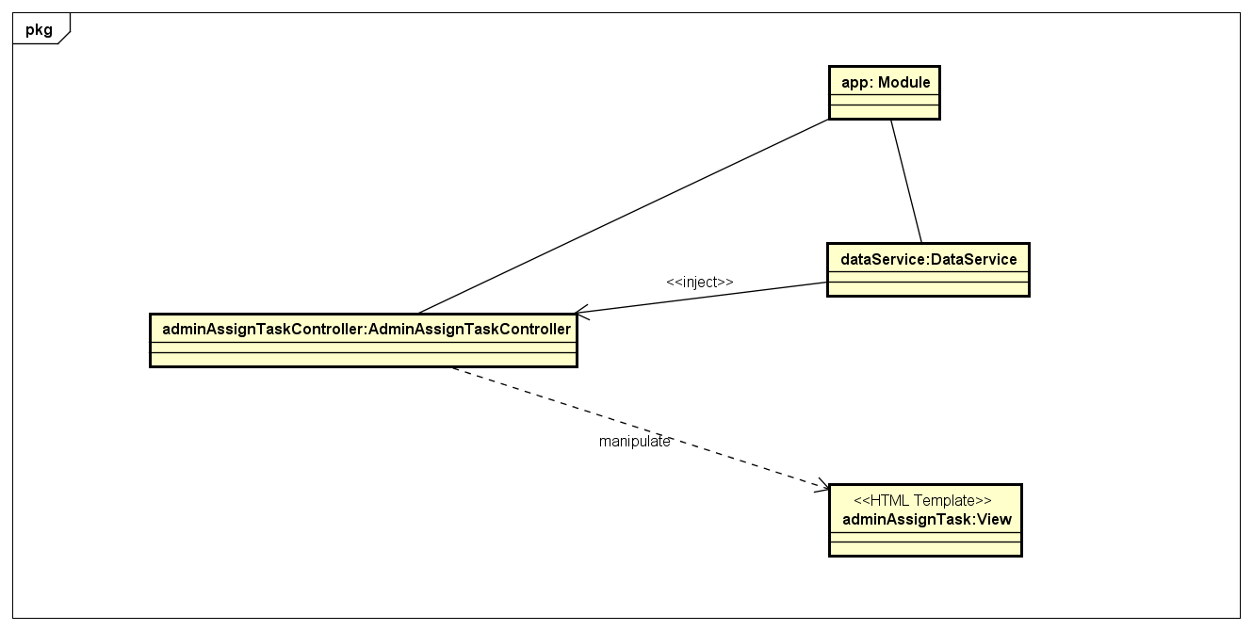

Figure . Object Diagram of Assign Task use case

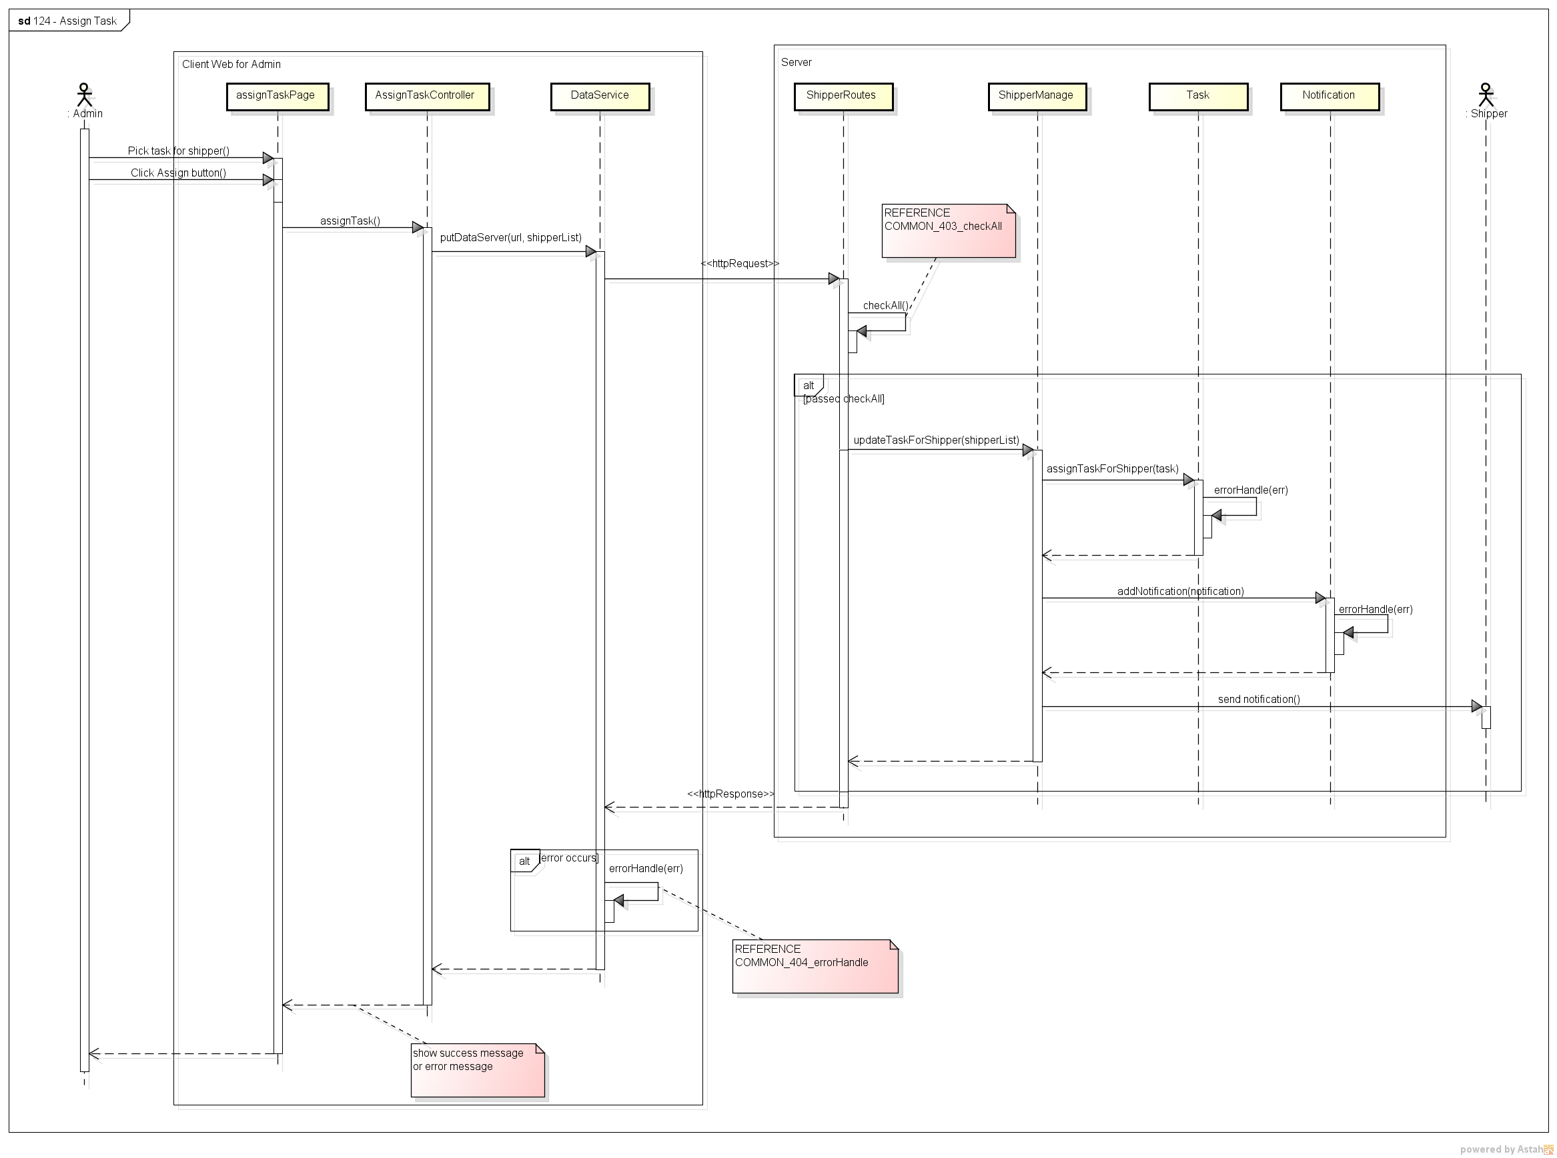

Figure . Sequence Diagram of Assign Task use case

###### 2.2.1.1.14. View Dashboard

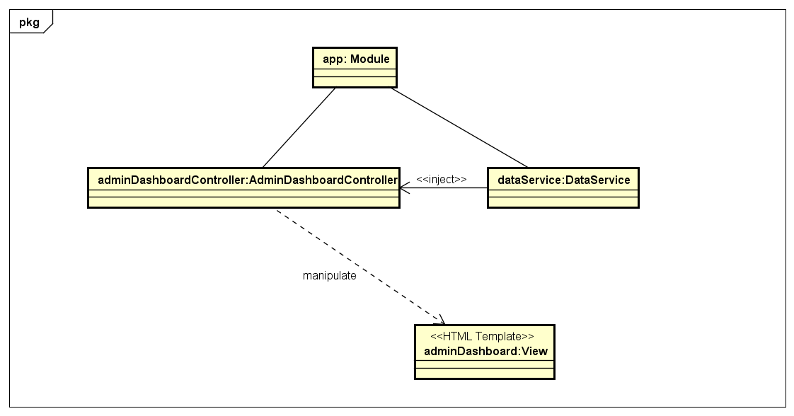

Figure . Object Diagram of View Dashboard use case

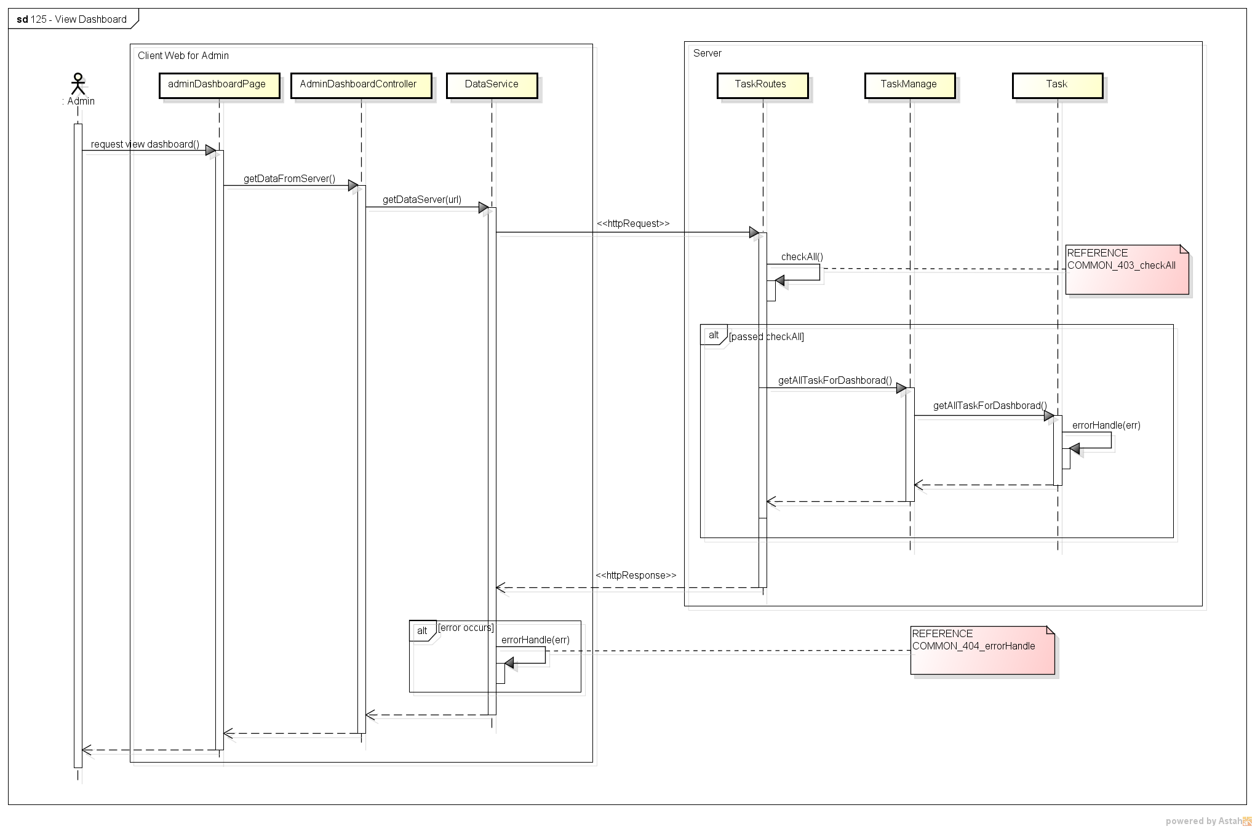

Figure . Sequence Diagram of View Dashboard use case

###### 2.2.1.1.15. View IssueBox

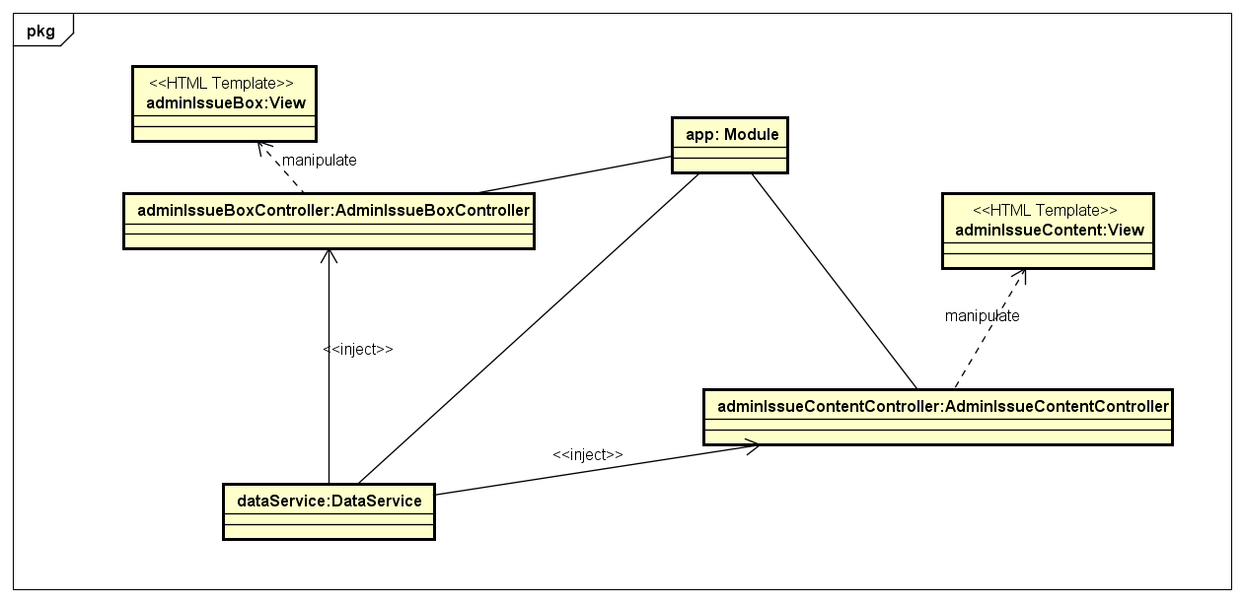

Figure . Object Diagram of View IssueBox use case

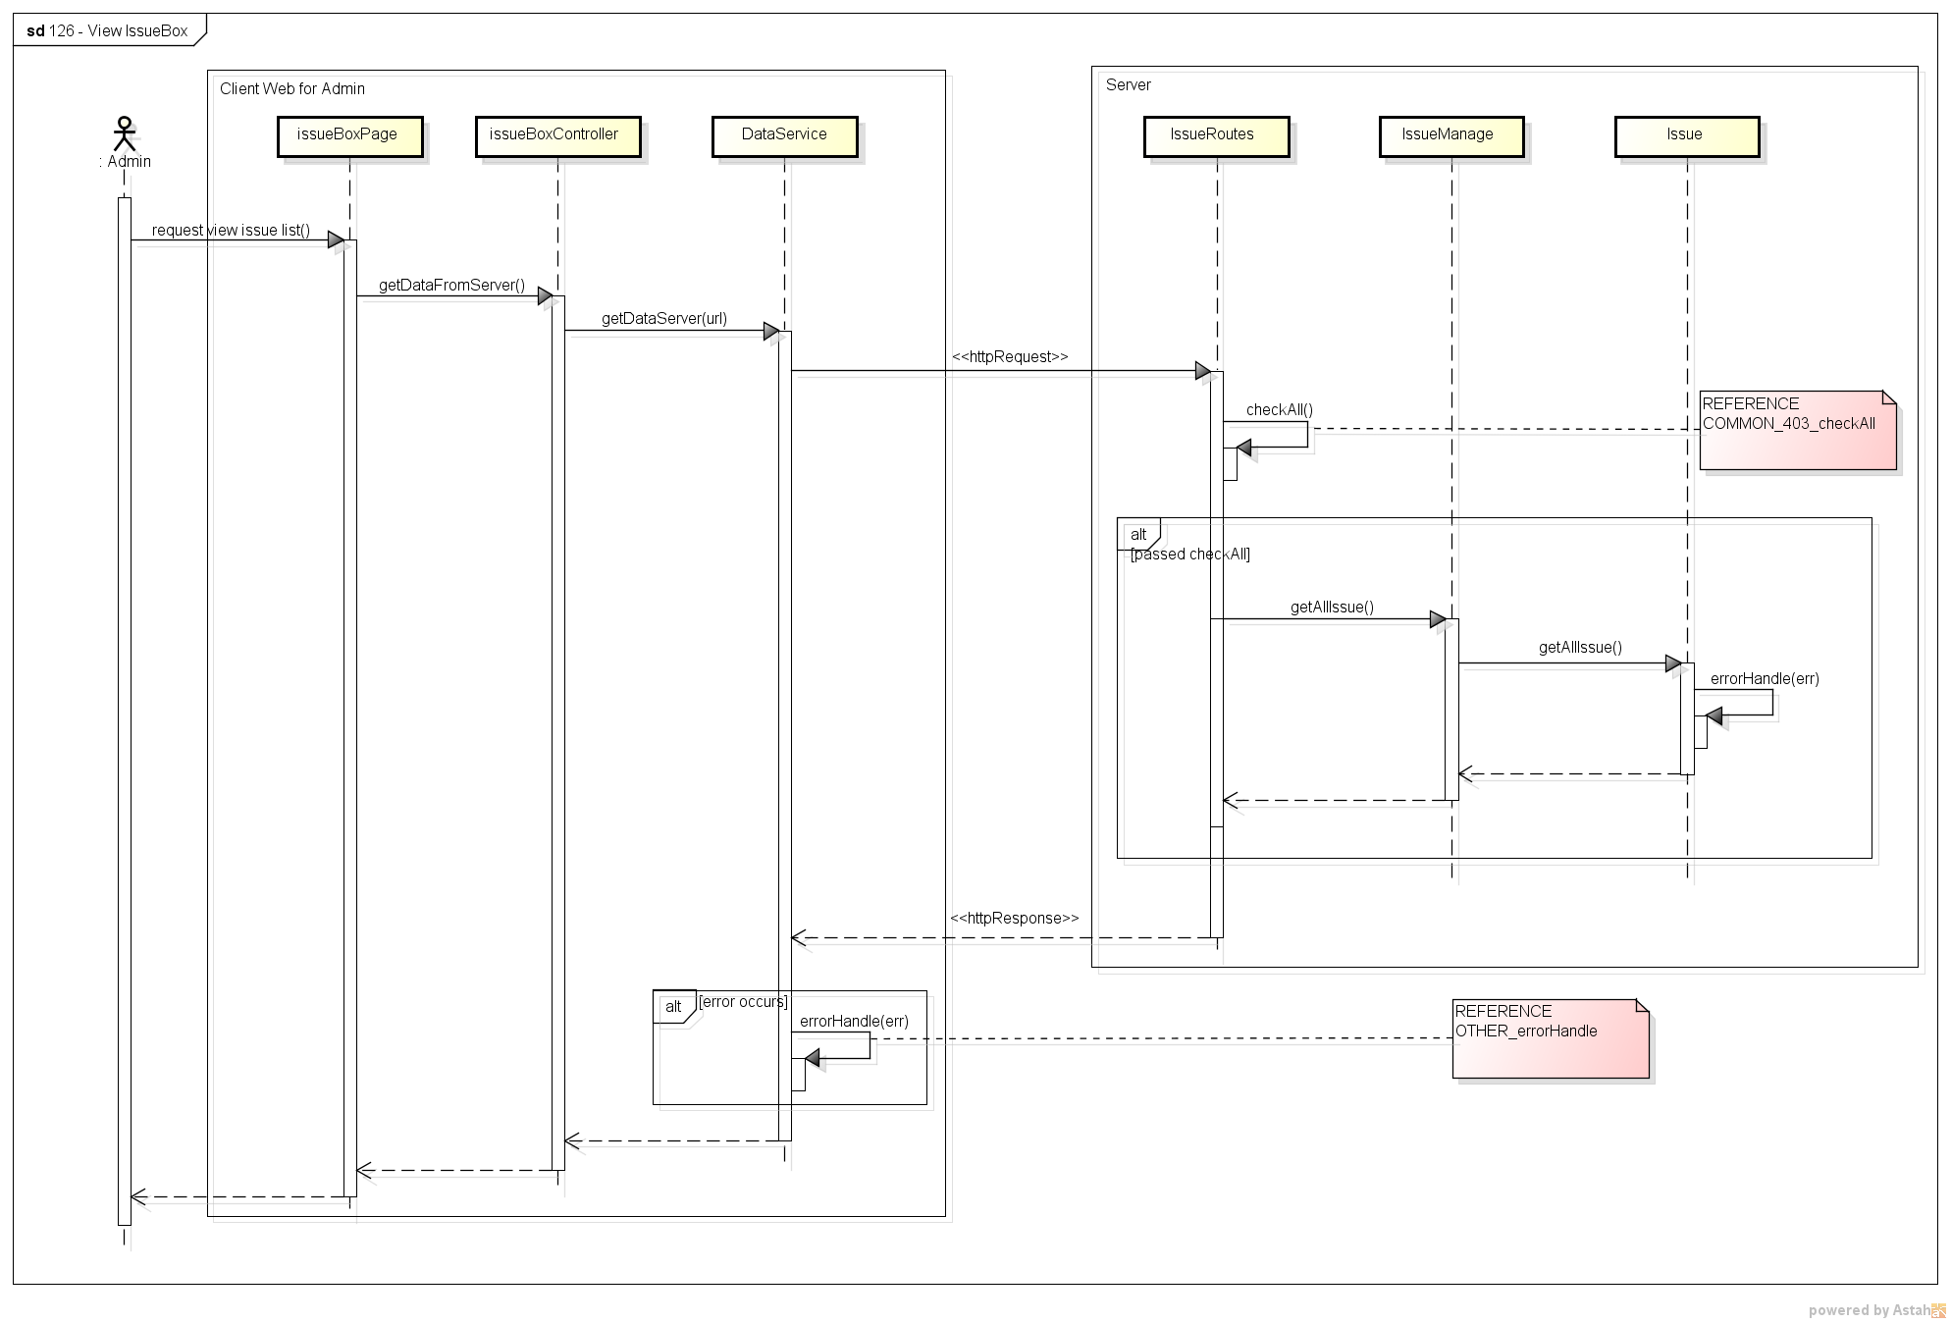

Figure . Sequence Diagram of View IssueBox use case

###### 2.2.1.1.16. Resolve Issue

*(*) Object Diagram of Resolve Issue use case refer to Figure 44*

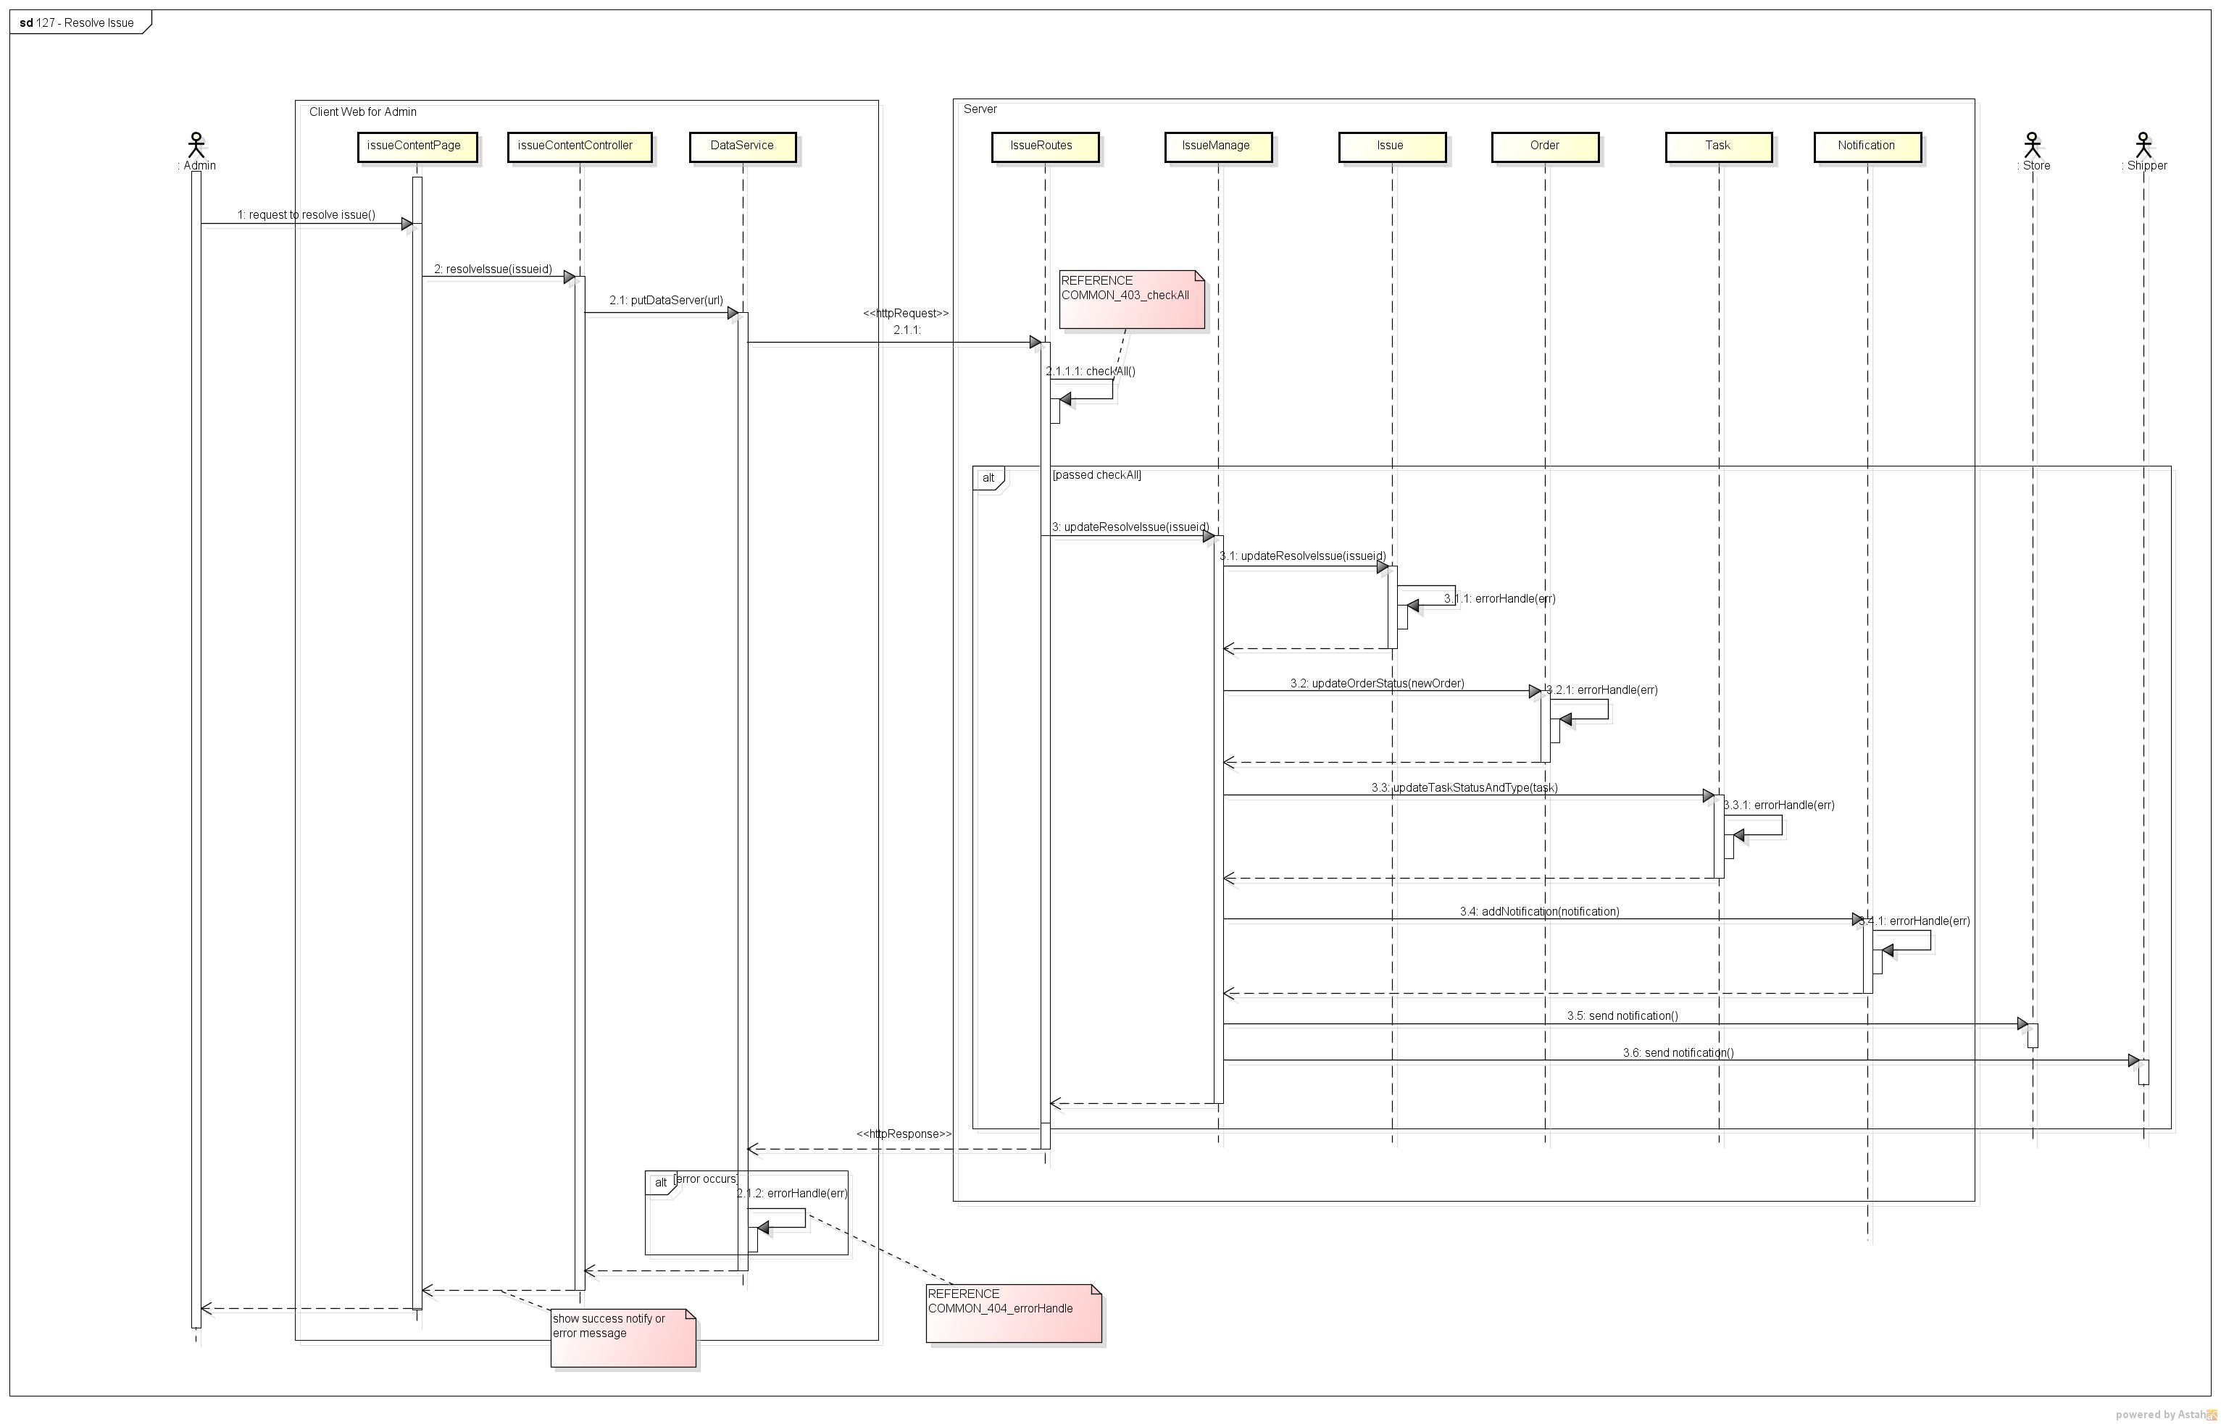

Figure . Sequence Diagram of Resolve Issue use case

###### 2.2.1.1.17. View Task’s List

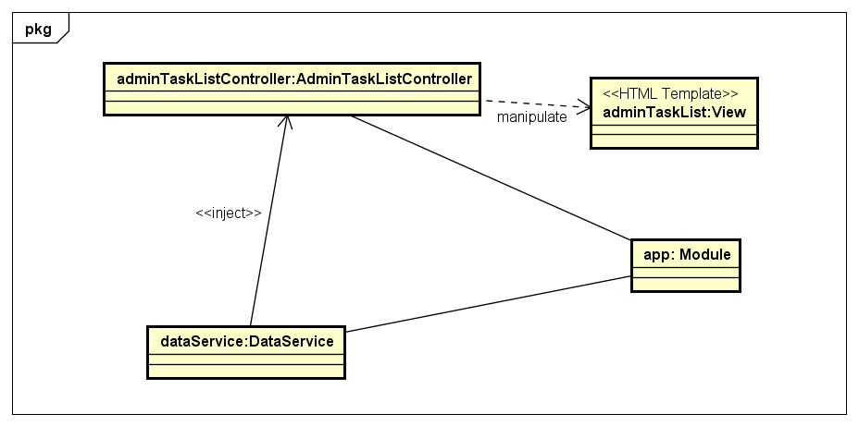

Figure . Object Diagram of View Task’s List use case

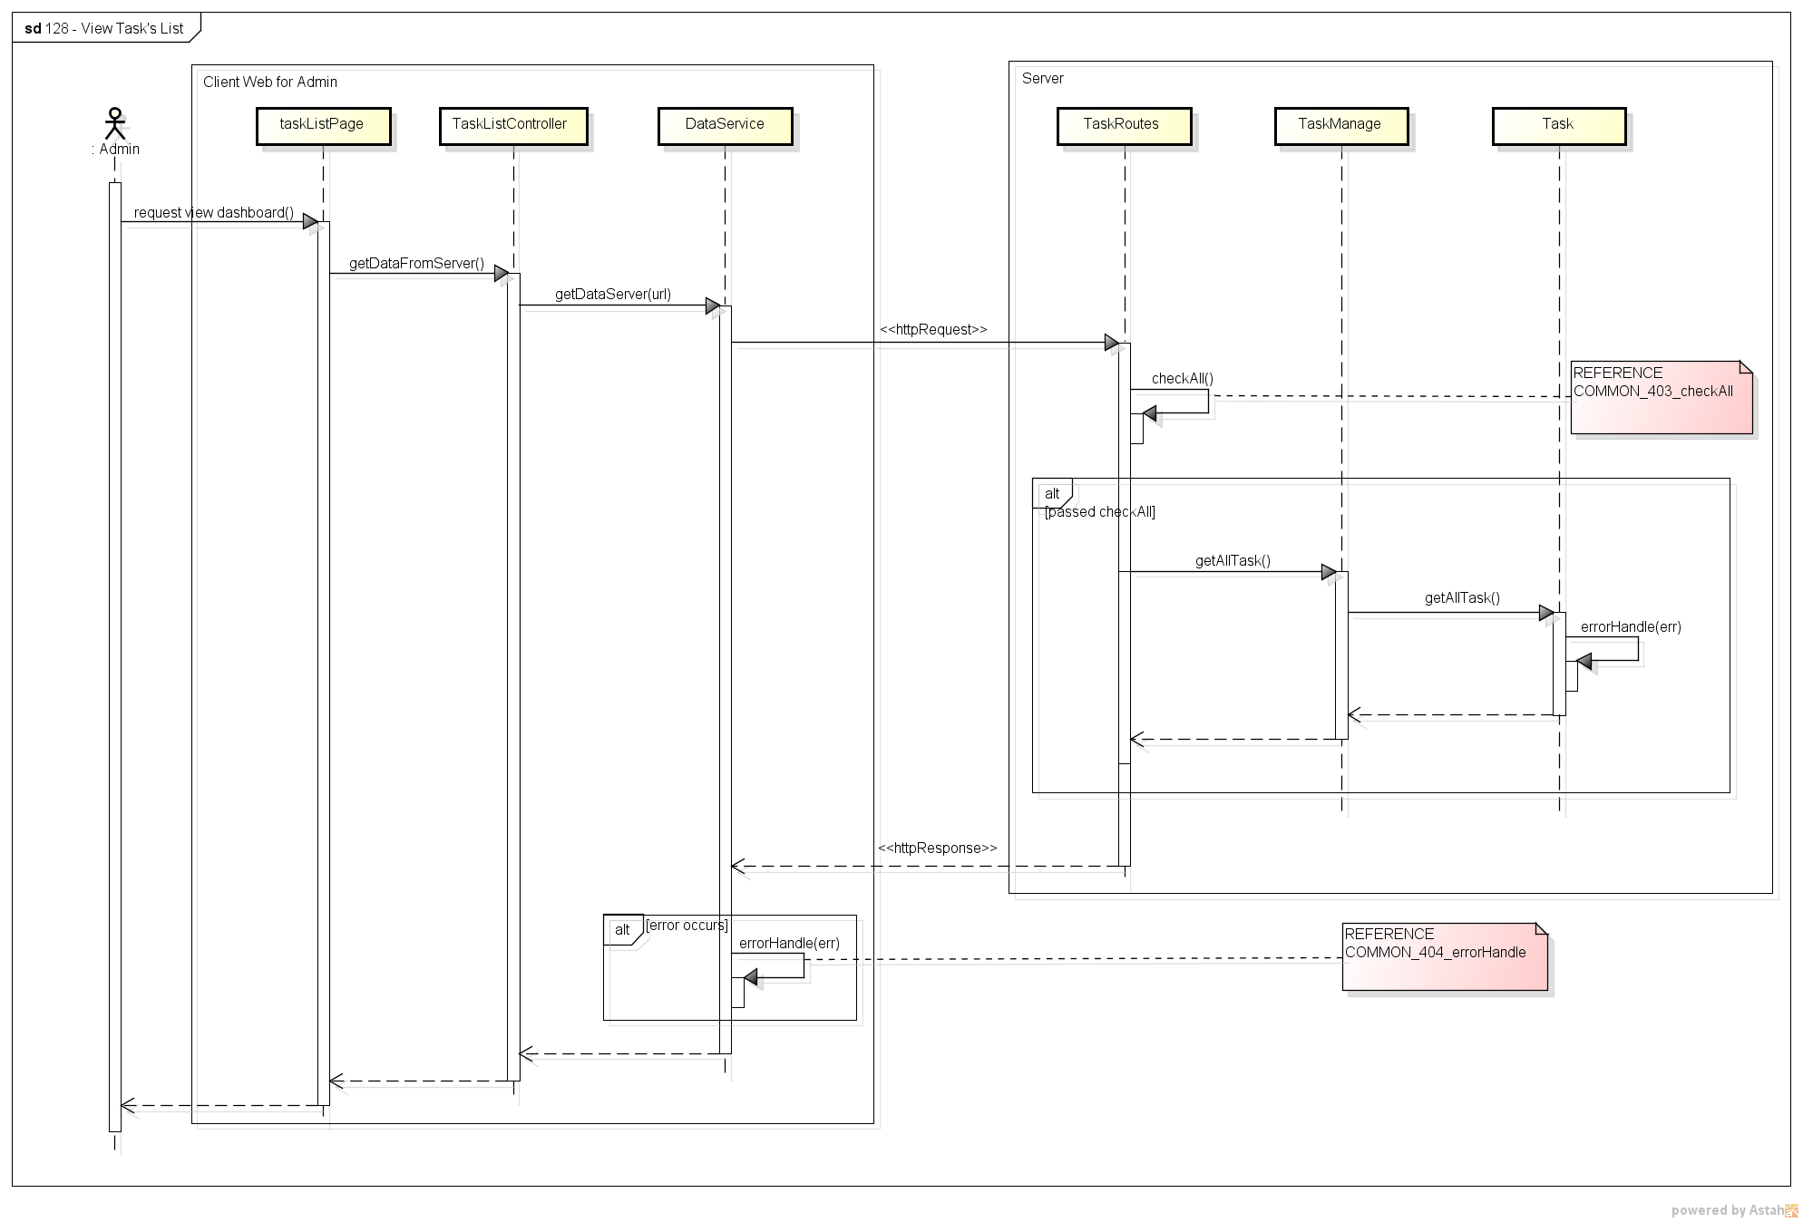

Figure . Sequence Diagram of View Task’s List use case

###### 2.2.1.1.18. View Order’s Detail

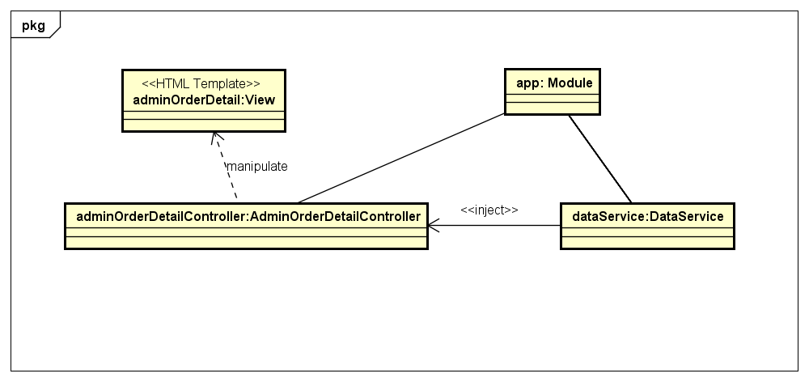

Figure . Object Diagram of View Order’s Detail use case

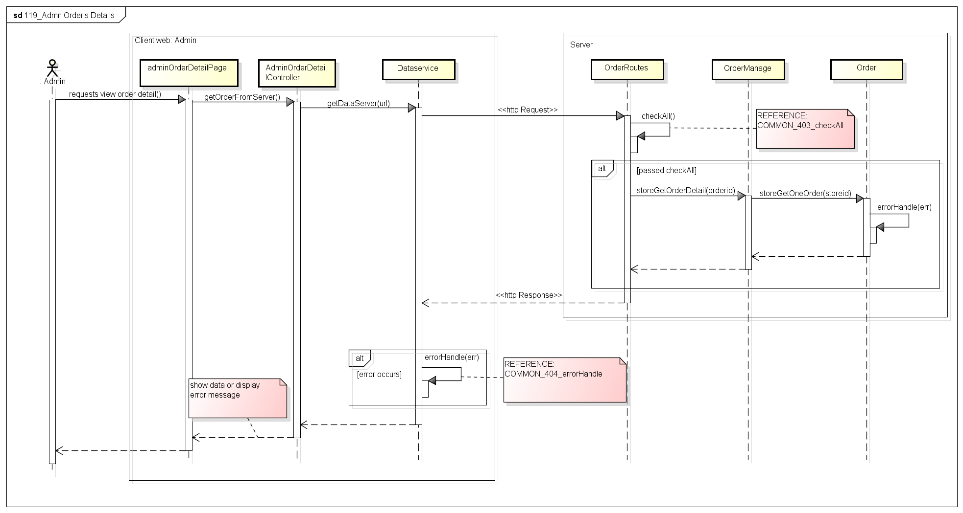

Figure . Sequence Diagram of View Order’s Detail use case

###### 2.2.1.1.18. View Report

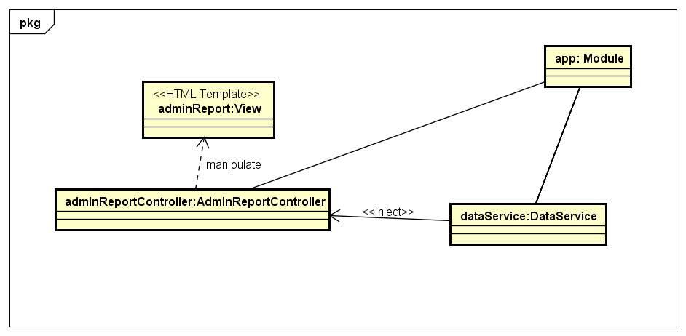

Figure . Object Diagram of View Report use case

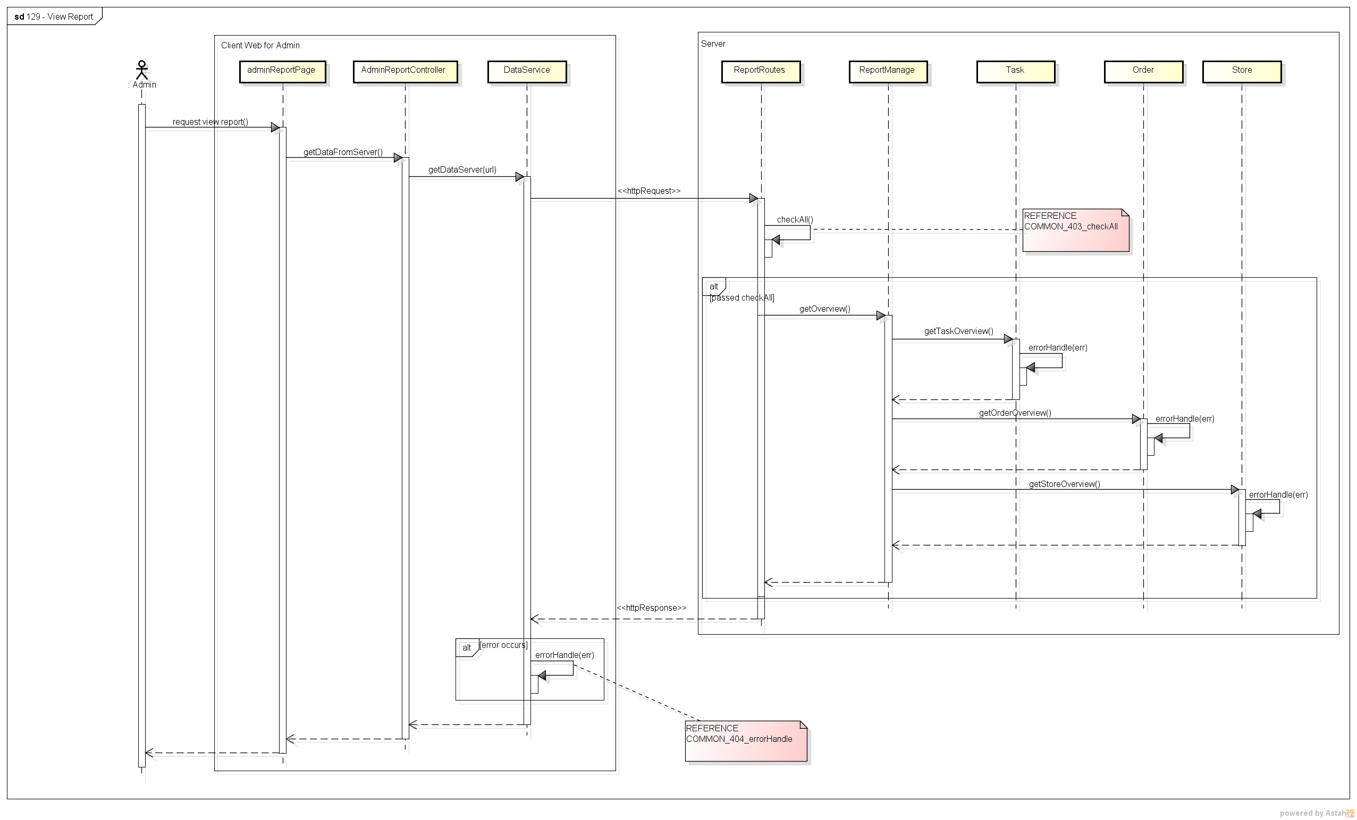

Figure . Sequence Diagram of View Report use case

##### **Store**

###### 2.2.1.2.1. View Dashboard

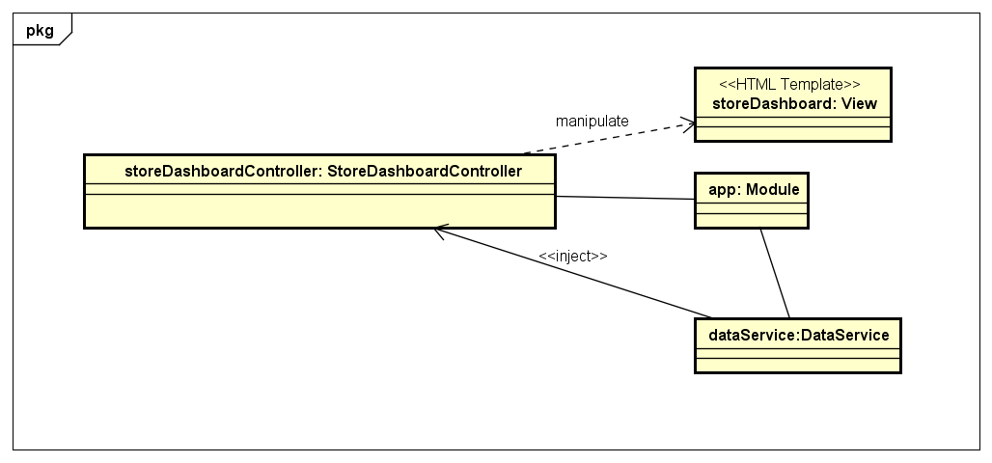

Figure . Object Diagram of View Dashboard use case

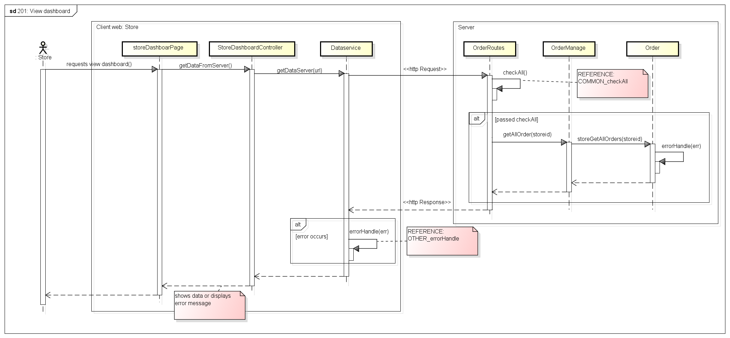

Figure . Sequence Diagram of View Dashboard use case

###### 2.2.1.2.2. View Profile

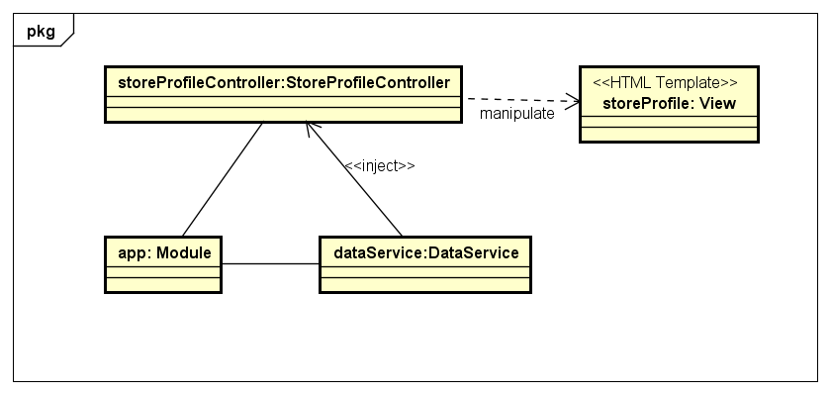

Figure . Object Diagram of View Profile use case

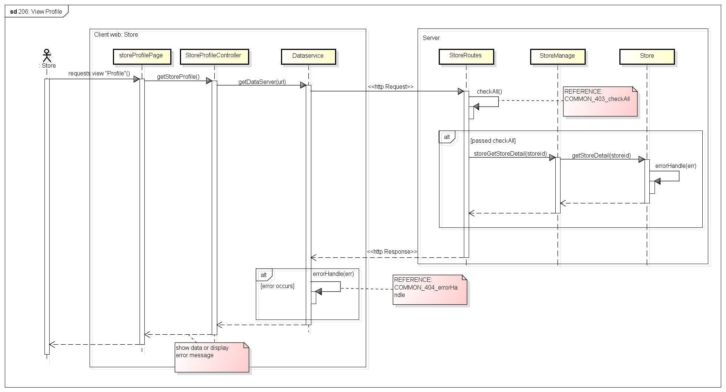

Figure . Sequence Diagram of View Profile use case

###### 2.2.1.2.3. Create Order

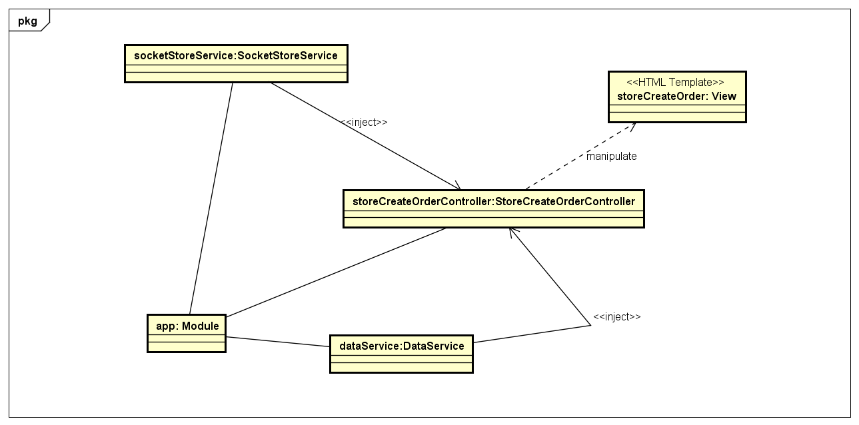

Figure . Object Diagram of Create Order use case

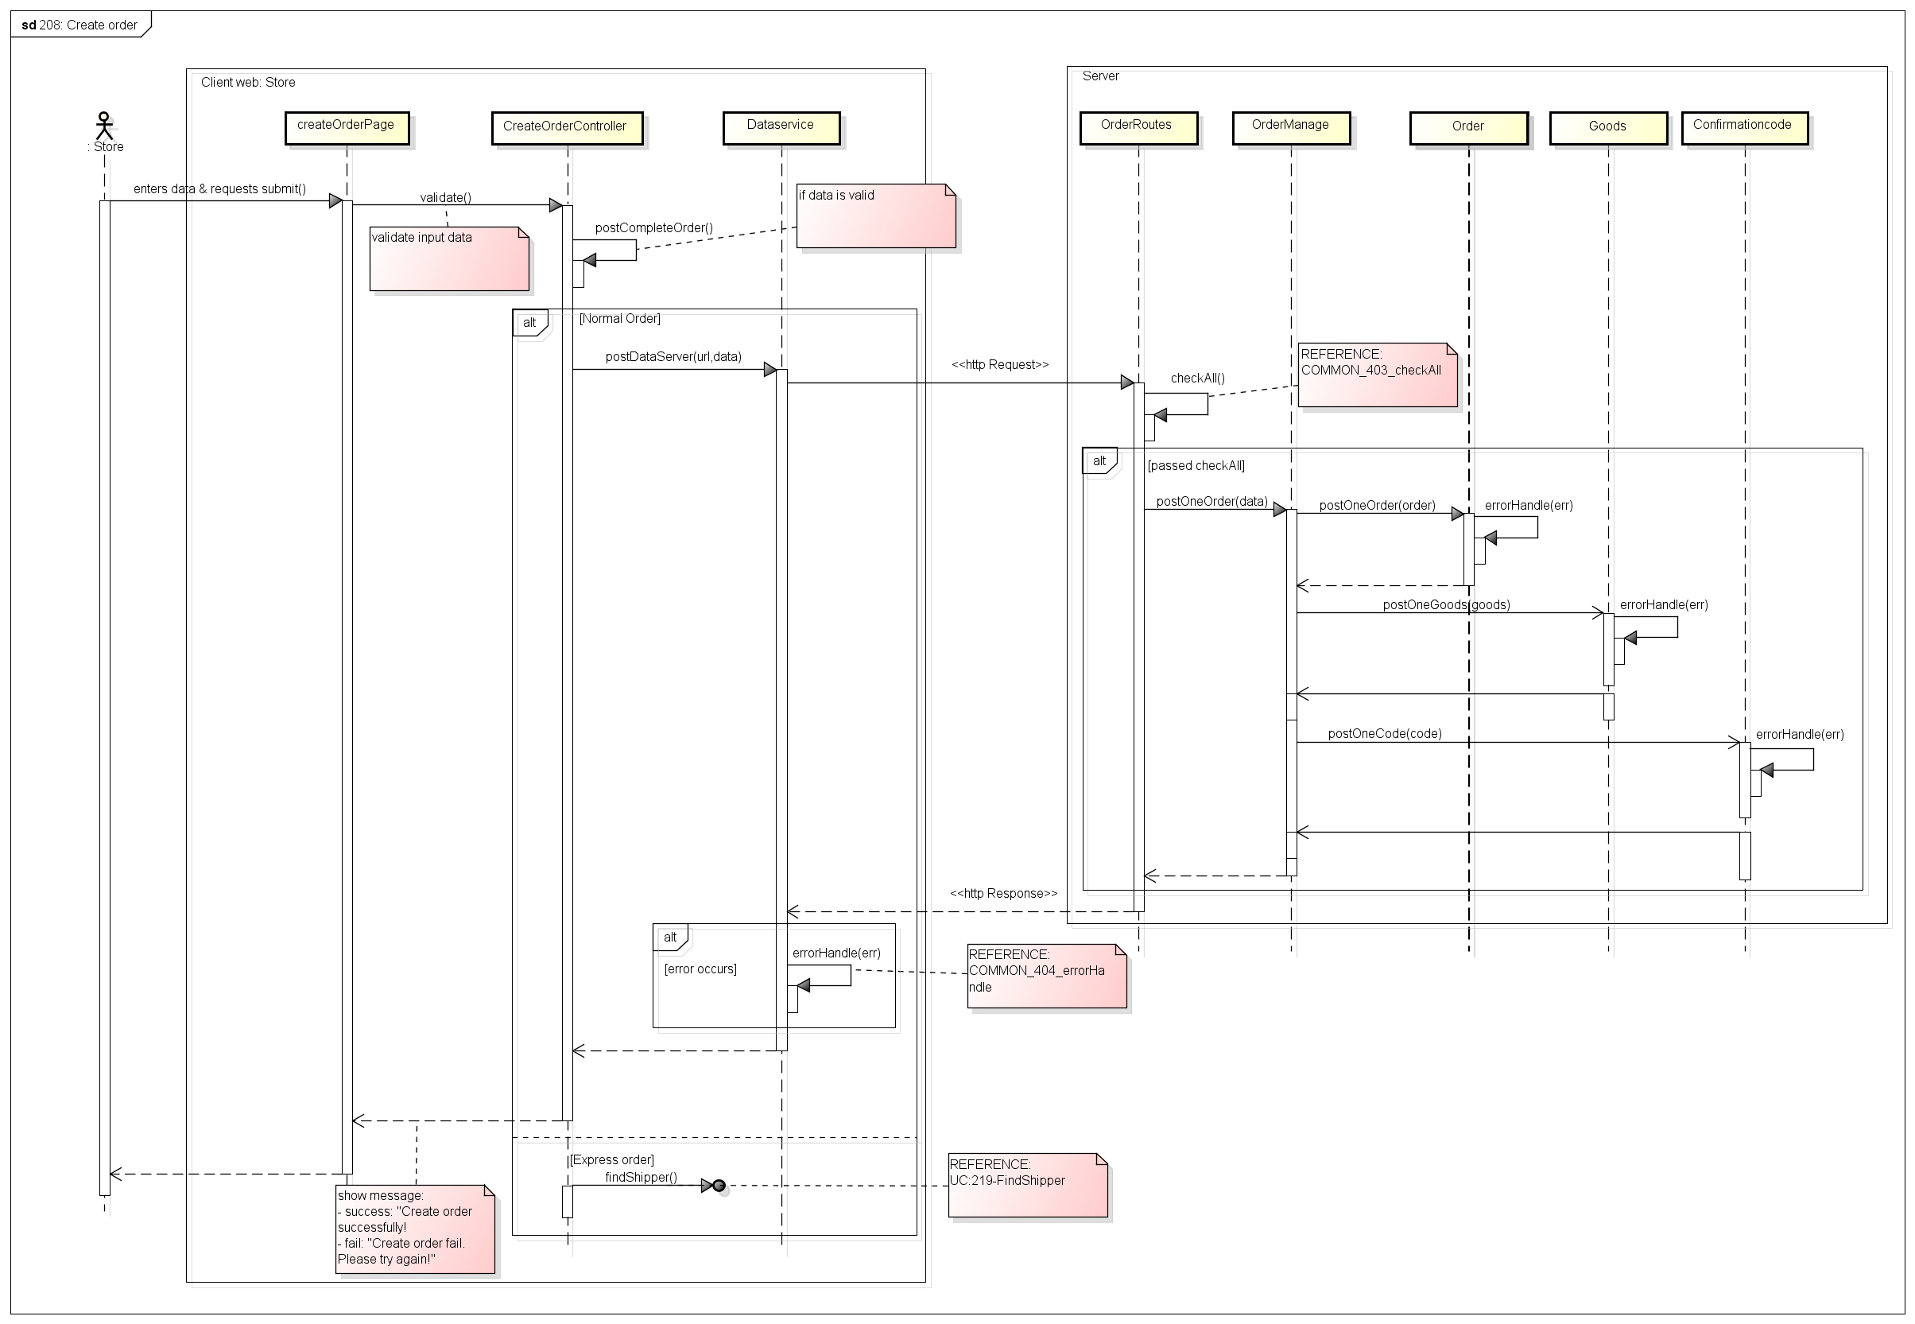

Figure . Sequence Diagram of Create Order use case

###### 2.2.1.2.4. Find Shipper

*(*) Object Diagram of Find Shipper use case refer to Figure57*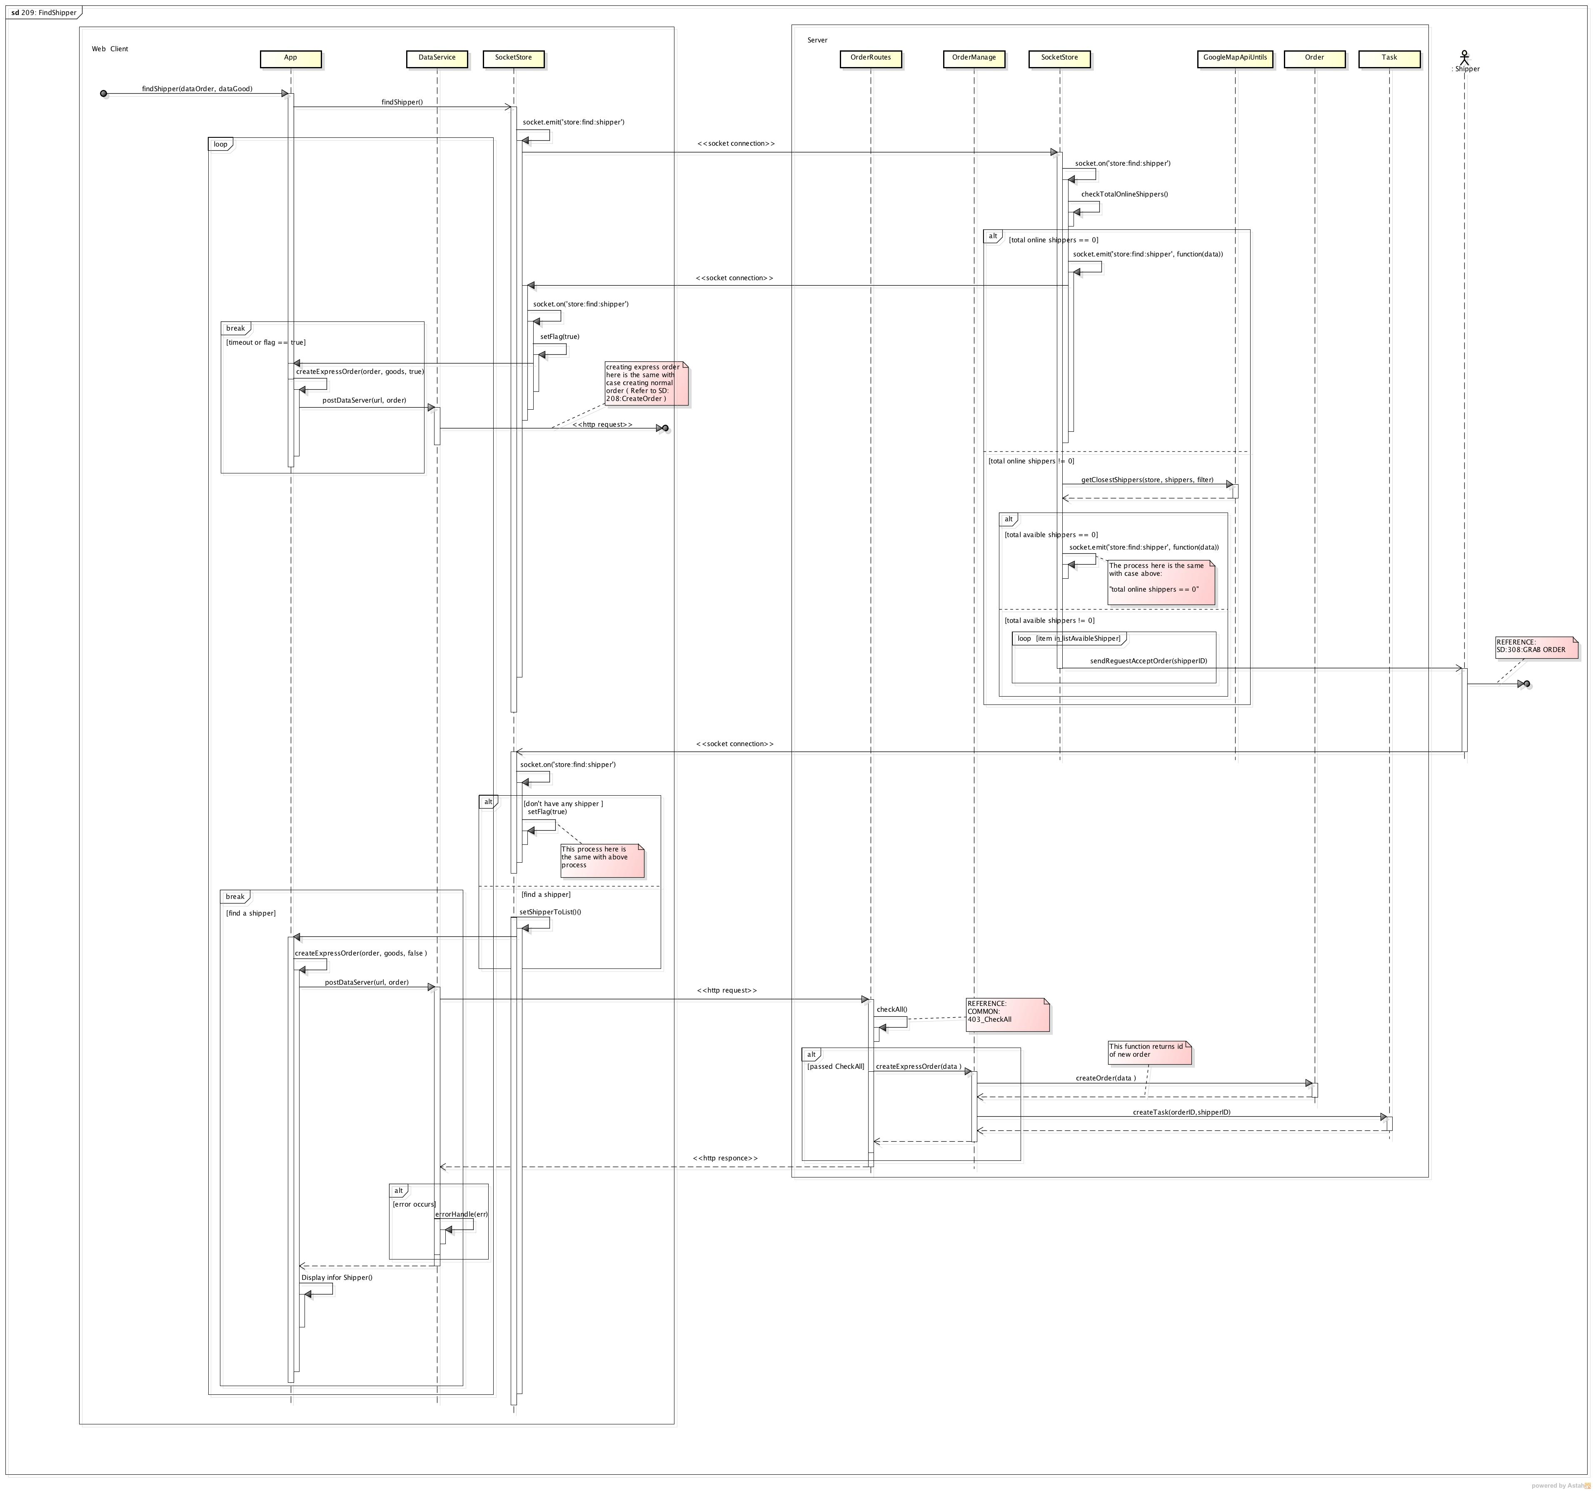

Figure . Sequence Diagram of Find Shipper use case

###### 2.2.1.2.5. Edit Order

*(*) Object Diagram of Edit Order use case refer to Figure66*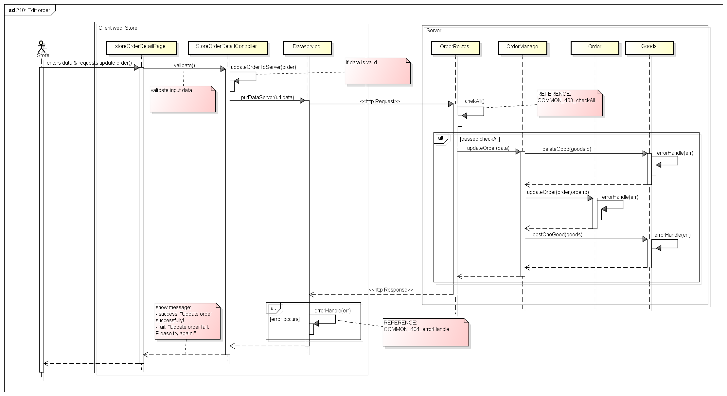

Figure . Sequence Diagram of Edit Order use case

###### 2.2.1.2.6. View Order’s History

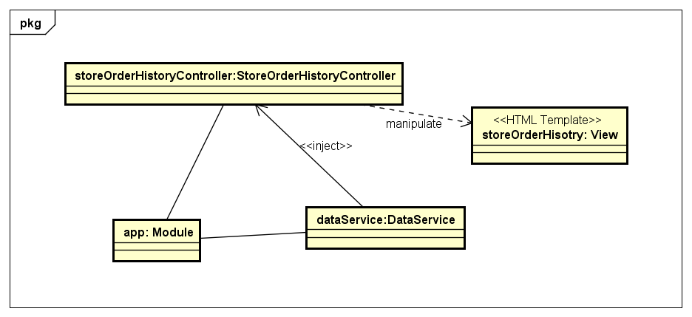

Figure . Object Diagram of View Order’s History use case

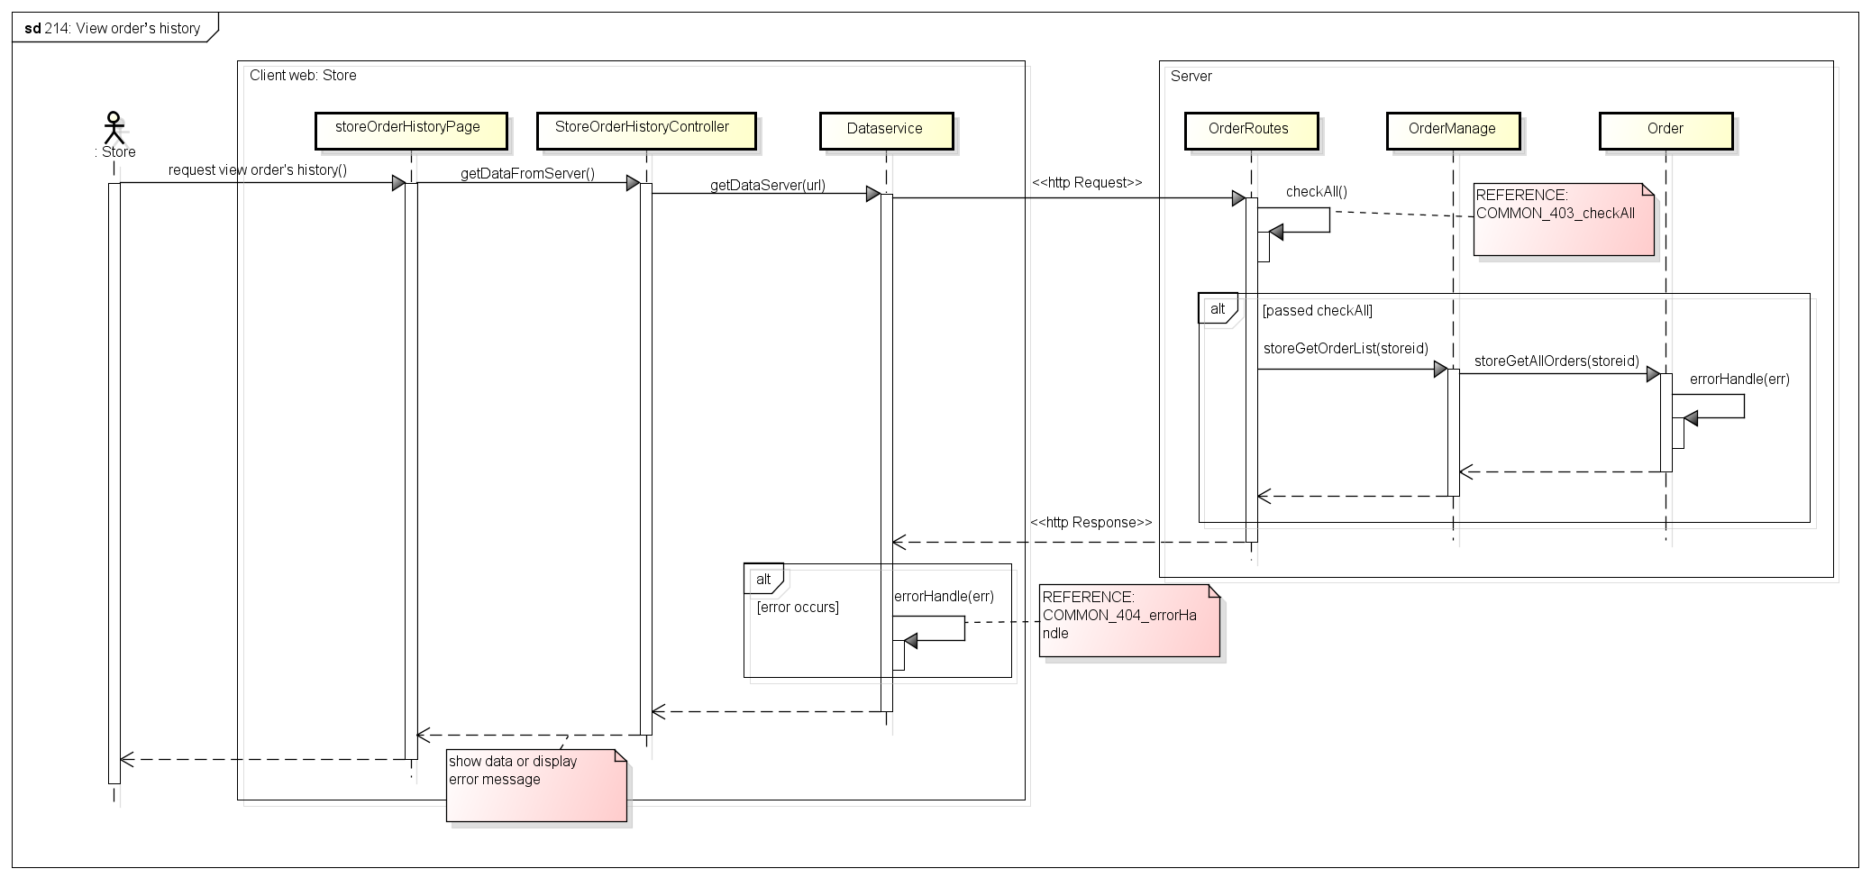

Figure . Sequence Diagram of View Order’s History use case

###### 2.2.1.2.7. Search Order

*(*) Object Diagram of Edit Order use case refer to Figure53****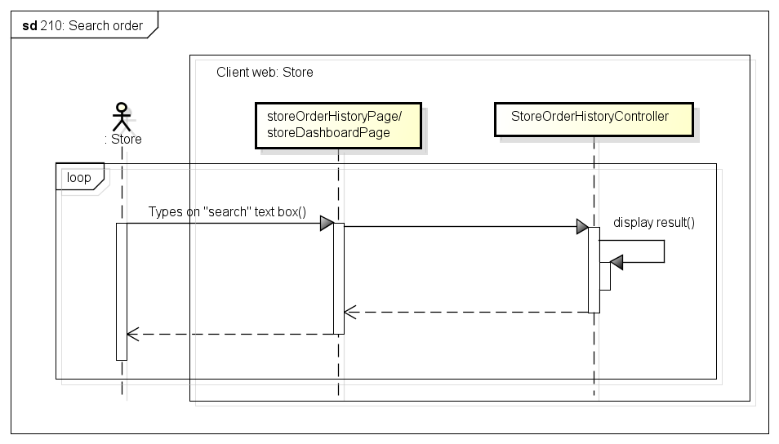***

Figure . Sequence Diagram of Search Order use case

###### 2.2.1.2.8. Cancel Order

*(*) Object Diagram of Edit Order use case refer to Figure53*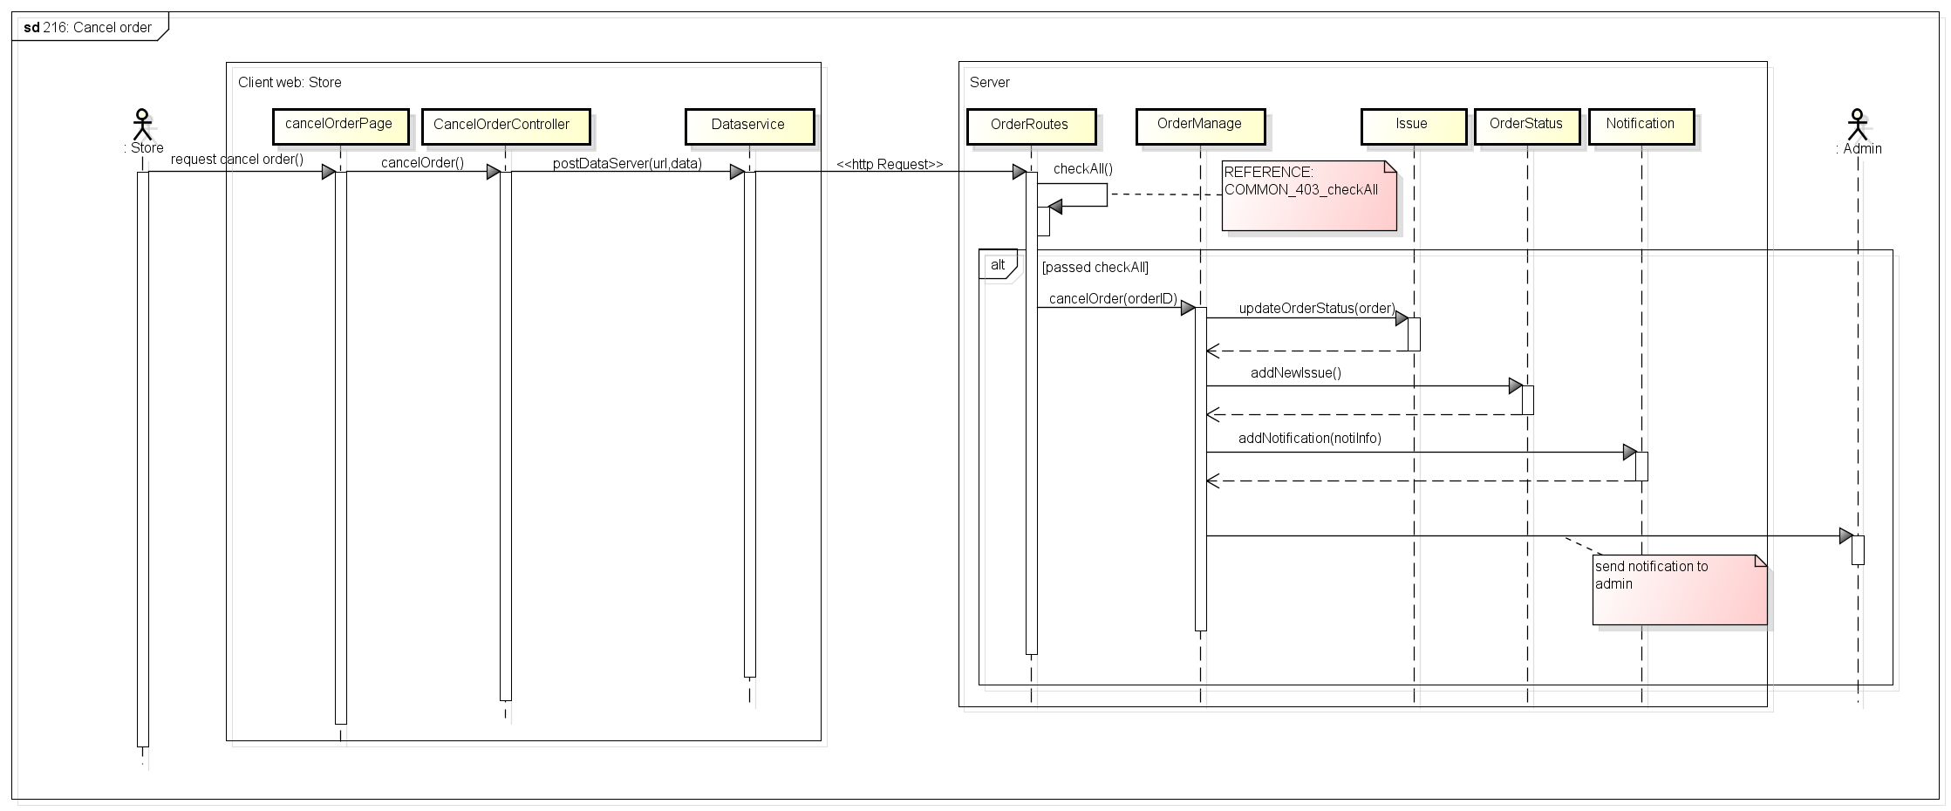

Figure . Sequence Diagram of Cancel Order use case

###### 2.2.1.2.9. Delete Order

*(*) Object Diagram of Edit Order use case refer to Figure53*

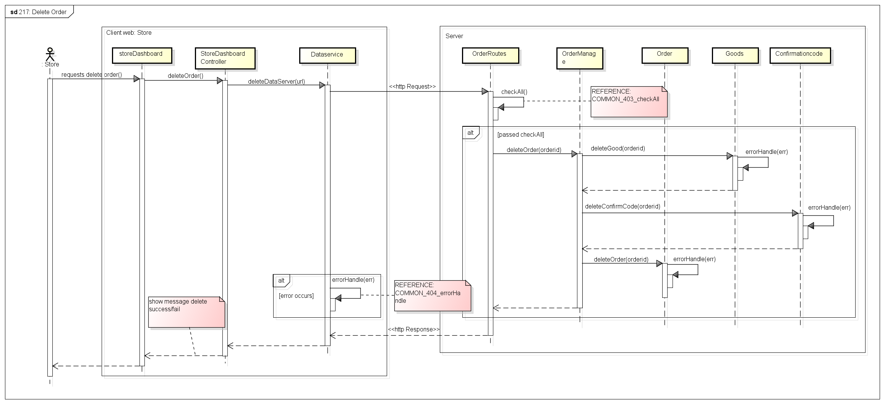

Figure . Sequence Diagram of Delete Order use case

###### 2.2.1.2.10. View Order’s Detail

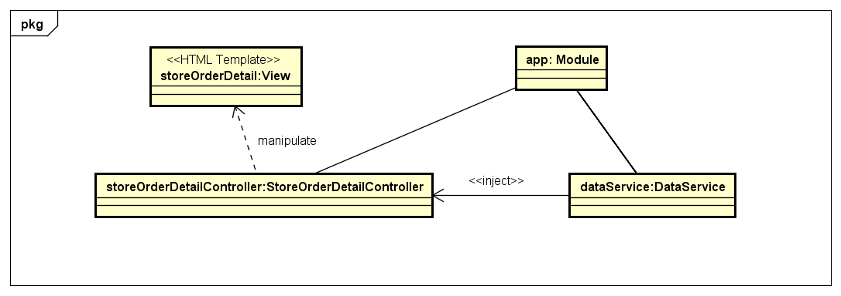

Figure . Object Diagram of View Order’s Detail use case

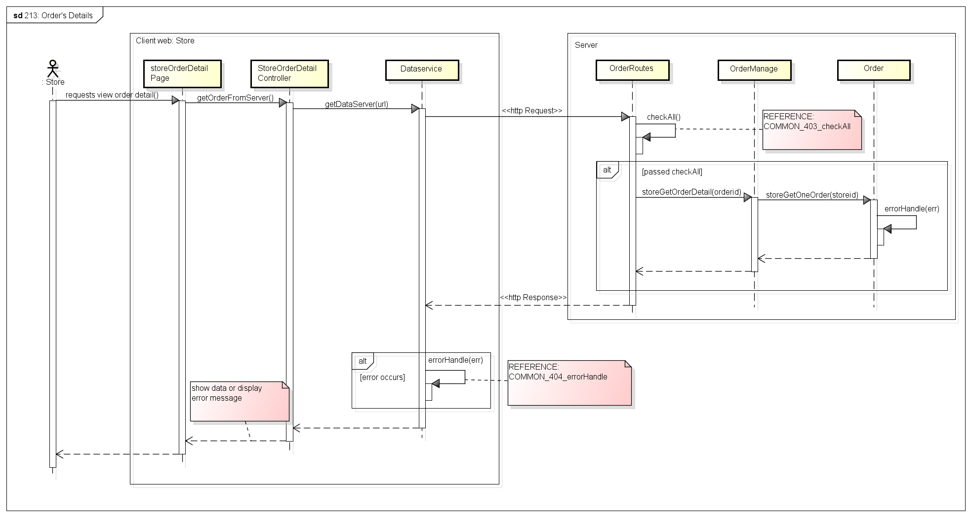

Figure . Sequence Diagram of View Order’s Detail use case

###### 2.2.1.2.11. View Transaction History

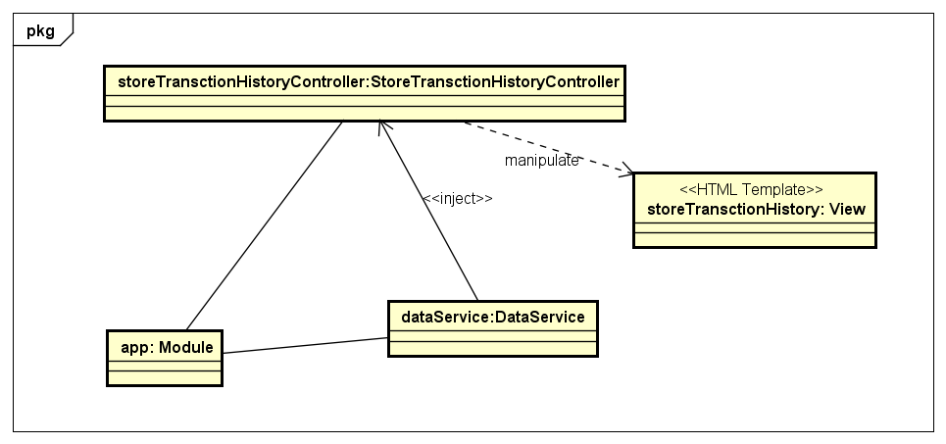

Figure . Object Diagram of View Transaction History use case

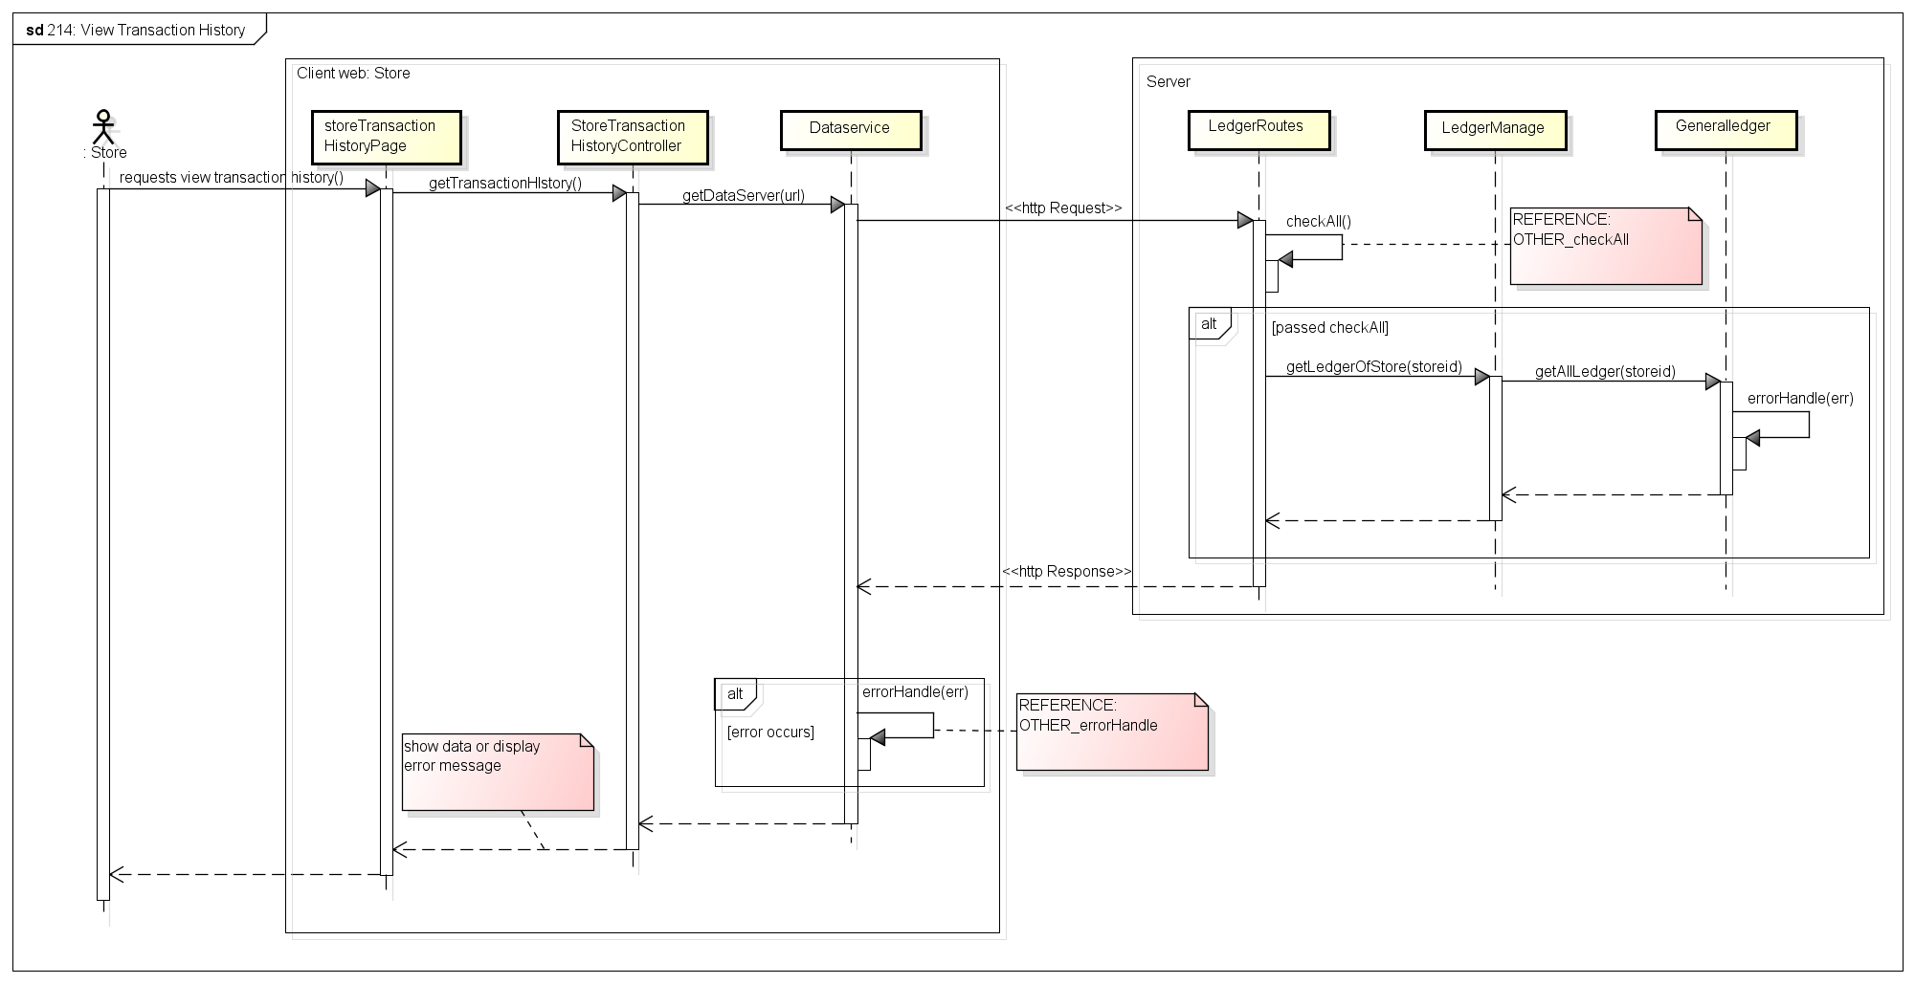

Figure . Sequence Diagram of View Transaction History use case

##### **Common**

###### 2.2.1.3.1. Login

Figure . Object Diagram of Login use case

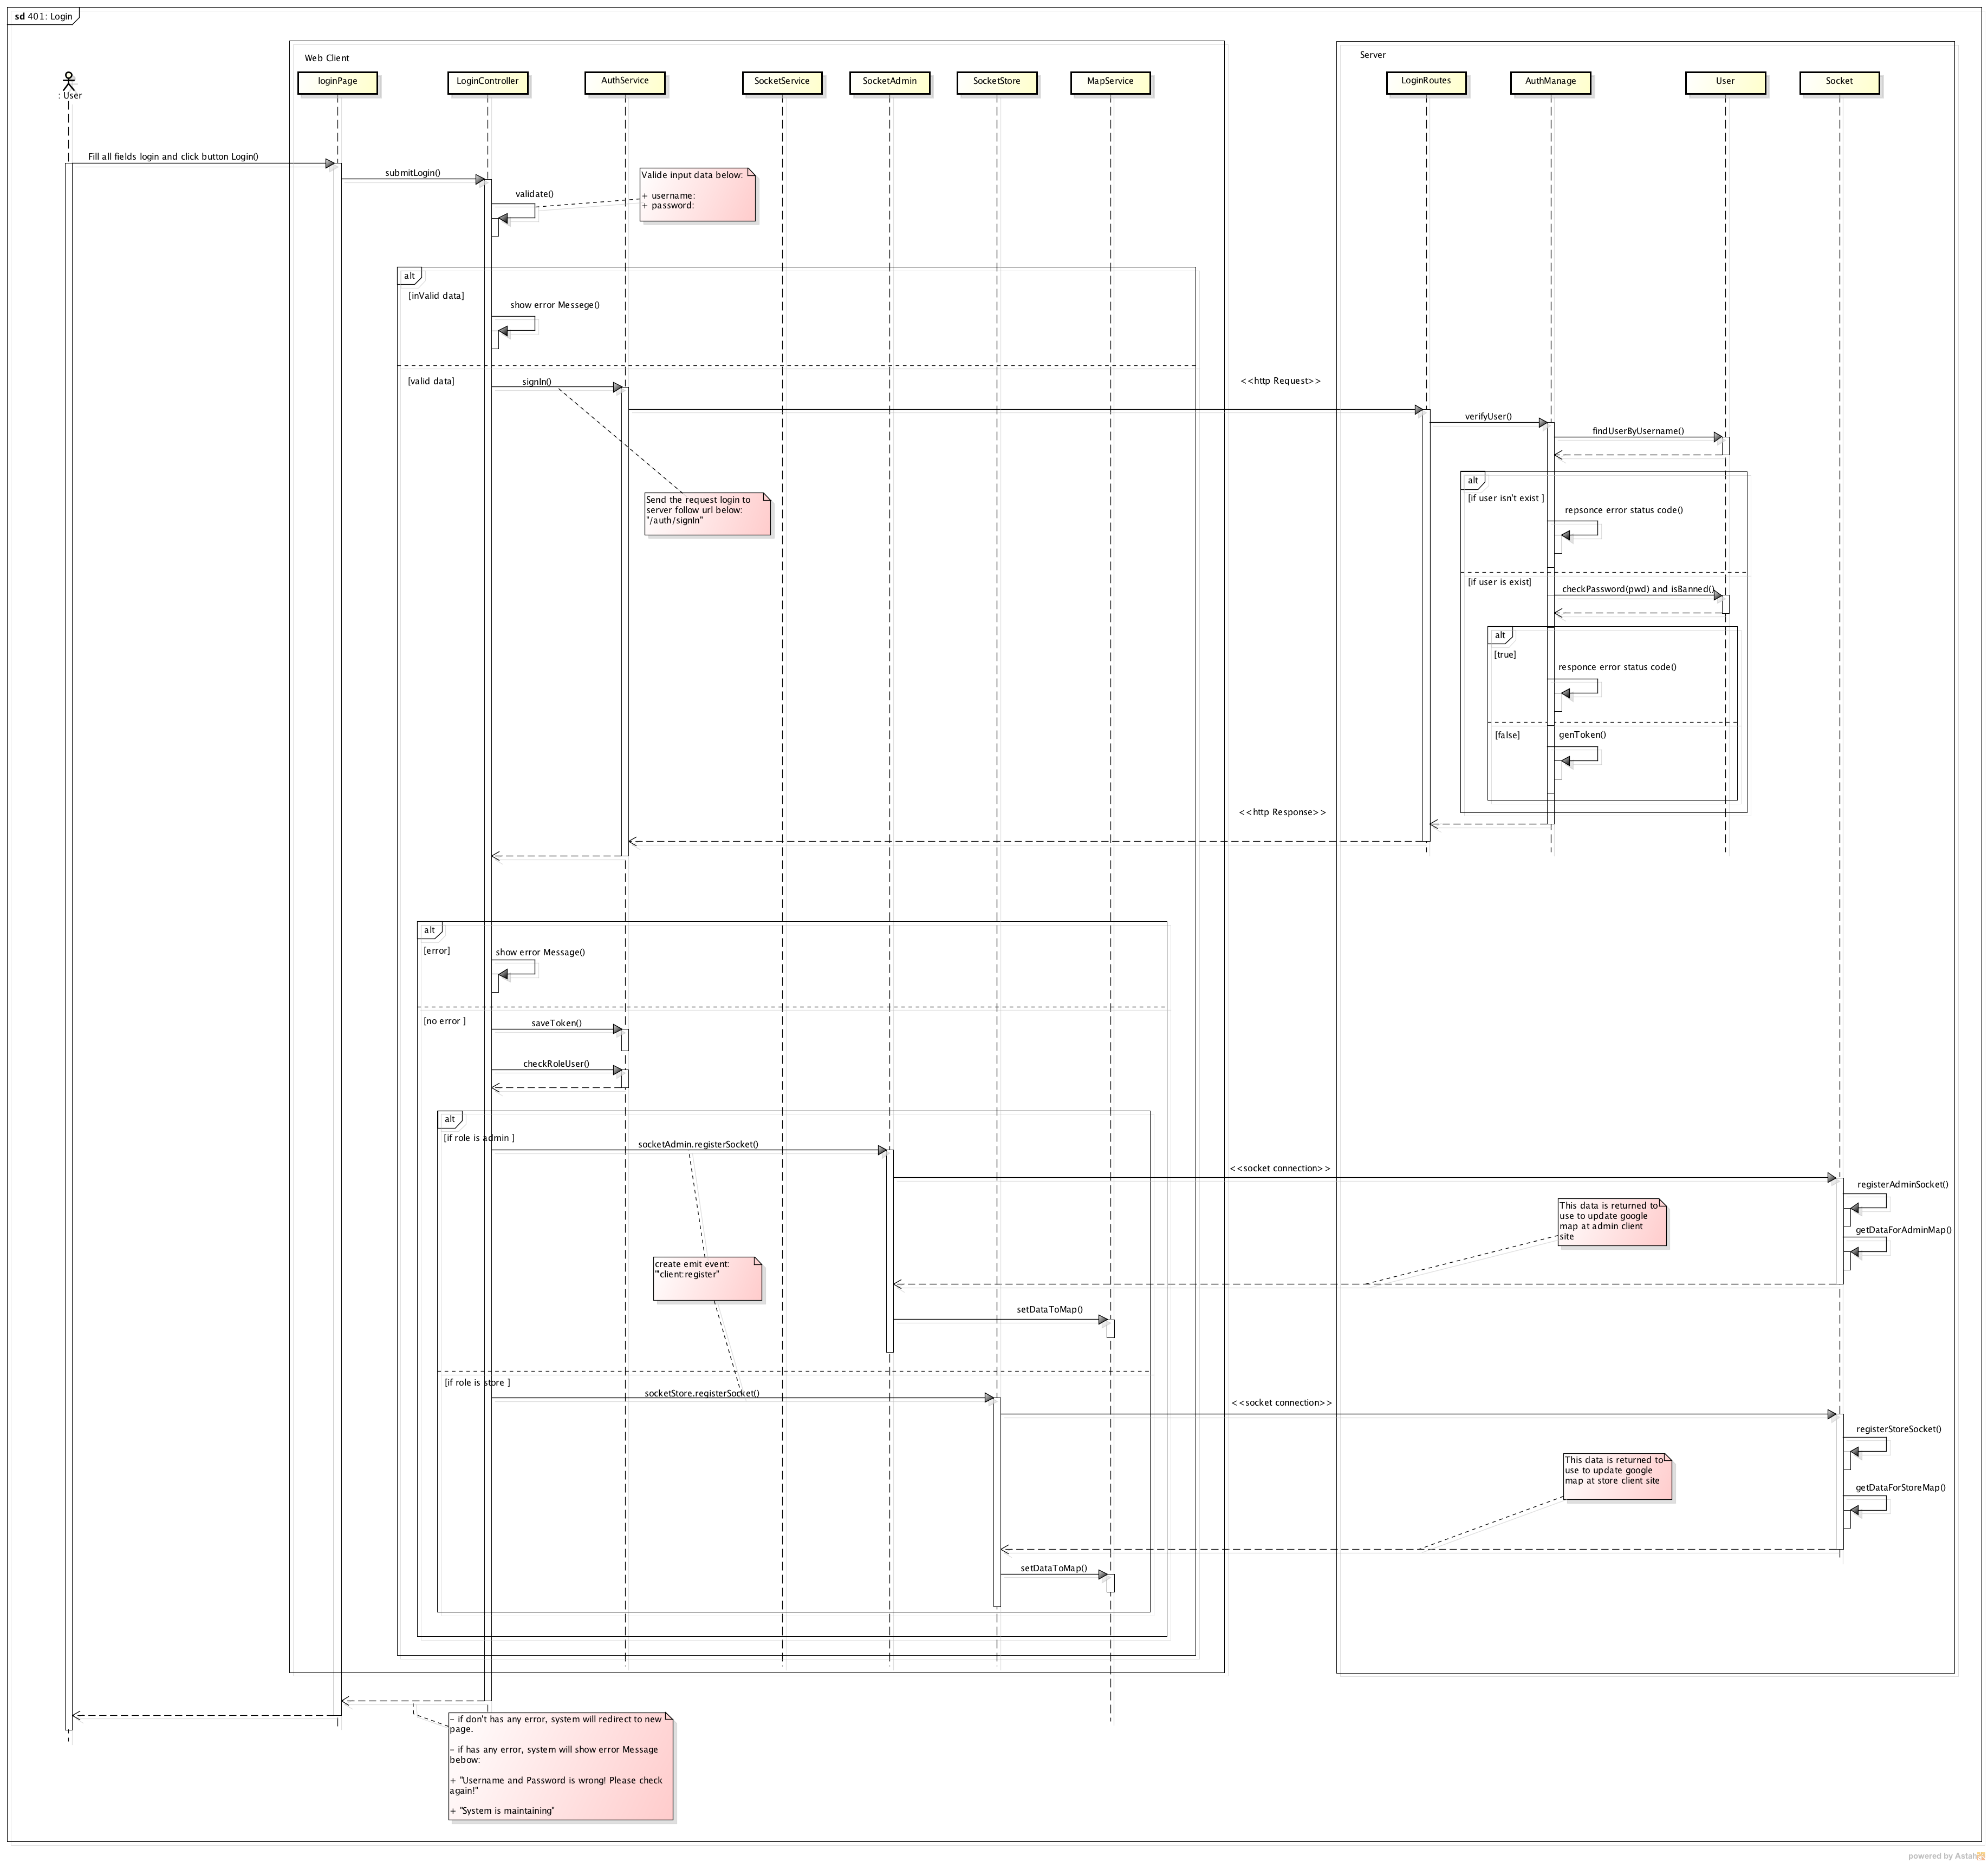

Figure . Sequence Diagram of Login

###### 2.2.1.3.2. Logout

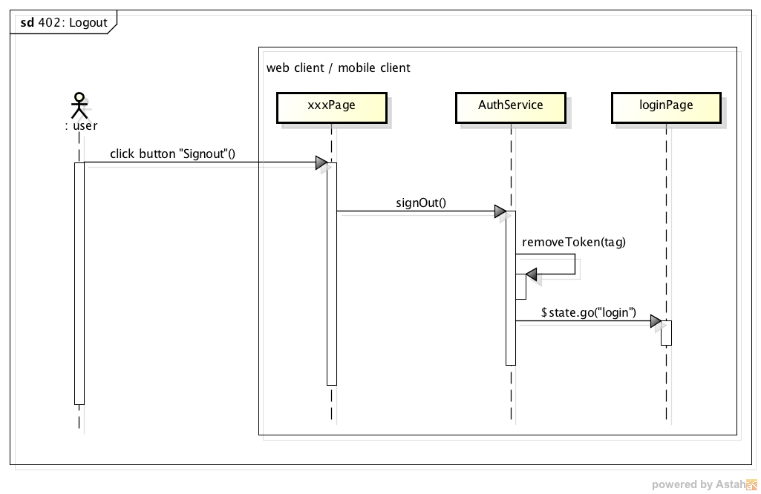

Figure . Sequence Diagram of Logout

###### 2.2.1.3.3. CheckAll

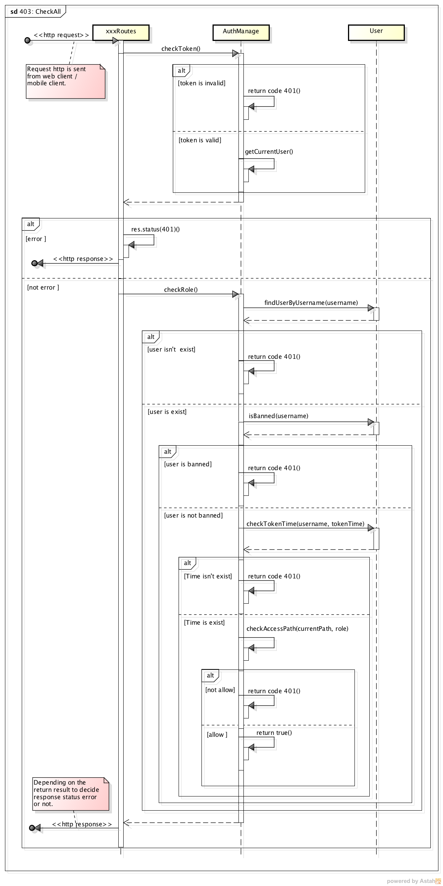

Figure . Sequence Diagram of CheckAll

###### 2.2.1.3.4. ErrorHandle

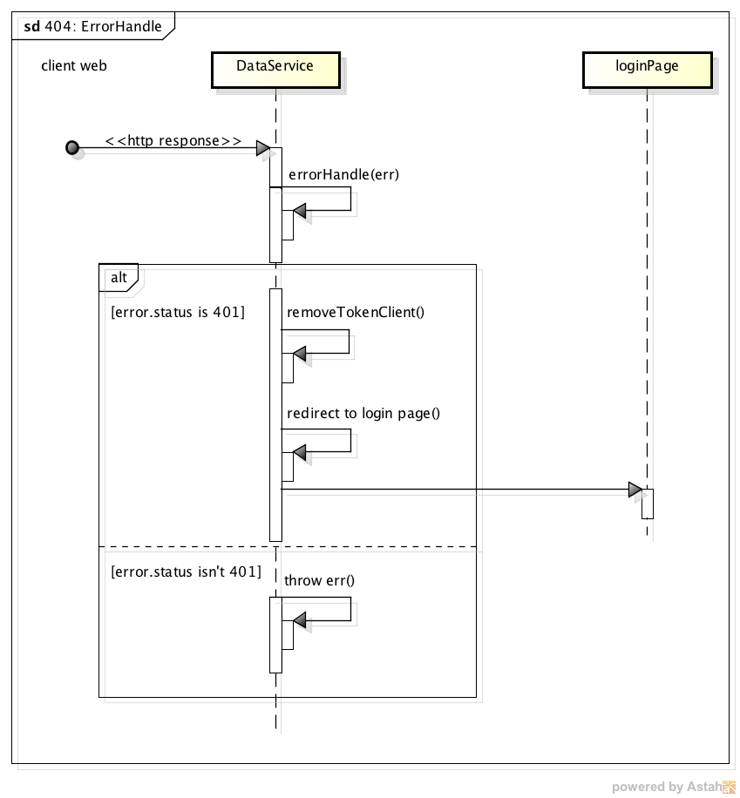

Figure . Sequence Diagram of ErrorHandle

###### 2.2.1.3.5. Notification

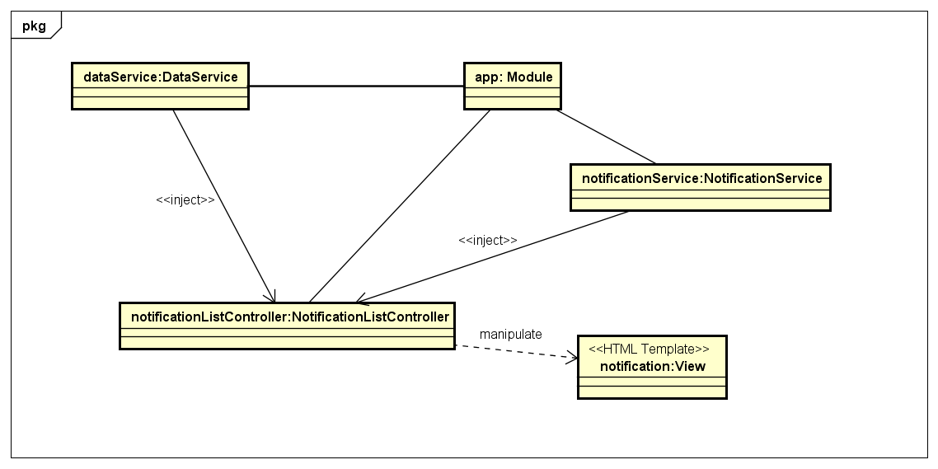

Figure . Object Diagram of Notification

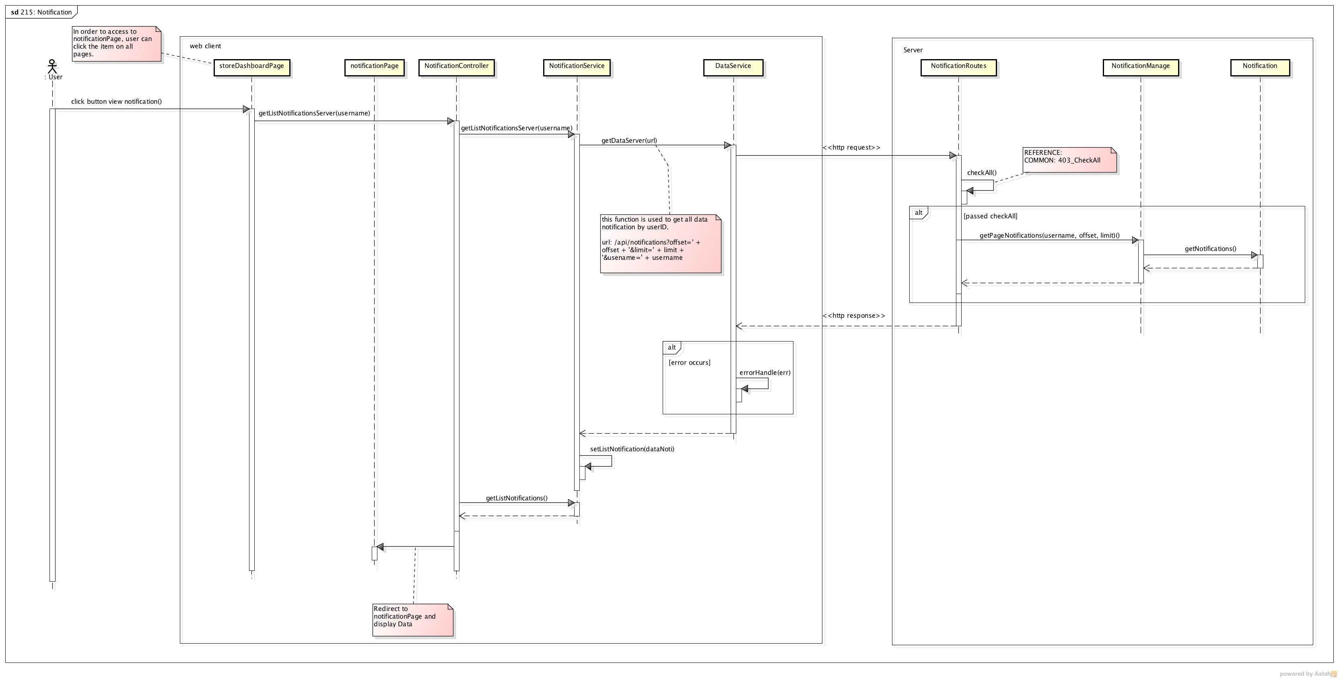

Figure . Sequence Diagram of Notification

##### **Class description**

###### AdminAddStoreController

* Attributes

|  |  |  |  |  |
| --- | --- | --- | --- | --- |
| No | Attributes | Type | Default | Description |
|  | newStore | Object | N/A | Information of new Store |
|  | newStoreOwner | Object | N/A | Information of new Store Owner |

* Methods

|  |  |  |  |  |
| --- | --- | --- | --- | --- |
| No | Methods | Parameters | Return | Description |
| 1 | getDataFromServer | N/A | N/A | Get data from server to display to screen |
| 2 | createStore | N/A | N/A | Post adding store request to server |

###### AdminAssignTaskController

* Attributes

|  |  |  |  |  |
| --- | --- | --- | --- | --- |
| No | Attributes | Type | Default | Description |
| 1 | tasksList | Array | [] | All tasks that can be assigned for other shipper of selected shipper |
| 2 | shipperList | Array | [] | List of all shipper |
| 3 | orderList | Array | [] | List of all orders that can be assigned for shipper |
| 4 | oldTasks | Array | [] | List tasks of shipper before assign |
| 5 | pickedShipper | Object | Null | Shipper is selected |
| 6 | searchShipperOptions | Array | [] | Options in drop-downlist for search shipper |

* Methods

|  |  |  |  |  |
| --- | --- | --- | --- | --- |
| No | Methods | Parameters | Return | Description |
| 1 | getDataFromServer | N/A | N/A | Get data from server to display to screen |
| 2 | assignTask | N/A | N/A | Send update shipper task request to server |
| 3 | pickOrder | Object | N/A | If user pick an order of order table, order will move to task table |
| 4 | pickTask | Object | N/A | If user pick an order of task table, order will move to order table |
| 5 | pickShipper | Object | N/A | After user select shipper, all tasks that can assigned for other shipper will be displayed in task table |
| 6 | moveAllProcessingTask | String | N/A | Move all orders in task table to order table |
| 7 | moveAllOrderToShipper | String | N/A | Move all orders which get issue to task table |
| 8 | sendSocketToShipper | N/A | N/A | Send a notification that task is assigned to shipper by socket |

###### AdminDashboardController

* Attributes

|  |  |  |  |  |
| --- | --- | --- | --- | --- |
| No | Attributes | Type | Default | Description |
| 1 | onlineShipper | Int | 0 | Number of online shippers |
| 2 | inactiveList | Array | [] | List of inactive tasks |
| 3 | activeList | Array | [] | List of active tasks |
| 4 | doneList | Array | [] | List of done tasks |
| 5 | failList | Array | [] | List of fail tasks |
| 6 | totalTaskToday | Int | 0 | Number of tasks in today |
| 7 | totalDoneToday | Int | 0 | Number of tasks have been done today |
| 8 | totalShipper | Int | 0 | Number of total shipper in system |
| 9 | totalDelivery | Int | 0 | Total delivery cost today |
| 10 | totalCoD | Int | 0 | Total cash of delivery today |

* Methods

|  |  |  |  |  |
| --- | --- | --- | --- | --- |
| No | Methods | Parameters | Return | Description |
| 1 | getDataFromServer | N/A | N/A | Get data from server to display to screen |
| 2 | dateCompare | N/A | N/A | Compare date of task for sorting |

###### AdminIssueBoxController

* Attributes

|  |  |  |  |  |
| --- | --- | --- | --- | --- |
| No | Attributes | Type | Default | Description |
| 1 | issueList | Array | [] | List of all issues |
| 2 | pageSize | Int | 1 | Total page of issue when display in list |
| 3 | currentPage | Int | 1 | Current page of issue list |

* Methods

|  |  |  |  |  |
| --- | --- | --- | --- | --- |
| No | Methods | Parameters | Return | Description |
| 1 | getDataFromServer | N/A | N/A | Get data from server to display to screen |
| 2 | sortByDate | N/A | N/A | Sort issue list by date when issue is sent |

###### AdminIssueContentController

* Attributes

|  |  |  |  |  |
| --- | --- | --- | --- | --- |
| No | Attributes | Type | Default | Description |
| 1 | issueid | Int | N/A | IssueID of issue |
| 2 | resolveType | Int | N/A | Type of resolving issue |
| 3 | issue | Object | N/A | Detail of this issue |

* Methods

|  |  |  |  |  |
| --- | --- | --- | --- | --- |
| No | Methods | Parameters | Return | Description |
| 1 | updateResolve | N/A | N/A | Send update issue request to database after processing in client |
| 2 | showConfirm | Int | N/A | Show confirm resolve popup |
| 3 | resolveIssue | N/A | N/A | Update issue is resolved by resolve type |
| 3 | resolveReturnIssue | N/A | N/A | Update order and task when order is returned to store |
| 4 | resolveStoreIssue | N/A | N/A | Update order and task when order is cancelled by store and shipper hasn’t been taken order |
| 5 | resolveContinueIssue | N/A | N/A | Update order and task when shipper can continue with issue order |
| 6 | resolveChangeShipperIssue | N/A | N/A | Update order and task when order is changed to other shipper |

###### AdminOrderListController

* Attributes

|  |  |  |  |  |
| --- | --- | --- | --- | --- |
| No | Attributes | Type | Default | Description |
| 1 | orderList | Array | [] | List of all orders |
| 2 | searchOptions | Array | [] | List of type for search order |
| 3 | dateOptions | Array | [] | List of date type for search order by complete date or pickup date |

* Methods

|  |  |  |  |  |
| --- | --- | --- | --- | --- |
| No | Methods | Parameters | Return | Description |
| 1 | getDataFromServer | N/A | N/A | Get data from server to display to screen |

###### AdminShipperListController

* Attributes

|  |  |  |  |  |
| --- | --- | --- | --- | --- |
| No | Attributes | Type | Default | Description |
| 1 | shipperList | Array | [] | List of all shippers |
| 2 | searchOptions | Array | [] | List of type for search shipper |

* Methods

|  |  |  |  |  |
| --- | --- | --- | --- | --- |
| No | Methods | Parameters | Return | Description |
| 1 | getDataFromServer | N/A | N/A | Get data from server to display to screen |
| 2 | getShipperOnline | N/A | N/A | Get status of shipper to display status of shipper is on or off |

###### AdminStoreDetailController

* Attributes

|  |  |  |  |  |
| --- | --- | --- | --- | --- |
| No | Attributes | Type | Default | Description |
| 1 | storeid | String | N/A | storeID of store |
| 2 | store | Object | N/A | Detail of this store |

* Methods

|  |  |  |  |  |
| --- | --- | --- | --- | --- |
| No | Methods | Parameters | Return | Description |
| 1 | getDataFromServer | N/A | N/A | Get data from server to display to screen |
| 2 | updateStore | N/A | N/A | Send update store request to server after information is modified by user |

###### AdminStoreListController

* Attributes

|  |  |  |  |  |
| --- | --- | --- | --- | --- |
| No | Attributes | Type | Default | Description |
| 1 | storeList | Array | [] | List of all store in system with ledger information |
| 2 | searchOptions | Array | [] | Type of store search |
| 3 | payFee | Int | 0 | Amount of payment when user add new transaction |
| 4 | selectedStore | Object | Null | Store is selected |
| 5 | reason | String | Null | Reason why store is blocked or is unblocked |

* Methods

|  |  |  |  |  |
| --- | --- | --- | --- | --- |
| No | Methods | Parameters | Return | Description |
| 1 | getDataFromServer | N/A | N/A | Get data from server to display to screen |
| 2 | showConfirm | N/A | N/A | Show Confirm Payment popup for user to enter payment |
| 3 | showConfirmAgain | N/A | N/A | Show Confirm Payment Again popup |
| 4 | blockConfirm | N/A | N/A | Show confirm popup when user block or unblock user |
| 5 | blockStore | N/A | N/A | Send update block store request to server |
| 6 | postLedger | N/A | N/A | Send post new transaction request after user confirm a payment |
| 7 | showTransactionHistory | Object, Date | N/A | Show popup contains transaction history of selected Store in specific period |

###### AdminTaskListController

* Attributes

|  |  |  |  |  |
| --- | --- | --- | --- | --- |
| No | Attributes | Type | Default | Description |
| 1 | taskList | Array | [] | List of all tasks |
| 2 | searchOptions | Array | [] | List of type for search task |

* Methods

|  |  |  |  |  |
| --- | --- | --- | --- | --- |
| No | Methods | Parameters | Return | Description |
| 1 | getDataFromServer | N/A | N/A | Get data from server to display to screen |
| 2 | dateSort | N/A | N/A | Sort taskList by taskdate |

###### AdminTransactionHistoryController

* Attributes

|  |  |  |  |  |
| --- | --- | --- | --- | --- |
| No | Attributes | Type | Default | Description |
| 1 | ledgerList | Array | [] | List of all transactions was added by admin |
| 2 | searchCustomOptions | Array | [] | List of type for search custom transaction |
| 3 | autoList | Array | [] | List of all transactions was added automatically by sytem |
| 4 | searchAutoOptions | Array | [] | List of type for search auto transaction |

* Methods

|  |  |  |  |  |
| --- | --- | --- | --- | --- |
| No | Methods | Parameters | Return | Description |
| 1 | getDataFromServer | N/A | N/A | Get data from server to display to screen |
| 2 | dateSort | N/A | N/A | Sort ledgerList and autoList by paydate |

###### AdminUserDetailController

* Attributes

|  |  |  |  |  |
| --- | --- | --- | --- | --- |
| No | Attributes | Type | Default | Description |
| 1 | username | String | N/A | username of user |
| 2 | user | Object | N/A | Detail of this user |

* Methods

|  |  |  |  |  |
| --- | --- | --- | --- | --- |
| No | Methods | Parameters | Return | Description |
| 1 | getDataFromServer | N/A | N/A | Get data from server to display to screen |
| 2 | updateUserInfo | N/A | N/A | Send update user request to server after information is modified by admin |

###### AdminOrderDetailController

* Attributes

|  |  |  |  |  |
| --- | --- | --- | --- | --- |
| No | Attributes | Type | Default | Description |
| 1 | orderid | String | N/A | Id of Order get from previous screen |
| 2 | order | Object | N/A | Information of order |
| 3 | goods | Object | N/A | Information of goods |
| 4 | listGoods | Array | N/A | List of |

* Methods

|  |  |  |  |  |
| --- | --- | --- | --- | --- |
| No | Methods | Parameters | Return | Description |
| 1 | getOrderFromServer | N/A | N/A | Get data from server and display to screen |
| 2 | updateOrderToServer | N/A | N/A | Post information of order to server to request update to database |
| 3 | editGoods | N/A | N/A | Edit information of a goods |
| 3 | addGoods | N/A | N/A | Add a goods to order |
| 4 | deleteGoods | N/A | N/A | Delete a goods |
| 5 | calculateWeight | Array | Double | Calculate total weight of goods on order |
| 6 | calculateOverWeightFee | String,Array | Double | Calculate over weight fee for order |
| 7 | calculateFee | String | N/A | Move all orders which get issue to task table |
| 8 | getProvince | N/A | N/A | Get list Province from server to fill to province drop down list |

###### AdminReportController

* Attributes

|  |  |  |  |  |
| --- | --- | --- | --- | --- |
| No | Attributes | Type | Default | Description |
| N/A | N/A | N/A | N/A | N/A |

* Methods

|  |  |  |  |  |
| --- | --- | --- | --- | --- |
| No | Methods | Parameters | Return | Description |
| 1 | updateCharExNoByStore | N/A | N/A | Update “Express/Normal” chart when user change store or year |
| 2 | updateCharComCanByStore | N/A | N/A | Update “Complete/Cancel” chart when user change store or year |
| 3 | updateCharFinByStore | N/A | N/A | Update “Finance” chart when user change store or year |
| 4 | drawCharFirstTimeRun | N/A | N/A | Draw charts at first time user access to report page |
| 5 | createDefaultData | N/A | Array | Create default data for charts |
| 6 | getDataForChart | Array, Object | Array | Convert data from server to data for display on Bar Chart |
| 7 | getDataForPeiChar | Object | Array | Convert data from server to data for display on Pei Chart |
| 8 | drawPeiChart | int, Object | N/A | Draw Pei Charts with input data |
| 9 | drawChart | int, Object | N/A | Draw Bar Charts with input data |

###### StoreDashboardController

* Attributes

|  |  |  |  |  |
| --- | --- | --- | --- | --- |
| No | Attributes | Type | Default | Description |
|  | totalOrder | Int | N/A | Total not yet paid orders |
|  | orderToday | Int | N/A | Total orders on today |
|  | totalCod | Double | N/A | Total cash on delivery of not yet paid orders |
|  | todayCod | Double | N/A | Total cash on delivery on today |
|  | totalFee | Double | N/A | Total ship fee of not yet paid orders |
|  | todayFee | Double | N/A | Total ship fee on today |
|  | listOrderInprocess | Array | N/A | List of in process orders |
|  | listOrderDone | Array | N/A | List of completed orders |
|  | listOrderDraft | Array | N/A | List of draft orders |
|  | searchOptionsInProcess | Array | N/A | List of value for search in process order |
|  | searchOptionsDone | Array | N/A | List of value for search done order |
|  | searchOptionsDraft | Array | N/A | List of value for search draft order |

* Methods

|  |  |  |  |  |
| --- | --- | --- | --- | --- |
| No | Methods | Parameters | Return | Description |
| 1 | getDataFromServer | N/A | N/A | Get data from server to display to screen |
| 2 | cancerOrder | N/A | N/A | Post request to cancel order of store to server and update screen |
| 3 | deleteDraffOrder | N/A | N/A | Post request to delete order of store to server and update screen |
| 4 | setCancelFee | Object | N/A | Calculate ship fee for order that store want to cancel |
| 5 | findShipperAgain | Object | N/A | Request to find a shipper |

###### StoreCreateOrderController

* Attributes

|  |  |  |  |  |
| --- | --- | --- | --- | --- |
| No | Attributes | Type | Default | Description |
| 1 | order | Object | N/A | Information of new store |
| 2 | listGoods | Array | [] | List of new goods |
| 3 | goods | Object | N/A | Information of new goods |

* Methods

|  |  |  |  |  |
| --- | --- | --- | --- | --- |
| No | Methods | Parameters | Return | Description |
| 1 | addGoods | N/A | N/A | Add a goods to order |
| 2 | editGoods | N/A | N/A | Edit information of a goods |
| 3 | deleteGoods | N/A | N/A | Delete a goods |
| 4 | postCompleteOrder | N/A | N/A | Post information of order to server to add to database |
| 5 | calculateWeight | Array | Double | Calculate total weight of goods on order |
| 6 | calculateOverWeightFee | String,Array | Double | Calculate over weight fee for order |
| 7 | calculateFee | String | N/A | Move all orders which get issue to task table |
| 8 | getProvince | N/A | N/A | Get list Province from server to fill to province drop down list |
| 9 | GenerateRandomCode | N/A | String | Generate code for authenticate shipper and end customer |
| 10 | updateWard() | N/A | N/A | Update ward drop down list when store change district. |

###### StoreOrderHistoryController

* Attributes

|  |  |  |  |  |
| --- | --- | --- | --- | --- |
| No | Attributes | Type | Default | Description |
| 1 | orderList | Array | N/A | List of order |
| 2 | searchOptions | Array | N/A | List value for search orders |

* Methods

|  |  |  |  |  |
| --- | --- | --- | --- | --- |
| No | Methods | Parameters | Return | Description |
| 1 | getDataFromServer | N/A | N/A | Get data from server to display to screen |

###### StoreProfileController

* Attributes

|  |  |  |  |  |
| --- | --- | --- | --- | --- |
| No | Attributes | Type | Default | Description |
| 1 | store | Object | N/A | Information of store |

* Methods

|  |  |  |  |  |
| --- | --- | --- | --- | --- |
| No | Methods | Parameters | Return | Description |
| 1 | getStoreProfile | N/A | N/A | Get data from server to display to screen |

###### StoreOrderDetailController

* Attributes

|  |  |  |  |  |
| --- | --- | --- | --- | --- |
| No | Attributes | Type | Default | Description |
| 1 | orderid | String | N/A | Id of Order get from previous screen |
| 2 | order | Object | N/A | Information of order |
| 3 | goods | Object | N/A | Information of goods |
| 4 | listGoods | Array | N/A | List of |

* Methods

|  |  |  |  |  |
| --- | --- | --- | --- | --- |
| No | Methods | Parameters | Return | Description |
| 1 | getOrderFromServer | N/A | N/A | Get data from server and display to screen |
| 2 | updateOrderToServer | N/A | N/A | Post information of order to server to request update to database |
| 3 | editGoods | N/A | N/A | Edit information of a goods |
| 3 | addGoods | N/A | N/A | Add a goods to order |
| 4 | deleteGoods | N/A | N/A | Delete a goods |
| 5 | calculateWeight | Array | Double | Calculate total weight of goods on order |
| 6 | calculateOverWeightFee | String,Array | Double | Calculate over weight fee for order |
| 7 | calculateFee | String | N/A | Move all orders which get issue to task table |
| 8 | getProvince | N/A | N/A | Get list Province from server to fill to province drop down list |

###### StoreTransctionController

* Attributes

|  |  |  |  |  |
| --- | --- | --- | --- | --- |
| No | Attributes | Type | Default | Description |
| 1 | ledgerList | Array | [] | List of all transactions was added by admin |
| 2 | searchCustomOptions | Array | [] | List of type for search custom transaction |
| 3 | autoList | Array | [] | List of all transactions was added automatically by sytem |
| 4 | searchAutoOptions | Array | [] | List of type for search auto transaction |

* Methods

|  |  |  |  |  |
| --- | --- | --- | --- | --- |
| No | Methods | Parameters | Return | Description |
| 1 | getDataFromServer | N/A | N/A | Get data from server to display to screen |

###### LoginController

* Attributes

|  |  |  |  |  |
| --- | --- | --- | --- | --- |
| No | Attributes | Type | Default | Description |
| N/A | N/A | N/A | N/A | N/A |

* Methods

|  |  |  |  |  |
| --- | --- | --- | --- | --- |
| No | Methods | Parameters | Return | Description |
| 1 | Submit | Object | Object | This function is used to send a request submit form login into server. Then, server will response data back. |

###### Notification

* Attributes

|  |  |  |  |  |
| --- | --- | --- | --- | --- |
| **No** | **Attributes** | **Type** | **Default** | **Description** |
| 1 | pageNumbers | Array | [] | Array of index of page number for pagination |
| 2 | listNotifications | Array | [] | Array of notifications in a page |
| 3 | totalNotifications | int | 0 | Total number of notifications of a user |

* Methods

|  |  |  |  |  |
| --- | --- | --- | --- | --- |
| **No** | **Methods** | **Parameters** | **Return** | **Description** |
| 1 | selectPage | int | N/A | Change to a page and update displayed list of notifications |
| 2 | goLeft | N/A | N/A | Go to left page of current page in pagination. |
| 3 | goRight | N/A | N/A | Go to right page of current page in pagination |
| 4 | passedTime | Date | String | Convert created date of notification to amount of elapsed time from current moment |
| 5 | readNotification | int | Object | Request to server to update status isRead of notification |

###### NotificationService

* Attributes

|  |  |  |  |  |
| --- | --- | --- | --- | --- |
| **No** | **Attributes** | **Type** | **Default** | **Description** |
| 1 | notificationsPerPage | int | 7 | Constant for number of notifications per page in pagination |
| 2 | currentPage | int | 0 | Current selected page of notifications |
|  | listNotifications | Array | [] | Displayed list of notifications of current selected page |
|  | totalNumberNotifications | int | 0 | Total number of notifications of a user |
|  | numberNewNotifications | int | 0 | Total number of unread notifications of a user |
|  | totalUnreadNotifications | int | 0 | Total number of unread notifications of a user |
|  | pageNumbers | Array | [] | Array of index of page number for pagination |

* Methods

|  |  |  |  |  |
| --- | --- | --- | --- | --- |
| **No** | **Methods** | **Parameters** | **Return** | **Description** |
| 1 | genPagination | N/A | N/A | Generate array of page numbers (pageNumbers) for navigation in pagination based on notificationsPerPage and totalNumberNotifications |
| 2 | getTotalNumberNotificationsServer | N/A | Object | Request to server and return a promise to be resolved for total number of notifications of a user |
| 3 | getTotalUnreadNotificationsServer | N/A | int | Request to server and return a promise to be resolved for total number of unread notifications of a user |
| 4 | getPageNumbers | N/A | int | Return array of index of page number for pagination (pageNumbers) |
| 5 | getNumberNewNotifications | N/A | int | Return total number of unread notifications of a user (numberNewNotifications) |
| 6 | setNumberNewNotifications | int | N/A | Set value for total number of unread notifications of a user |
| 7 | setCurrentPage | int | N/A | Set value for current selected page |
| 8 | getCurrentPage | N/A | int | Return current index page |
| 9 | getListNotificationsServer | N/A | Array | Return list of notifications of current selected page |
| 10 | readNotification | int | Object | Request to server to update status isRead of a notification |
| 11 | addNotification | Object | Object | Request to server to add new notification and return a promise to be resolved for inserted notification |

###### AuthService

* Attributes

|  |  |  |  |  |
| --- | --- | --- | --- | --- |
| No | Attributes | Type | Default | Description |
| 1 | dataFactory | Object | {} | The object to provide API functions for calling from other places |

* Methods

|  |  |  |  |  |
| --- | --- | --- | --- | --- |
| No | Methods | Parameters | Return | Description |
| 1 | getDataServer | String | Object | Send http request to server with GET method |
| 2 | postDataServer | String, Object | Object | Send http request to server with POST method |
| 3 | putDataServer | String, Object | Object | Send http request to server with PUT method |
| 4 | deleteDataServer | String | Object | Send http request to server with DELETE method |
| 5 | errorHandle | Object | N/A | Handle the error return of sending http request, log out if the error has status 401 (Unauthorized) |

###### DataService

* Attributes

|  |  |  |  |  |
| --- | --- | --- | --- | --- |
| No | Attributes | Type | Default | Description |
| 1 | dataFactory | Object | {} | The object to provide API functions for calling from other places |

* Methods

|  |  |  |  |  |
| --- | --- | --- | --- | --- |
| No | Methods | Parameters | Return | Description |
| 1 | getDataServer | String | Object | Send http request to server with GET method |
| 2 | postDataServer | String, Object | Object | Send http request to server with POST method |
| 3 | putDataServer | String, Object | Object | Send http request to server with PUT method |
| 4 | deleteDataServer | String | Object | Send http request to server with DELETE method |
| 5 | errorHandle | Object | N/A | Handle the error return of sending http request, log out if the error has status 401 (Unauthorized) |

###### SocketService

* Attributes

|  |  |  |  |  |
| --- | --- | --- | --- | --- |
| No | Attributes | Type | Default | Description |
| 1 | socket | Object | N/A | Initial instance |
| 2 | api | Object | N/A | The public object to provide API functions |

* Methods

|  |  |  |  |  |
| --- | --- | --- | --- | --- |
| No | Methods | Parameters | Return | Description |
| 1 | on | String, function | N/A | Listen the specific event from socket server and then fire the callback function |
| 2 | sendPacket | Object,  Object,  Object,  String,  function | N/A | Send socket event to server and then fire the callback function |
| 3 | disconnect | N/A | N/A | Force disconnect a socket connection |
| 4 | connect | N/A | N/A | Setup a socket connection |

#### Web Server

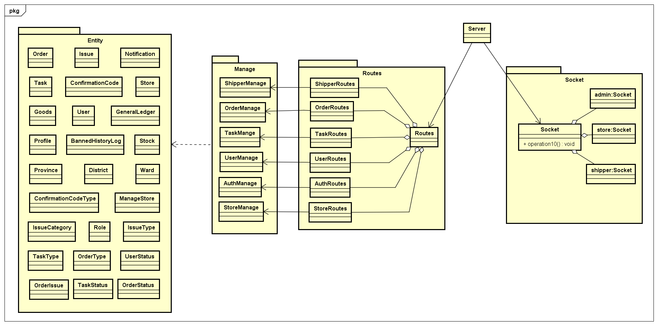

Figure . Class Diagram of Server

##### Class Description

###### 2.2.2.1.1. ShipperManage

* Attributes

|  |  |  |  |  |
| --- | --- | --- | --- | --- |
| No | Attributes | Type | Default | Description |
| N/A | N/A | N/A | N/A | N/A |

* Methods

|  |  |  |  |  |
| --- | --- | --- | --- | --- |
| No | Methods | Parameters | Return | Description |
| 1 | getTasks | String | Object | Return an object that hold info of all un-finished tasks regard to shipperID; throw error messages when get error |
| 2 | getHistory | String, int | Object | Return tasks done or fail regard to shipperID and current page to display |
| 3 | getDetail | String, int | Object | Return detail information of an task regard to shipperID and taskid |
| 4 | getOrderStatusList | N/A | Object | Return the object contents all the status of tasks |
| 5 | nextStep | N/A | String | Change the status of order to next step, change status of task; send socket notification to shipper and admin. Return a message success or error. |
| 6 | createIssuePending | String, Object, Array, int | Object | Create a new pending issue and add related order into database  Return the created issue |
| 7 | changeIsPending | String, int | N/A | Resolve an issue and send socket message to the store owns that order |
| 8 | getAllShipper | N/A | Array | Return list of all shippers |
| 9 | getAllOrderToAssignTask | N/A | Array | Return list of all orders that assignable in database |
| 10 | getAllShipperWithTask | N/A | Array | Return list of all shippers and their current tasks |
| 11 | getAllShipperWithTaskForProcessing | N/A | Array | Return list of shippers are having issue |
| 12 | updateTaskForShipper | Array | Object | Update information of a task |
| 13 | getShipperStatus | String | boolean | Get status of shipper by shipperID |
| 14 | getTaskBeIssuePending | String | Array | Get list of task is pending because the shipper got issue |
| 15 | countTaskOfShipper | String | int | Count current task of the shipper by shipperID |
| 16 | changeShipperStatus | String, boolean | String | Change status of shipper to on or off, return message success or error |
| 17 | createShipperID | N/A | String | Create an unique and valid ID for new shipper |

###### 2.2.2.1.2. IssueManage

* Attributes

|  |  |  |  |  |
| --- | --- | --- | --- | --- |
| No | Attributes | Type | Default | Description |
| N/A | N/A | N/A | N/A | N/A |

* Methods

|  |  |  |  |  |
| --- | --- | --- | --- | --- |
| No | Methods | Parameters | Return | Description |
| 1 | getAllIssue | N/A | Array | Get list of all issues in database |
| 2 | getIssueDetail | int | Object | Get detail information of an issue |
| 3 | updateResolveIssue | int, int | Object | Resolve an issue with type of resolve |
| 4 | postBannedLog | Object | Object | Ban a user cause of some reason |
| 5 | createIssueDisconnect | String | Object | Auto raise an issue when shipper disconnect away the socket server in period time |
| 6 | getUserHasIssue | N/A | Array | Get all users who are having un-resolved issue |

###### 2.2.2.1.3. UserManage

* Attributes

|  |  |  |  |  |
| --- | --- | --- | --- | --- |
| No | Attributes | Type | Default | Description |
| N/A | N/A | N/A | N/A | N/A |

* Methods

|  |  |  |  |  |
| --- | --- | --- | --- | --- |
| No | Methods | Parameters | Return | Description |
| 1 | getProfileUser | String | Object | Get profile of a user |
| 2 | getUserDetail | String | Object | Get detail information of a user |
| 3 | putUser | Object | Object | Update data of a user |
| 4 | putProfile | Object | Object | Update profile for a shipper |
| 5 | addNewUser | Object | Object | Create a new user |

###### 2.2.2.1.4. StoreManage

* Attributes

|  |  |  |  |  |
| --- | --- | --- | --- | --- |
| No | Attributes | Type | Default | Description |
| N/A | N/A | N/A | N/A | N/A |

* Methods

|  |  |  |  |  |
| --- | --- | --- | --- | --- |
| No | Methods | Parameters | Return | Description |
| 1 | get | N/A | Array | Get all stores |
| 2 | postNewStore | N/A | Object | Add new Store to database |
| 3 | put | N/A | Object | Update Store with new information to database |
| 4 | getLatestLedgerOfStore | String | Object | Get latest ledger information of specific store |
| 5 | getAllStoreWithLedger | N/A | Array | Get all stores with information of ledger |
| 6 | getTotalFee | N/A | Array | Get total fee of all stores |
| 7 | getTotalCoD | N/A | Array | Get total cash on delivery of all stores |
| 8 | getLatestAutoAccountDate | N/A | Date | Get latest date of ledger that is added automatically by system |
| 9 | updateLedgerForOrder | int | Object | Update which ledger is paid for order |
| 10 | postNewLedger | Object | Object | Add new ledger (transaction) to database |
| 11 | getStoreName | Array | Array | Get list store’s name by storeid |
| 12 | getStoreDetail | String | Object | Get detail of store by storeid |
| 13 | createStoreOwnerID | N/A | String | Create new username for new store owner |
| 14 | createStoreID | N/A | String | Create new storeid for new store |
| 15 | postNewManageStore | N/A | Object | Add relation of new store’s owner and new Store is managed by this store’s owner to database |
| 16 | getAllLedger | N/A | Array | Get all transaction |
| 17 | getLedgerOfStore | String, Date | Array | Get all ledgers of specific store after specific date |
| 18 | storeGetAllLedger | String | Object | Get all ledgers of specific store |

###### 2.2.2.1.5. OrderMange

* Attributes

|  |  |  |  |  |
| --- | --- | --- | --- | --- |
| No | Attributes | Type | Default | Description |
|  | wardID | String | N/A | ID of ward |
|  | name | String | N/A | Name of ward |
|  | type | String | N/A | Type of ward |
|  | districtID | String | N/A | ID of district has ward |
|  | location | String | N/A | Location of ward in map |

* Methods

|  |  |  |  |  |
| --- | --- | --- | --- | --- |
| No | Methods | Parameters | Return | Description |
| 1 | getAllOrder | String | Array | Get all order of store by storeID |
| 2 | calculateShipFee | String, Array, int | double | Calculate ship fee for an Order |
| 3 | calculateOverWeightFee | String, Array, Array | double | Calculate over weight fee for an Order |
| 4 | GenerateRandomCode | int | String | Create confirm codes for an Order |
| 5 | postOneOrder | Object | Object | Create new order into order table |
| 6 | updateOrder | Object | Object | Update order when user edit info of an order |
| 7 | deleteOrder | String | int | Delete an order in order table |
| 8 | putDraff | Object | Object | Add new draft order in order table |
| 9 | cancelOrder | Object | Object | Request cancel order from Store. Insert new row data into issue table, notification table and notify to Admin |
| 10 | getOrderList | Object | Array | Get all order list from order table |
| 11 | getTodayTotal | N/A | Array | Calculate total COD and Fee of all stores |
| 12 | storeGetOrderList | String | Array | Get list order of a store |
| 13 | countOrder | String | Array | Calculate total of order by month or year of a store. |
| 14 | getOverView | N/A | Array | Get all orders, stores, shipper, fee of system to statistical |
| 15 | pushIntoArray | Array, Object | int | Push Item into Array. If item not exist in array, then add item in array. If item exist in array, then update item.  Return index of item in array |
| 16 | getOrderCount | N/A | Array | Get number order of store by month, year |
| 17 | getMoneyCount | N/A | Array | Get total fee and cod of all orders of store |
| 18 | getCountOrdersDoneOrFail | N/A | Array | Count number of done orders and fail orders of all stores |
| 19 | getProvince | N/A | Array | Get all provinces |